# Table Of Contents

## Part I — Strategic Summary (Decision-first)

### 1. Executive Summary

1.1 Key questions answered  
1.2 Top findings  
1.3 Recommended actions  
1.4 What success looks like (KPIs + guardrails)

## Part II — Context, Evidence, and Scope

### 2. Business Context and Objectives

2.1 What “fan journey analytics” means for a physical + digital experience  
2.2 Decisions supported (operations, marketing, experience design)  
2.3 Primary metrics and guardrails  
2.4 Industry Context and Related Work  
2.5 Scope, assumptions, and limitations  
2.5.1 Scope and what the proxy dataset captures adequately  
2.5.2 Key assumptions (and how they constrain interpretation)  
2.5.3 Limitations of the proxy dataset (and analytic mitigations)  
2.5.4 What additional Netflix House data would make the system production‑grade

## Part III — Analytics Findings

### 3. Data and Scope

3.1 Dataset overview (RetailRocket event logs)  
3.2 Data grain and entities (visitor, session, item/category, transaction)  
3.3 Key fields used and derived features  
3.4 Data quality checks + limitations (missingness, ID coverage, timestamp granularity)  
3.5 What internal Netflix House data would improve (POS, foot traffic, dwell sensors, staffing)

### 4. Methodology Overview

4.1 Analytics approach (SQL metric layer → modeling → decision outputs)  
4.2 Sessionization approach (how sessions/time‑spent were defined)  
4.3 Funnel definitions (view → add‑to‑cart → transaction)  
4.4 Evaluation design (train/test split, time-based validation where applicable)  
4.5 Forecasting methodology (demand planning)  
4.6 Recommendation methodology (discovery and relevance)  
4.7 Cold‑start methodology (new users and new items/experiences)  
4.8 Retention/churn methodology (30-day return risk)  
4.9 Experimentation and causal inference (incrementality and measurement validity)  
4.10 Methodology summary and alignment with Netflix House decision needs

### 5. Fan Behavior and Journey Insights

5.1 Temporal demand and session structure  
5.2 Funnel performance and friction localization  
5.3 Category / “experience space” preferences  
5.4 Segmentation highlights (browsers vs high‑intent vs buyers; implications)

### 6. Forecasting and Planning Insights

6.1 Forecast target(s) (daily visitors; demand proxy)  
6.2 Feature engineering (lags, rolling stats, recency, seasonality proxies)  
6.3 Models tested and baseline strategy  
6.4 Performance summary (MAE/MAPE, stability)  
6.5 Operationalizing forecasts (staffing/inventory triggers, confidence bands)

### 7. Recommendation System Evaluation

7.1 Recommender goal (next‑best item/experience)  
7.2 Baselines tested (popularity, co‑visitation)  
7.3 Offline metrics (Precision@K, Recall@K, NDCG@K)  
7.4 Coverage & novelty (avoid over‑concentration; catalog health)  
7.5 Implications for in‑venue + app discovery experiences

### 8. Cold Start Strategy

8.1 New user cold start (diverse slate; rapid warm‑start)  
8.2 New item cold start (content/category‑based similarity; controlled exposure)  
8.3 Monitoring plan (engagement lift, diversity, long‑term retention guardrails)

### 9. Retention / Churn Risk Modeling

9.1 Problem definition (30‑day return risk)  
9.2 Feature categories (recency/frequency, funnel behavior, breadth/entropy)  
9.3 Models + evaluation (ROC‑AUC, PR‑AUC, lift by decile)  
9.4 Targeting strategy (who to intervene on + what action)  
9.5 Risks: bias, over‑targeting, measurement pitfalls

### 10. Statistical Rigor and Experimentation Plan

10.1 A/B test design for a new recommendation/experience surface  
10.2 Power and sample size logic (high level)  
10.3 Significance testing approach + multiple comparisons  
10.4 Causal considerations (spillover, novelty effects, seasonality)

## Part IV — Productionization and Operating Model

### 11. Recommendations and Next Steps (May need to rewrite and move to the back)

11.1 Operational recommendations (capacity, staffing, queue mitigation)  
11.2 Experience recommendations (which categories/spaces to highlight; navigation/signage)  
11.3 Personalization roadmap (MVP → improved models → online validation)  
11.4 Measurement plan (dashboards + alerts + experiment cadence)

### 12. System Blueprint

12.1 Event taxonomy and logging schema (digital + physical)  
12.2 Metric layer and semantic definitions (single source of truth)  
12.3 Data quality contracts and observability (freshness, completeness, anomaly detection)  
12.4 Model serving and monitoring (forecast, recommender, churn risk)  
12.5 Experiment registry and causal analytics integration

### 13. Proxy Calibration Plan

13.1 Instrumentation requirements (entry scans, dwell, queue, POS, exposures)  
13.2 Calibration methodology (mapping proxy signals → physical outcomes)  
13.3 Sensitivity analysis and robustness checks  
13.4 Drift monitoring and recalibration cadence

### 14. Venue Quasi‑Experimentation Playbook

14.1 When randomization is feasible (switchback, time-sliced tests)  
14.2 When randomization is infeasible (ITS, synthetic controls, DiD)  
14.3 Spillover/interference management (venue congestion externalities)  
14.4 Reporting templates (effect sizes, uncertainty, guardrails, diagnostics)

### 15. Experience Launch Observability

15.1 “Experience Health” scorecard (launch readiness, discoverability, conversion, congestion)  
15.2 Cold-start exposure targets and exploration budgets  
15.3 Launch monitoring and alerting (RecSysOps analogue)  
15.4 Post-launch evaluation (incrementality + long-run portfolio health)

## Appendix

A. Definitions (metrics, session rules, churn label definition)  
B. SQL / pipeline notes (how tables/views were built)  
C. Model hyperparameters and validation details  
D. Additional charts (optional)

Part I — Strategic Summary

# 1. Executive Summary

This work sample develops a portable, reproducible **fan-journey analytics prototype** for a Netflix House–style environment by treating a public interaction log (RetailRocket) as a **phygital proxy** for the sequence of states that matter operationally: discovery → intent → conversion → return. The goal is not to claim one-to-one equivalence between e-commerce clicks and venue footsteps, but to demonstrate a Netflix-aligned methodology that turns behavioral logs into an operating system: **proxy validity → calibrated measurement → causal evaluation → operational rollouts**.

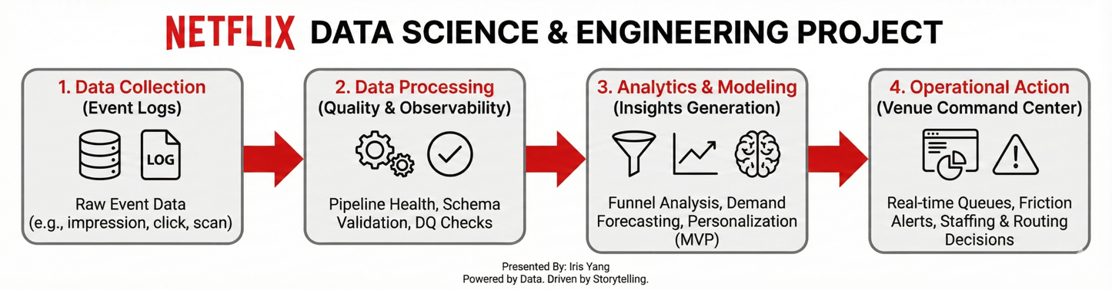

Empirically, the proxy data exhibit pronounced temporal demand heterogeneity that would directly translate into venue load management. Engagement varies by roughly an order of magnitude across the day (peak ≈ 113,677 vs trough ≈ 11,489 unique visitors), implying that staffing, routing, and congestion guardrails must be designed around predictable daypart swings rather than average demand.

The funnel analysis further indicates that the largest attrition occurs before purchase: a low overall conversion baseline (buyers/visitors ≈ 0.83%) coexists with a substantially higher intent formation rate (add-to-cart user rate ≈ 2.68%), suggesting that the highest-leverage interventions live upstream in discovery relevance and commitment friction—not merely checkout mechanics.

To support planning, the project establishes a baseline daily-demand forecaster using lightweight, production-realistic features (lags and weekday effects). The Gradient Boosting model achieves **MAE ( mean absolute error) ≈ 1,167 visitors** with **MAPE(mean absolute percentage error) ≈ 34.6%**, indicating that demand is volatile and that operational use should emphasize decision thresholds and uncertainty bands rather than point estimates alone.

For personalization, the report evaluates two deployable baselines—popularity and item-to-item co-visitation—and shows that co-visitation provides a consistent offline improvement, motivating it as an MVP (Minimum Viable Product, a good-enough model) candidate generation strategy before more complex models are justified.

Finally, the report translates analytics into Netflix-style operational practice: a metric hierarchy (primary/secondary/guardrails), an experimentation plan grounded in power feasibility, and an engineering-minded blueprint for event logging, monitoring, and quasi-experimental evaluation when randomization is infeasible in physical venues.

Optimizing the Physical & Digital Fan Journey Through Advanced Analytics, ML, and Experimentation.

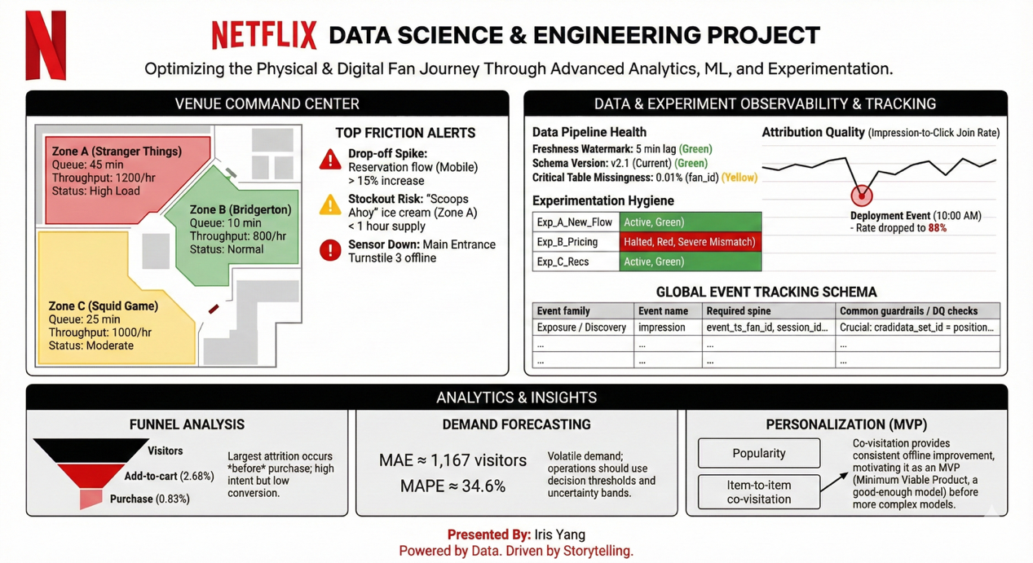

Optimizing the Physical & Digital Fan Journey Through Advanced Analytics, ML, and Experimentation.

## 1.1 Key questions answered

This work sample is organized around a set of applied research questions that collectively describe, model, and operationalize the **fan journey** as an empirical process—beginning with exposure and exploration, proceeding through intent formation and conversion, and extending to return behavior and measurement validity.

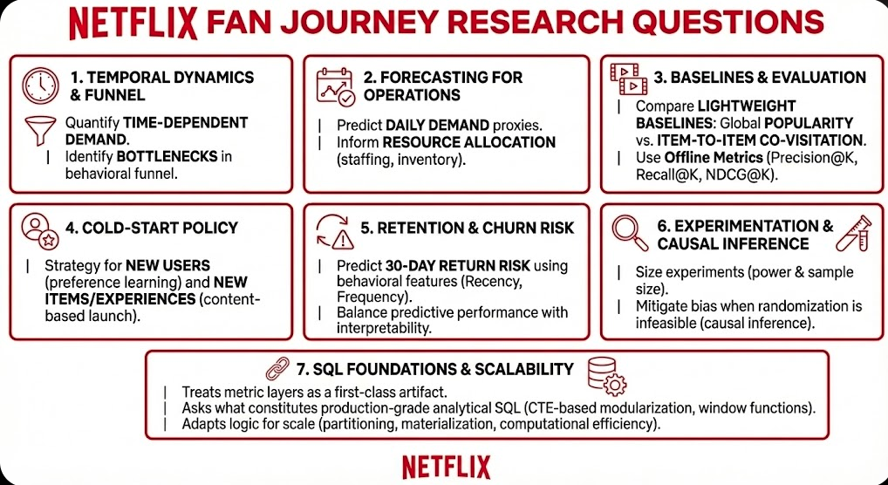

**(1) Fan behavior and temporal dynamics.**  
The first objective is descriptive and diagnostic: to quantify the extent of **time-dependent demand heterogeneity** and to identify where users exit the journey. Concretely, the analysis asks (i) when engagement is highest and lowest (via hour-of-day arrival patterns), and (ii) where the behavioral funnel exhibits its largest attrition, operationalized as progression from **view → add-to-cart → transaction**. The purpose is to isolate bottlenecks that plausibly reflect discovery relevance gaps or commitment friction.

**(2) Planning and forecasting for operational decision support.**  
Given the observed volatility of engagement, the second objective is predictive: to assess whether demand can be forecast with sufficient fidelity to inform **resource allocation**. The central question is whether a model of daily demand proxies (e.g., unique visitors or transactions) can provide actionable accuracy for staffing, inventory, and experience operations, acknowledging that point prediction is less important than producing a planning-relevant estimate (and, ideally, uncertainty bounds).

**(3) Personalization baselines and evaluation methodology.**  
The third objective concerns discovery optimization. The project asks which **lightweight, production-feasible baselines** constitute strong starting points for recommendation—specifically, global **popularity** versus **item-to-item co-visitation**. It further asks how to evaluate these approaches using standard offline ranking metrics (Precision@K, Recall@K, NDCG@K) under a time-respecting validation scheme, recognizing that offline relevance is a necessary (but insufficient) precursor to online lift.

**(4) Cold-start policy for new users and newly launched items/experiences.**  
Because recommender systems operate under persistent sparsity—new visitors with minimal history and new catalog entities with minimal interactions—the fourth objective is policy-oriented: (i) what exposure strategy is appropriate for **new users** to accelerate preference learning without over-concentrating on a narrow set of popular items, and (ii) what mechanism supports the “launch” of **new items/experiences** (e.g., content-based similarity) before collaborative signals accumulate.

**(5) Retention and churn risk modeling.**  
The fifth objective extends beyond immediate conversion to the longitudinal outcome of return behavior. The analysis asks which behavioral features (e.g., recency, frequency, breadth of interaction) are informative for predicting **30-day return risk**, and which modeling choices balance predictive performance with interpretability and operational utility (e.g., logistic regression as an explanatory baseline versus a non-linear booster for incremental predictive gain).

**(6) Experimentation and causal inference for reliable decision making.**  
Because observational associations are insufficient for product and marketing decisions, the sixth objective focuses on measurement rigor. The project asks (i) how to size experiments to detect practically meaningful lift given low base-rate outcomes (power and sample size planning), and (ii) how to mitigate bias when randomized assignment is unavailable, through causal inference framing and adjustment strategies (e.g., propensity weighting), while making assumptions explicit.

**(7) SQL foundations and scalability considerations.**  
Finally, the project treats the metric layer as a first-class artifact. It asks what constitutes **production-grade analytical SQL** (e.g., CTE-based modularization, window functions for ranking and segmentation) and how the same logic would be adapted for scale (partitioning, materialization strategies, and computational efficiency) in a Netflix-like environment.

## 1.2 Top findings

**Dataset footprint (proxy fan journey logs).** The proxy dataset contains approximately 2.76M time-stamped events and is heavily skewed toward discovery behavior: 2,664,312 views, 69,332 add-to-cart events, and 22,457 transactions. Across these interactions we observe ~1.41M unique visitors, of whom 11,719 ever transact. This mix is typical of early-funnel, browse-dominant journeys: conversion is sparse, so intent signals (e.g., add-to-cart or save-to-plan) become essential for both modeling and measurement.

**Traffic / “arrival pattern”.** Hourly arrivals exhibit strong daypart effects, with a peak around 20:00 (~113,677 unique visitors) and a trough around 10:00 (~11,489), nearly a 10× swing. For a physical venue, this scale of volatility directly translates into staffing, queue management, and on-site inventory risk; it also means that “average day” reporting can hide the operational reality unless metrics are time-aware.

**Funnel performance (high-level).** At an aggregate level, baseline conversion (buyers/visitors) is ~0.83%. The upstream transition from view to add-to-cart is ~2.69% (unique), while the downstream transition from add-to-cart to transaction is ~31.1% (unique). The largest drop-off therefore occurs before explicit intent, suggesting that discovery relevance, information clarity, and commitment friction are the highest-leverage levers for improvement.

**Demand forecasting (daily unique visitors).** A Gradient Boosting baseline achieved test MAE ≈ 1,167 visitors and test MAPE ≈ 34.6%. Practically, this indicates that demand is volatile and that forecasts based only on endogenous history have limited precision; forecast quality should improve materially once exogenous drivers are incorporated (campaign calendar, seasonality, content mix, and geo/timezone effects).

**Recommendation system (offline).** On a time-based split (Train: 2,204,880 events; Test: 551,221 events), an item-to-item co-visitation baseline outperformed a popularity baseline: Popularity achieved Precision@10 = 0.0008, Recall@10 = 0.0068, and NDCG@10 = 0.0033, whereas co-visitation achieved Precision@10 = 0.0012, Recall@10 = 0.0088, and NDCG@10 = 0.0047. Although absolute values are small in a large-catalog, single-label setting, the relative gains are consistent (+50% Precision@10, +29% Recall@10, +42% NDCG@10), supporting co-visitation as a production-feasible personalization starting point.

**Cold start.** For new users, a category-balanced “diverse slate” reduces over-concentration on a few popular categories and accelerates preference learning by sampling broadly across the catalog. For new items/experiences, TF-IDF content similarity over item properties provides a practical nearest-neighbor strategy to seed exposure (implemented here on the top 20k most-viewed items using ~1.33M property rows), which is especially relevant when interaction history is not yet available.

**Retention / churn modeling (30-day return risk).** A transaction-based churn definition is extremely imbalanced in the proxy setting (~99.97% labeled as “churn”) because purchases are rare. Despite this, models showed separable signal (Logistic Regression ROC-AUC ~0.77; XGBoost ROC-AUC ~0.76). The key implication for Netflix House is definitional: “return” should be anchored in engagement and visitation behavior, not only purchases, to avoid both label sparsity and misleading retention conclusions.

**Experimentation and causal inference.** Given a baseline conversion of ~0.83%, detecting a 5% relative lift requires on the order of ~766k users per variant, making many conversion-based tests slow and expensive. This motivates using leading indicators (intent formation, time-to-intent, engagement depth) as primary experimental endpoints while reserving purchase outcomes for validation. In a causal inference demo, naïve observational estimates were heavily biased (true ATE $5.00 vs naïve $10.56), and inverse-propensity weighting (IPTW) moved the estimate toward the truth ($5.87), reinforcing the need for randomization where feasible and transparent quasi-experimental assumptions otherwise.

## 1.3 Recommended actions

On the basis of the descriptive, predictive, and evaluative results summarized in Sections 1.1–1.2, the following actions are recommended to translate the analysis into an operationally deployable “fan journey analytics” capability.

**(1) Institutionalize time-aware operations planning as a first-order control system.**  
Given the magnitude of intraday demand heterogeneity (near order-of-magnitude trough-to-peak variation), staffing, inventory replenishment, and on-site activation should be parameterized explicitly as functions of time (e.g., peak bands defined by historical percentiles of hourly traffic). In practice, this implies implementing a lightweight planning layer that (i) converts traffic forecasts into downstream workload expectations using empirically estimated funnel rates and (ii) triggers predefined operational playbooks (e.g., staffing flex, queue mitigation, replenishment cadence) when projected demand crosses capacity-relevant thresholds.

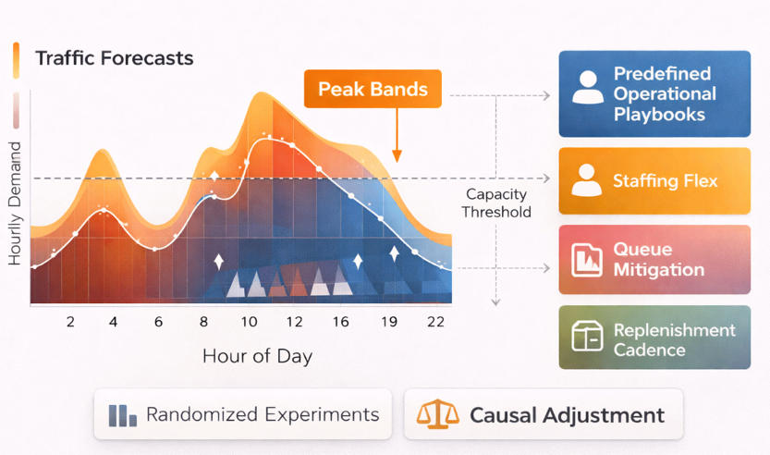

**(2) Prioritize early-funnel interventions and adopt leading indicators as primary optimization targets.**  
Because the dominant attrition occurs upstream (view → add-to-cart), the most leverageable improvements are those that increase intent formation rather than those that exclusively optimize late-stage checkout. Accordingly, product and experience initiatives should focus on improving discovery relevance and reducing commitment friction, while monitoring a small set of high-frequency leading indicators (e.g., add-to-cart rate; time-to-first-intent) that provide faster statistical feedback than purchase outcomes in low base-rate environments.

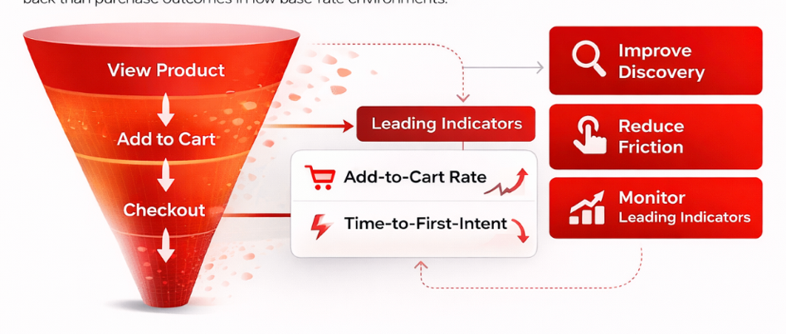

**(3) Deploy a production-feasible personalization baseline with explicit diversity and catalog-health constraints.**  
The offline evaluation indicates that contextual association signals (item-to-item co-visitation) outperform global popularity baselines, suggesting an actionable “MVP recommender” path. A pragmatic deployment would (i) operationalize co-visitation recommendations for in-session guidance, (ii) retain popularity as a fallback when history is sparse, and (iii) enforce guardrails such as category-level diversity, coverage, and concentration limits to avoid over-amplifying a small set of “hero” items and to maintain portfolio health.

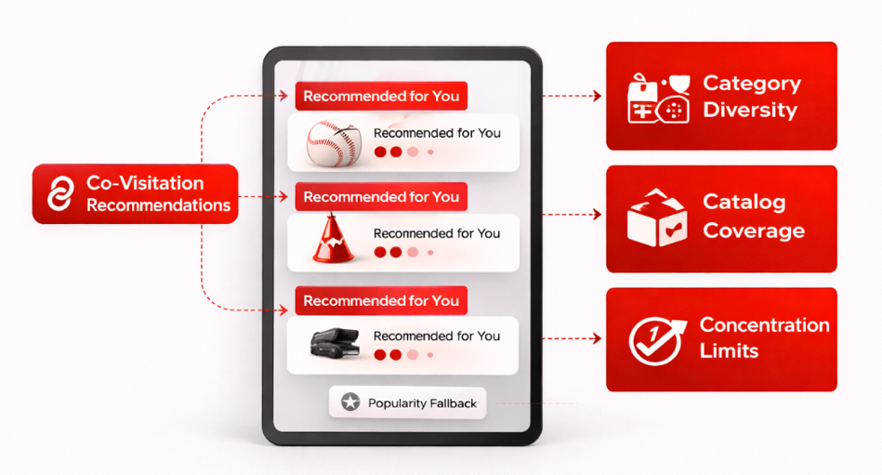

**(4) Formalize cold-start policy for both new users and newly launched items/experiences.**  
Cold start should be treated as a policy regime rather than an exception case. For new users, a category-balanced, diversified slate can reduce over-concentration and accelerate preference elicitation. For new items, content-based similarity derived from item attributes can be used to seed exposure prior to the accumulation of collaborative signals, supplemented by a controlled exploration budget to ensure sufficient initial data collection. Success criteria should include both immediate engagement lift and longer-run diversity/coverage stability.

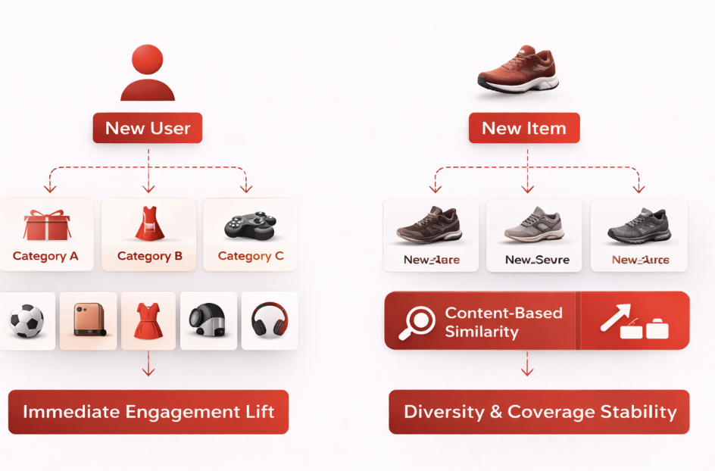

**(5) Reframe retention measurement and embed causal discipline in targeting and evaluation.**  
The transaction-based 30-day churn label is extremely imbalanced in the proxy data, underscoring the methodological point that retention definitions must match the operational construct of “return.” For a Netflix House–style experience, retention should incorporate engagement-based return (e.g., revisit/booking/app re-engagement), enabling more actionable intervention design. Interventions (e.g., win-back messaging, personalized re-entry slates) should be evaluated through appropriately powered experiments when feasible; when randomization is not feasible, causal adjustment methods (e.g., propensity weighting) should be used explicitly with assumptions stated and diagnostics reported.

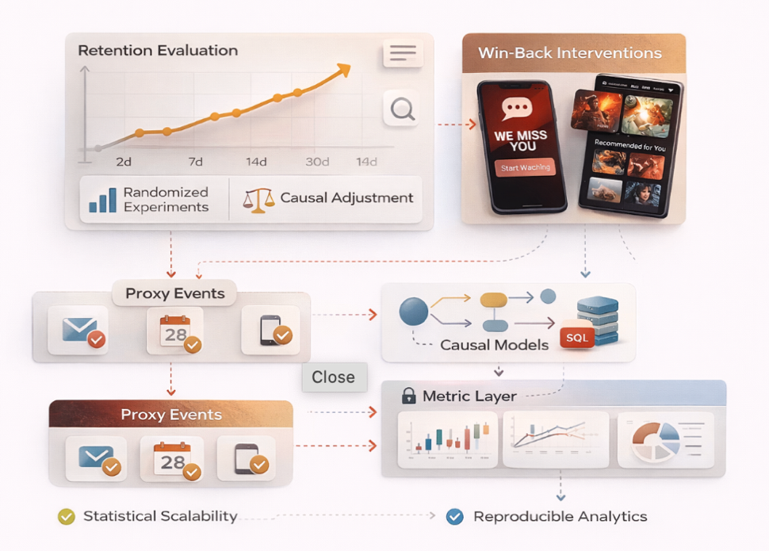

**Implementation note: analytics scalability and reproducibility.**  
To support the above actions at production scale, the project’s SQL-first metric layer should be operationalized as a curated data product (e.g., partitioned Parquet storage by date/event type, materialized KPI views, and approximate distinct counts for dashboard responsiveness), ensuring consistent definitions across forecasting, recommender evaluation, and retention modeling workflows.

## 1.4 What success looks like (KPIs + guardrails)

A fan-journey analytics system is only “successful” if it improves outcomes **and** remains safe to operate. To avoid optimizing one metric at the expense of the guest experience or venue stability, success should be defined through a **hierarchical measurement framework** that separates (i) primary business outcomes, (ii) leading indicators used for rapid iteration, and (iii) guardrails that prevent harmful side effects.

**KPIs (Key Performance Indicators)** are the small set of measurable outcomes the organization uses to track whether the system is delivering value. In this report, KPIs are defined so they can be used as operational targets (for staffing, routing, merchandising, and product changes) and as evaluation endpoints in experiments or quasi-experiments.

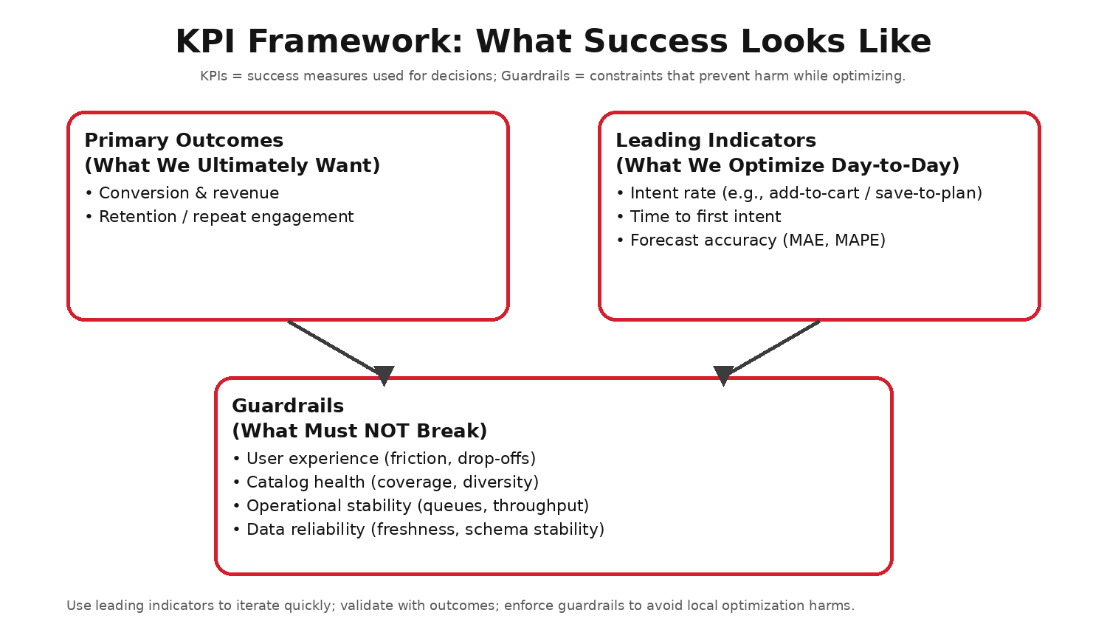

### 1.4.1 Primary KPIs (outcomes and leading indicators)

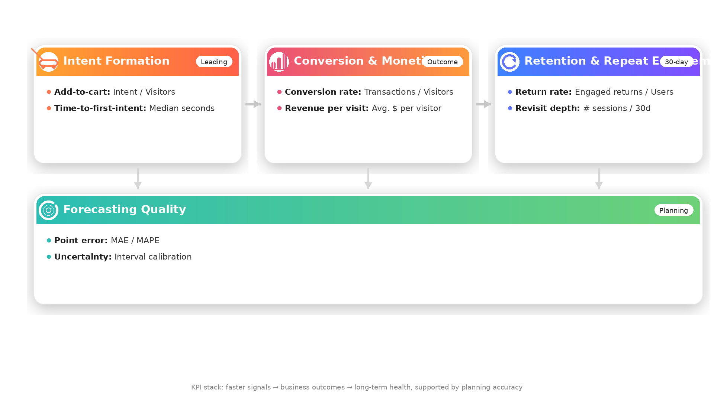

**(1) Conversion & monetization (outcome KPI).**  
The core outcome KPI is **conversion rate**, defined as **transactions per unique visitor** (equivalently, unique buyers divided by unique visitors). This is interpretable, comparable over time, and directly aligned with business value in commerce-like journeys. In a Netflix House deployment, “transactions” generalize to **ticket purchases**, **add-on purchases**, and **merchandise/F&B point-of-sale transactions**, and should be tracked at appropriate grains (per visit, per attendee, and per day) depending on the decision context.

**(2) Intent formation (leading indicator KPI).**  
Because the largest funnel attrition typically occurs upstream (browsing → intent), the primary leading indicators are:

* **Add-to-cart (or save-to-plan) rate (intent users / unique visitors):** This leading indicator captures the share of visitors who move from passive browsing into an explicit commitment signal. In a Netflix House setting, analogous events include reservation starts, waitlist joins, or “save this experience” actions. Because it sits upstream of purchases, shifts in this metric typically reflect discovery relevance, information clarity, and perceived value before conversion.
* **Time-to-first-intent (elapsed time from first interaction to first intent signal):** This measures how quickly a visitor reaches a commitment moment after entering the journey. Longer times can indicate choice overload, confusing navigation, missing information (pricing/availability), or capacity constraints that delay commitment; shorter times generally signal clearer journey architecture and better-targeted entry points.

Because intent metrics update quickly and are far less sparse than purchases, they serve as practical primary endpoints for rapid iteration and experimentation when base conversion is low.

**(3) Retention / repeat engagement (longitudinal outcome KPI).**  
Retention should be measured as the **fraction of users who return within a fixed horizon** (e.g., 30 days). Critically, “return” should be defined using **engagement-based outcomes** (e.g., revisit, reservation initiation, attendance scans, meaningful app re-engagement), not purchases alone. This improves both statistical power and operational relevance, especially in sparse conversion regimes where purchase-only labels can be extremely imbalanced.

**(4) Forecasting quality (planning KPI).**  
Forecasting supports staffing, inventory, and capacity planning and should be evaluated using:

* **MAE and MAPE for point forecast accuracy:** MAE (Mean Absolute Error) provides an interpretable “average miss” in visitor counts, which maps directly to staffing and inventory deltas. MAPE (Mean Absolute Percentage Error) normalizes error relative to demand volume, making it easier to compare performance across low-traffic and peak days. For operational use, both should be reviewed by segment and seasonality regime, since the cost of under-forecasting is typically concentrated at peaks.
* **Interval calibration for uncertainty-aware planning:** When forecasts are used with prediction intervals, calibration ensures that stated coverage levels (e.g., 80% or 95%) match reality. Well-calibrated intervals support risk-aware triggers such as “staff up if the 80th-percentile forecast exceeds capacity,” and help decision makers choose buffers explicitly rather than relying on ad hoc safety margins.

Operationally, the goal is not only to minimize average error, but to be accurate enough—at known uncertainty levels—to set staffing and inventory triggers with explicit risk tolerances.

### 1.4.2 Guardrails (constraints that prevent harmful optimization)

**(1) Experience friction guardrails (guest experience protection).**  
To ensure conversion gains are not achieved by increasing friction, monitor:

* **Prolonged interaction sequences without intent:** Patterns such as many views with no progression are a practical early warning sign that visitors are exploring but not finding a compelling next step. In practice, this can reflect poor relevance, unclear value propositions, missing availability cues, or friction in moving from exploration to commitment.
* **Repeated item interactions without advancement:** Repeatedly returning to the same item/category without committing often signals uncertainty (e.g., unclear pricing, limited time slots, or confusing requirements). Tracking this behavior helps distinguish genuine interest from stalled progress and can guide targeted UX or messaging improvements.
* **Sudden shifts in stagewise funnel rates:** Abrupt changes in transitions (for example, a jump in abandonment after add-to-cart) can indicate an unintended experience regression, a capacity shock, or an instrumentation change. Monitoring these rates as guardrails helps catch degradations early, before they manifest as downstream revenue declines.

Taken together, these friction measures function as guardrails: they can reveal a degrading journey even if downstream conversion appears temporarily stable.

**(2) Personalization & catalog health guardrails (avoid over-concentration).**  
Recommendation systems can unintentionally over-expose “hero” items. Success therefore requires maintaining:

* **Coverage (breadth of catalog surfaced):** Coverage ensures that discovery surfaces do not repeatedly route traffic to the same small set of items. In a physical venue context, broad coverage is also an operational tool: distributing attention across zones and time slots reduces congestion risk.
* **Diversity (variety within a slate):** Diversity controls keep recommendation slates from becoming overly homogeneous, supporting exploration and increasing the chance that different visitor intents are served. This is particularly important when guests arrive with mixed goals (merchandise browsing, attractions, dining) and limited time on-site.
* **Concentration and novelty controls:** Explicit limits on how much exposure the top items can capture prevent “rich-get-richer” feedback loops and protect the long tail of the catalog. Novelty constraints ensure that returning visitors continue to see fresh options, while also helping operations avoid over-concentrating demand on a single activation.

In physical venues, these are not merely “fairness” constraints—over-concentration on a small set of activations can create localized congestion, reduce dwell quality, and ultimately erode satisfaction and return intent.

**(3) Fairness and portfolio balance guardrails (sustained ecosystem health).**  
Independent of model accuracy, stakeholders often require that the system does not systematically starve certain categories/IPs/experiences. Practical checks include monitoring exposure share by category, long-tail traffic trends, and whether growth is being driven by a narrow subset of the portfolio at the expense of broader engagement.

**(4) Operational stability & data reliability guardrails (decision-grade trust).**  
A system cannot be decision-grade if its data pipelines are unstable. Minimum reliability guardrails include:

* **Pipeline latency and data freshness (SLA adherence):** Operational decisions (staffing adjustments, queue mitigation, inventory replenishment) depend on timely telemetry. Defining and enforcing SLAs for end-to-end data latency ensures dashboards and models reflect current conditions rather than yesterday’s reality.
* **Schema and instrumentation stability:** Stable event definitions are required for trustworthy time-series comparisons. Versioning instrumentation, logging changes, and schema evolution prevents silent discontinuities that can masquerade as product or operational effects.
* **Anomaly detection for spikes and drops:** Automated checks for sudden volume shifts help detect outages, logging failures, bot traffic, or campaign-driven surges that can invalidate short-horizon decisions. Flagging and annotating anomalous periods keeps downstream reporting, forecasting, and experiments from being misled by data quality artifacts.

These reliability controls keep dashboards and models decision-grade over time, preventing product and operations teams from reacting to data artifacts rather than true changes in guest behavior.

Part II — Context, Evidence, and Scope

# 2. Business Context and Objectives

This work sample is situated in the context of **experience-led entertainment**—specifically, a Netflix House–style environment in which fan engagement spans **both digital touchpoints** (marketing, app/web discovery, reservation flows) and **physical touchpoints** (arrival, queueing, on-site navigation, retail/F&B purchasing, and post-visit re-engagement). In such settings, the “product” is not a single screen or feature; rather, it is a **multi-stage journey** in which user intent, operational constraints, and experience quality interact dynamically.

From a decision-science standpoint, the central challenge is that performance is jointly determined by:

1. **Demand formation:** This is the top-of-funnel process that determines how many guests arrive, when they arrive, and what intent they bring. In practice it is shaped by marketing cadence, local events, and IP resonance, and it sets the baseline load the venue must absorb.
2. **Capacity and service constraints:** Staffing, throughput, inventory, and queue dynamics determine whether interest becomes a smooth experience or congestion and lost revenue. Because these constraints bind in physical settings, analytics must treat capacity as a first-class input, not an afterthought.
3. **Discovery and choice architecture:** How experiences and merchandise are organized, ranked, and explained—across digital surfaces and on-site touchpoints—shapes what guests notice and how easily they commit. Information architecture can also concentrate demand in specific zones, creating operational side effects that simple conversion metrics may miss.
4. **Longitudinal outcomes:** Return behavior, satisfaction, and affinity capture the longer-run value of the experience beyond a single visit or purchase. These outcomes close the loop: great experiences amplify future demand through repeat visitation and word-of-mouth, while poor experiences can depress lifetime value.

Accordingly, “success” cannot be fully captured by a single aggregate KPI. Instead, it requires a measurement system that is simultaneously:

* **Predictive:** The system should forecast traffic and intent under uncertainty so teams can plan staffing, inventory, and queue mitigation proactively. Prediction intervals (not only point forecasts) are essential for risk-aware peak planning.
* **Diagnostic:** When performance shifts, the analytics layer should localize where the journey is breaking (for example, many browse events with no intent) and surface likely failure modes. This turns monitoring into actionable hypotheses for product, marketing, and operations teams.
* **Prescriptive:** Beyond describing what happened, the system should connect metrics to levers—recommendation policies, messaging cadence, merchandising layouts, and staffing actions—so decision makers can choose interventions that plausibly improve outcomes.
* **Causally grounded:** The measurement strategy must distinguish incrementality from correlation through experimentation when feasible and principled quasi-experimental methods when not. Without causal grounding, optimization can overestimate lift by simply targeting already high-intent guests or by ignoring capacity-driven confounding.

Because internal Netflix House data are not publicly available, this project uses a public event-log dataset (RetailRocket) as a **structural proxy** for the digital component of the journey. The intent is not to claim equivalence of domains, but to demonstrate an approach that is **methodologically transferable**: constructing a reusable metric layer, modeling demand and propensity, evaluating recommendation strategies, and defining a measurement plan consistent with real-world operational decision making.

In this proxy setting, the mapping is deliberately explicit:

* **View events:** In the proxy dataset, views are treated as discovery/browsing exposure—the digital analogue of a guest exploring offerings before committing. They provide the high-volume signal needed to model early-funnel engagement.
* **Add-to-cart events:** Add-to-cart is used as a proxy for intent formation, analogous to saving an experience, starting a reservation, or signaling commitment. Because it is far more frequent than purchases, it is a practical leading indicator for optimization and experimentation.
* **Transaction events:** Transactions represent completed conversion in the proxy setting. Conceptually, this maps to completed reservations, ticket purchases, or on-site POS transactions—events that monetize intent.
* **Visitor identity (visitorid):** The visitor identifier plays the role of a fan/guest ID, enabling sequence modeling (what was explored before commitment), cohorting (new vs returning), and retention measurement.
* **Item and category metadata:** Catalog metadata stand in for the set of experiences and items that can be surfaced. In a Netflix House implementation, analogous metadata would describe zones, IP activations, time slots, ticket types, and merchandising categories so that reporting and recommendations are catalog-aware.

The objective of Section 2 is to formalize what “fan journey analytics” entails in a hybrid physical–digital system and to clarify the decision context motivating the analyses that follow.

## 2.1 What “fan journey analytics” means for a physical + digital experience

**Engineering-Focused Data Science Workflow**

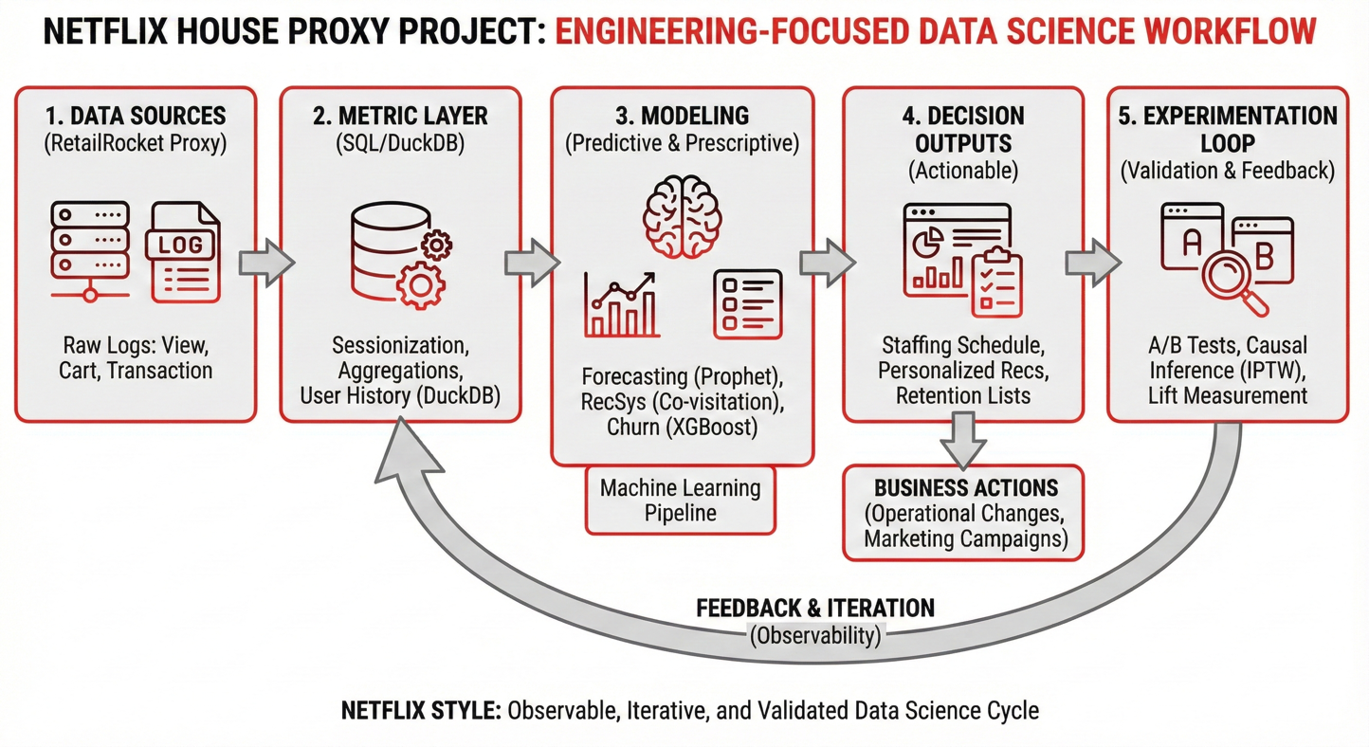

**Observable, Iterative, and Validated Data Science Cycle**

**Fan journey analytics** refers to the measurement and modeling of user progression through a sequence of states—spanning exposure, exploration, commitment, consumption, and return—to support **decision-relevant interventions**. In a hybrid physical–digital experience, the journey is characterized by (i) multiple, heterogeneous touchpoints, and (ii) constraints and externalities that are weak or absent in purely digital systems.

### Conceptual structure: states, transitions, and interventions

A useful analytic abstraction is a staged process in which a fan transitions between states, for example:

1. **Exposure and acquisition:** This stage covers marketing and referral touchpoints that bring a fan into the journey and set initial intent. It includes channel and campaign timing effects that shape who arrives and when.
2. **Discovery and evaluation:** Here the fan browses and compares options, gathering information about experiences or merchandise. Personalization and clear UX are most influential at this stage because they determine what the fan actually considers.
3. **Commitment:** Commitment is the moment a fan signals intent—adding to a plan/cart, beginning checkout, or confirming a reservation. Friction here is often driven by unclear availability, pricing, or perceived value, and it is a common point where capacity constraints surface.
4. **Consumption:** Consumption corresponds to the in-venue experience: arrival, queueing, throughput across zones, dwell time, and add-on purchasing. Because service constraints dominate in this stage, analytics must track congestion and throughput alongside engagement.
5. **Post-consumption outcomes:** After the visit, satisfaction, likelihood to recommend, and return propensity determine longer-run value. These outcomes feed back into demand formation via repeat visitation and word-of-mouth.

Fan journey analytics seeks to quantify:

* **Transition probabilities:** Estimating browse-to-intent and intent-to-conversion rates makes the “where are we losing guests?” question concrete and supports sizing the impact of upstream interventions.
* **Time dynamics:** Hour-of-day and day-of-week effects, plus the latency between stages (e.g., time from exposure to intent), are essential for staffing and for interpreting changes that may shift timing rather than total volume.
* **Heterogeneity across segments:** Different segments behave differently (new vs returning, high-intent vs casual). Modeling this heterogeneity avoids one-size-fits-all optimization and supports targeting that respects operational limits.
* **Sensitivity to policy levers:** Quantifying how outcomes respond to levers—recommendation logic, merchandising, staffing, and messaging cadence—connects measurement directly to decision making and sets up what experiments or causal methods must estimate.

### Why hybrid experiences are analytically distinct

Compared with a purely digital product, a physical + digital system introduces at least three important complexities:

1. **Capacity constraints and congestion externalities.**  
   Interventions that increase demand or concentrate attention (e.g., promoting a “hero” experience) can degrade experience quality through queue formation, stockouts, and service strain. Consequently, analytics must couple conversion objectives with **experience guardrails** and must treat operational metrics (throughput, congestion proxies) as first-class constraints.
2. **Time dependence as a core determinant of performance.**  
   Demand is often bursty and strongly dependent on the hour of day and day of the week. As a result, effective analytics must support both **forecasting** (for staffing/inventory planning) and **intra-day monitoring** (for real-time mitigation).
3. **Measurement and causal identification challenges.**  
   Marketing and experience interventions are frequently targeted and non-random, which can induce substantial confounding. Thus, credible fan journey analytics requires an experimentation plan (when randomization is feasible) and a causal inference toolkit (when it is not), with explicit assumptions and diagnostics.

### What the analytics system must ultimately deliver

Operationally, a mature fan journey analytics capability should provide:

* **Metric layer with stable definitions:** A shared metric layer ensures funnel, demand, retention, and catalog-health measures are defined consistently across teams. Stable definitions are a prerequisite for trustworthy experiments and longitudinal comparisons.
* **Planning outputs:** Forecasts with uncertainty should translate into decision-ready staffing and inventory triggers, including peak planning and contingency buffers—not only point estimates.
* **Discovery optimization:** Recommendation evaluation should measure relevance while enforcing diversity and coverage constraints, because the goal is to route attention in ways that maintain catalog health and avoid concentrating demand in a way that harms the on-site experience.
* **Retention and lifecycle modeling:** Retention modeling should use an engagement-appropriate definition of return for experience settings (often visitation and re-engagement, not purchase-only), enabling post-visit messaging and reactivation programs to be evaluated credibly.

Within the constraints of public data, this project instantiates these components in simplified form to demonstrate the end-to-end reasoning, technical execution, and measurement discipline required for applied work in Marketing & Experience Data Science.

## 2.2 Decisions supported (operations, marketing, experience design)

The analytic program in this work sample is oriented toward **decision support**, rather than model development in isolation. In a hybrid physical–digital experience (e.g., Netflix House), the primary stakeholder questions are not “what is the metric,” but “what should we do differently next week, and with what confidence?” Accordingly, the project is structured around recurring decision classes that arise in venue operations, experience design, marketing measurement, personalization, and retention management.

**(1) Operations planning (venue + service delivery).**  
Operations decisions require converting demand uncertainty into concrete resource allocation. The central decision problems include: (i) estimating expected traffic volumes over short horizons (next day to next week), (ii) identifying predictable **peak-congestion windows** at intraday resolution, and (iii) translating predicted demand into staffing, inventory replenishment cadence, and capacity controls. The analytical outputs that directly support these decisions are: (a) arrival-pattern characterization, (b) short-horizon demand forecasts (with error characterization), and (c) workload translation using empirically estimated funnel rates (e.g., expected intent and conversion volume conditional on traffic).

**(2) Experience design (journey architecture and friction localization).**  
Experience design decisions focus on where the journey stalls and why. The project therefore treats the funnel as a diagnostic instrument: identifying whether the dominant attrition occurs at discovery (browse without commitment), at intent (cart abandonment), or at conversion (checkout failure). This diagnostic framing supports interventions such as improving relevance of surfaced options, clarifying choice architecture (e.g., bundles, “next best” pathways), and reducing commitment friction (e.g., streamlined flows, clearer calls-to-action). The analytic contribution is the localization of friction to specific transitions and the identification of measurable leading indicators that respond rapidly to changes.

**(3) Marketing effectiveness (incrementality under realistic constraints).**  
Marketing decisions are fundamentally causal: stakeholders require estimates of **incremental lift**, not merely correlation between exposure and outcomes. Thus, the project explicitly incorporates an experimentation and causal inference plan to address two common decision settings: (i) randomized tests (e.g., creative or messaging variants), where power and sample-size feasibility constrain what can be measured quickly; and (ii) non-randomized, targeted interventions (e.g., win-back outreach), where confounding is expected and causal adjustment becomes necessary. The goal is to supply decision makers with effect estimates and uncertainty that are defensible under the relevant identification assumptions.

**(4) Personalization (discovery policy selection and evaluation).**  
Personalization decisions include selecting a recommendation policy that improves discovery while respecting operational and portfolio constraints. The project evaluates simple but production-feasible baselines (popularity versus co-visitation) using time-respecting offline metrics as a screening step. The decision focus is pragmatic: establishing a credible MVP policy that improves relevance relative to naïve baselines, and defining the measurement framework required to validate it online (where true business impact is assessed).

**(5) Retention management (return risk stratification and intervention design).**  
Retention decisions require identifying users at elevated risk of non-return (within a defined horizon) and mapping that risk into intervention policies (who to target, when, and with what content). The project demonstrates how to operationalize a forward-looking return risk label, build standard recency/frequency/breadth features, and evaluate predictive models for ranking utility. Critically, it also highlights that retention is definition-sensitive: in experience contexts, “return” is often more meaningfully captured by engagement-based behaviors than by purchase-only outcomes.

## 2.3 Primary metrics and guardrails

A decision-grade analytics system requires a **metric hierarchy** that separates (i) primary outcomes, (ii) leading indicators suitable for rapid iteration, and (iii) guardrails that prevent localized optimization from degrading experience quality, portfolio health, or operational reliability. In this project, the metric framework is designed to be both **operationally interpretable** and **statistically actionable** under low base-rate conversion.

### 2.3.1 Primary outcome metrics (north-star outcomes)

**(1) Conversion / transactions (macro-outcome).**  
The primary outcome is the **transaction rate** (unique buyers per unique visitors) and its time-indexed analogs (transactions per day). In a Netflix House setting, this generalizes naturally to conversion endpoints such as ticket purchase, add-on purchase, and point-of-sale transactions. The analytic rationale is that transaction outcomes are high-salience, readily interpretable, and directly connected to business value.

**(2) Retention / repeat engagement (longitudinal outcome).**  
The second outcome dimension is **return behavior** within a fixed horizon (e.g., 30 days). Methodologically, the key requirement is that the return definition be **aligned to the operational construct of interest**. For experience contexts, this is often best measured via engagement-return (revisit, reservation, meaningful re-engagement), rather than purchase-only return, which can be too sparse and can yield uninformative class imbalance.

### 2.3.2 Leading indicators (high-frequency metrics for iteration)

Because transaction events can be rare and slow-moving, the system relies on leading indicators that respond faster and therefore enable practical experimentation and optimization:

**(1) Intent formation.**  
The primary leading indicator is the **add-to-cart rate** (or, more generally, the proportion of users who exhibit an intent signal). In experience settings, this corresponds to “add to plan,” “reserve intent,” or “checkout initiation.” A second, complementary indicator is **time-to-first-intent**, which reflects friction and decision certainty early in the journey.

**(2) Demand and timing for planning.**  
For operations, the key leading indicators are **daily unique visitors** and **hourly unique visitors** (arrival patterns). These measures link directly to staffing bands and real-time capacity playbooks and provide early visibility into imminent congestion risk.

### 2.3.3 Guardrails (constraints to prevent harmful optimization)

Guardrails are treated as first-class metrics because, in hybrid experiences, unguarded optimization can produce negative externalities (e.g., congestion, degraded satisfaction, long-tail starvation).

**(1) Experience-quality guardrails (friction and drop-off diagnostics).**  
Key guardrails include: (i) elevated drop-off at specific funnel transitions, (ii) long browsing sequences without intent (a proxy for poor discovery or decision uncertainty), and (iii) shifts in funnel shape over time that suggest instrumentation changes or emergent bottlenecks. These measures function as safeguards against “conversion gains” that are achieved by increasing user burden or by concentrating attention in ways that degrade experience quality.

**(2) Personalization guardrails (coverage–novelty–diversity trade-offs).**  
Recommendation systems should be evaluated not only on relevance but also on catalog health. Accordingly, guardrails include **coverage** (how broadly the catalog is surfaced), **concentration** (share of exposure captured by the most popular items), and **diversity/novelty** (whether the system facilitates discovery beyond a narrow popular core). These guardrails are particularly important in physical experiences, where over-concentration can translate into queue formation and operational strain.

**(3) Forecasting guardrails (stability and calibration).**  
For planning models, success is not solely low average error. It also requires stability across time and segments (e.g., day-of-week, venue/daypart in a real deployment) and, ideally, calibrated uncertainty (prediction intervals whose coverage matches observed outcomes). These guardrails ensure forecasts are decision-grade rather than intermittently correct.

Taken together, these primary metrics and guardrails define a measurement system capable of supporting iterative improvement while preserving the integrity of the fan experience and the long-term health of the catalog/portfolio.

## 2.4 Industry Context and Related Work

### 2.4.1 Validating the Proxy Strategy: The “Phygital” Bridge

Netflix House–style experiences sit squarely in what the services and retail literature increasingly describes as **phygital** customer journeys—journeys in which digital and physical touchpoints are no longer separable stages, but mutually reinforcing components of a single experience. In phygital contexts, customers routinely move between digital interfaces (e.g., discovery, planning, navigation, reservations, and social sharing) and physical environments (e.g., attendance, dwell, queueing, and on-site purchase), creating a blended behavioral trace that is partially digital even when the “product” is a physical visit (Gustafsson, Öberg, & Shams, 2025).

This industry context motivates the central design choice in this work sample: **treating an e-commerce event log as a proxy “digital twin” of a physical fan journey**. Conceptually, the RetailRocket sequence of **view → add-to-cart → transaction** is not presented as a literal equivalence to Netflix House operations; rather, it is used as a *structural analogue* that supports disciplined methodology development (funnel diagnostics, time-of-day arrivals, demand forecasting, recommendation evaluation, and retention modeling) under a realistic event-log format.

A key reason this proxy strategy is defensible—especially in early-stage prototyping—is that **intent can be inferred from sparse, partial clickstream signals**. Prior work in clickstream modeling demonstrates that purchase or conversion intent can be predicted even from limited browsing trajectories, suggesting that short sequences of digital interactions often contain meaningful behavioral information about downstream outcomes (Requena et al., 2020).

### 2.4.2 Proxy Calibration and Sensitivity Analysis

The most significant scientific and operational risk in a proxy-based approach is not the modeling itself—it is the **validity of the proxy mapping** (i.e., whether online interaction stages reliably correspond to physical journey states). For Netflix House, this risk is manageable if the proxy strategy is treated as a **calibrated measurement system** rather than an assumption.

**Proxy calibration** is the process of empirically learning how digital events relate to physical states once even minimal instrumentation for Netflix House becomes available. In practice, calibration can be achieved through a short pilot (e.g., several weeks at a single venue) that logs *both* (i) digital interactions and (ii) physical outcomes, linked via privacy-preserving identifiers. The goal is not perfect mapping, but a quantifiable relationship between proxy signals and operational truths—such as attendance, dwell, queue entry, and on-site purchasing.

A concrete calibration plan would include:

1. **Define the physical “ground truth” outcomes.**  
   For a venue, the most defensible operational outcomes are (a) attendance (entry scans), (b) dwell time by zone, (c) queue time, and (d) POS transactions.
2. **Define proxy variables that plausibly lead to those outcomes.**  
   Examples include page views of an attraction, add-to-cart behavior for tickets/merch, reservation searches, schedule browsing, or wait-time checks.
3. **Fit mapping functions (calibration models).**  
   These can be as simple as monotonic regression or logistic models estimating relationships like:
   * *P(attend within 7 days | digital intent signals)*
   * *Expected dwell time | attraction exploration intensity*
   * *Expected queue entry | repeated content/attraction views*

The practical value of calibration is supported by empirical work showing that **time spent in physical store sections is meaningfully related to purchase probability**, indicating that intermediate “engagement” states (like dwell) can serve as measurable bridges between exploration and purchase (Takai & Yada, 2010). This matters because calibration gives Netflix House a principled way to translate digital micro-signals (views, saves, carting) into physical operational expectations (dwell, congestion, staffing needs).

**Sensitivity analysis** complements calibration by asking: *Which conclusions remain true if the proxy mapping is imperfect?* This is especially important early on, when calibration data are limited. In this report’s context, sensitivity analysis can be operationalized as:

* **Scenario bounds on proxy validity.**  
  For example, assume add-to-cart corresponds to “high intent” with probability in a plausible range (e.g., 0.4–0.8) and check whether (a) funnel bottleneck identification, (b) forecast-driven staffing thresholds, or (c) experiment sizing conclusions materially change.
* **Robustness checks on key decisions.**  
  If the “largest drop-off” remains between discovery and intent across multiple plausible mappings, then the strategic conclusion (improving discovery relevance and reducing friction) is robust even if the proxy is noisy.
* **Drift monitoring.**  
  Once deployed, proxy relationships can drift (seasonality, IP launches, pricing, tourism cycles). Calibration models should be treated as living measurement layers with monitoring and periodic refresh.

Taken together, calibration and sensitivity analysis make the proxy strategy **auditable** and **engineering-friendly**: they convert a potential weakness (“this is only clickstream”) into a controlled measurement pipeline with explicit uncertainty, ongoing validation, and decision robustness.

### 2.4.3 Aligning with Netflix’s Causal Culture: Quasi-Experimentation and Observational Causal Inference

Netflix’s engineering culture strongly emphasizes learning causal impact, not only correlations, and this becomes even more critical in physical venues where interference, logistics, or guest experience often constrain classic randomized A/B tests. Netflix explicitly discusses the importance of causal measurement and the value of methods that surface heterogeneous effects across segments; the company also describes using **Observational Causal Inference (OCI)** to generate early insights and hypotheses that can later be tested more directly (Netflix Technology Blog, 2025).

For Netflix House, the implication is practical: many interventions—such as introducing a new IP installation, modifying queue design, changing pricing bundles, or adjusting signage—should be evaluated through **quasi-experimental designs** and careful adjustment rather than naïve before/after comparisons. In this work sample, the causal section demonstrates how confounding can inflate naïve estimates and how adjustment strategies move estimates closer to the true effect. The industry-aligned extension is to treat venue changes as “deployments” that require the same rigor Netflix applies in digital contexts: segmentation-aware measurement, explicit counterfactual thinking, and conservative interpretation when randomization is unavailable.

### 2.4.4 Cold Start Operations: Reframing Venue Launch as Content Launch (RecSysOps)

Netflix’s recommendation stack treats “cold start” as an operational problem, not only an algorithmic one: new items launch continuously, and the system must remain healthy while the environment changes. Netflix’s RecSysOps framing emphasizes practices for operating large-scale recommender systems—issue detection, prediction, diagnosis, and resolution—under constant change (Saberian & Basilico, 2022).

A particularly relevant idea for Netflix House is that cold-start risk can be anticipated *before launch*. In RecSysOps, Netflix describes predicting whether an item is likely to experience a cold-start issue in advance, leaving room to intervene (Saberian & Basilico, 2022).   
Translated to a physical experience context, the operational analogue is to anticipate whether a new attraction or themed offering will be under-discovered or mis-targeted, and to “warm start” it using metadata (IP, genre, audience affinity) until behavioral signals accumulate. This is not merely personalization; it is launch reliability: ensuring new experiences do not fail due to invisibility or mismatched targeting during the earliest learning window.

Taken together, these three pillars define a single, production-oriented thesis for Netflix House analytics: **start with proxy validity, then earn trust through calibration, and finally institutionalize causal learning for rollout decisions.** The phygital literature motivates why a clickstream-derived funnel can function as a defensible first-pass digital twin of a physical journey. Still, the proxy is only decision-grade once it is **calibrated against ground truth** (entry scans, dwell, queue, POS) and stress-tested via **sensitivity analyses** that quantify what conclusions remain robust under imperfect mappings. With a calibrated measurement layer in place, the same engineering discipline Netflix applies to causal inference at scale can be brought to venue interventions: when randomization is feasible, experiments are preferred; when it is not, **quasi-experimental designs** (e.g., interrupted time series, synthetic controls) provide a principled counterfactual to estimate incrementality. This sequence—**validated proxy → calibrated measurement → causal evaluation → operational rollouts**—creates a closed-loop system in which new experiences can launch with metadata-driven cold-start policies, be monitored with “experience health” observability, and be iterated through causal evidence rather than retrospective correlation.

## 2.5 Scope, Assumptions, and Limitations

### 2.5.1 Scope and What the Proxy Dataset Captures Adequately

This work sample is intentionally scoped as a **portable, reproducible prototype** designed to demonstrate methodological competence—metric design, behavioral analysis, forecasting, recommender evaluation, retention modeling, and causal reasoning—using public data. The analyses therefore prioritize what can be credibly inferred from an anonymized interaction log and associated item metadata, while explicitly separating (i) what the proxy represents well, (ii) what it cannot represent, and (iii) what additional instrumentation would be required for production deployment in a Netflix House–style environment.

Within that scope, the RetailRocket event log captures several elements that are structurally appropriate for a fan-journey analytics prototype:

1. **Event-log behavioral structure.**  
   Time-stamped user–item interactions are the canonical input for funnel analysis, cohorting, sequence modeling, and offline evaluation.
2. **A tractable funnel analogue.**  
   The three event types—**view, add-to-cart, transaction**—form a simplified progression from exploration to intent to conversion, enabling stagewise diagnosis and the use of intent signals to complement sparse purchases.
3. **Metadata for catalog-aware analysis and cold start.**  
   Item properties and a category tree enable category rollups, segmentation, and content-based strategies for new-item cold start.
4. **Portable behavioral feature families.**  
   Recency, frequency, breadth (unique items), and time-of-day patterns can be derived directly and used consistently across forecasting, retention, and recommendation.

### 2.5.2 Key Assumptions and How They Constrain Interpretation

To maintain validity, several simplifying assumptions—typical of early-stage prototypes—are made explicit:

1. **Proxy mapping between e-commerce events and experience journey states.**  
   The analysis assumes view ≈ discovery, add-to-cart ≈ intent, and transaction ≈ conversion. This mapping supports methodological demonstration, not domain equivalence. In Netflix House, these would be replaced or augmented by higher-fidelity signals (reservations, entry scans, on-site purchases).
2. **Timestamps are internally consistent but not necessarily localized.**  
   Hour-of-day results are interpreted as evidence of strong temporal heterogeneity rather than definitive “local time” behavior, since timezone and geo mixture are unobserved.
3. **Transactions are treated as one outcome signal, not the only definition of success.**  
   Because purchases are sparse in the proxy dataset, intent and engagement measures are treated as essential complements rather than secondary metrics.

### 2.5.3 Limitations of the Proxy Dataset and Analytic Mitigations

Several limitations materially restrict the claims that can be made from the dataset:

1. **No impression/exposure logging.**  
   The dataset does not record what was shown but ignored, preventing impression-level CTR and limiting causal claims about exposure.  
   *Mitigation:* view is treated as a downstream proxy for discovery; recommendation strategies are evaluated using time-based offline ranking metrics, with the explicit caveat that online experimentation is required for incremental impact.
2. **No price, promotion, or capacity information.**  
   Without price and capacity constraints, elasticity and congestion dynamics cannot be estimated.  
   *Mitigation:* forecasting is framed as demand-proxy estimation used for operational triggers rather than constrained optimization.
3. **No venue, geo, or channel identifiers.**  
   Location-level segmentation and attribution are impossible.  
   *Mitigation:* results are aggregate; production recommendations explicitly call for venue/timezone stratification.
4. **Sparse conversions induce extreme imbalance for purchase-defined retention.**  
   A transaction-defined retention label produces severe imbalance.  
   *Mitigation:* the exercise is treated as a methodological demonstration and motivates engagement-based retention definitions in an experience setting.
5. **No randomized experiments embedded in the data.**  
   Treatment assignment is absent, so causal effects cannot be identified from the log alone.  
   *Mitigation:* the report includes an experimentation plan plus a causal inference demonstration illustrating confounding risk and adjustment strategies.

### 2.5.4 What Additional Netflix House Data Would Make the System Production-Grade

A production fan-journey analytics system for Netflix House would require integrating first-party sources that directly measure physical constraints and marketing exposure. The most consequential additions include:

1. Ticketing/reservations (slots, capacity, cancellations/refunds).
2. Entry scans and foot-traffic instrumentation (arrival/departure curves; dwell).
3. Queue-time telemetry by attraction/space.
4. POS data across retail and F&B (attach rates, stockouts, substitution).
5. Marketing exposure logs (touches, creative variants, frequency).
6. Satisfaction signals (surveys, complaints, return intent; NPS-like measures).

These sources would materially improve forecast accuracy (exogenous drivers + segmentation), enable capacity-aware personalization policies, and strengthen causal inference through improved treatment measurement and richer covariates.

Part III — Analytics Findings (What we learned from the proxy data)

# 3. Data and Scope

This work sample is designed as a portable, reproducible prototype for “fan journey analytics” in a Netflix House–style environment. Because first-party Netflix House data are not publicly available, the project uses the **RetailRocket** event-log dataset as a structural proxy—not because e-commerce clicks are equivalent to venue behavior, but because the data shape is the same as what hybrid experiences generate: a large volume of time-stamped user actions over a catalog, accompanied by item metadata that can support segmentation, cold start, and portfolio analysis. The goal of Section 3 is to describe what the dataset contains, what can be credibly inferred from it, how it is transformed into analysis-ready tables, and where its limits constrain interpretation.

Across the report, the proxy mapping is deliberately explicit so that the methodology can transfer cleanly to Netflix House instrumentation later. We treat view as a discovery/browsing analogue, addtocart as an intent signal analogous to “save-to-plan” or “start reservation,” and transaction as a conversion analogue. This simplified journey structure is sufficient to build a unified metric layer, evaluate time-dependent demand patterns, test baseline forecast models, screen deployable recommenders, and demonstrate return-risk modeling under leakage control—while remaining honest about what an observational log cannot provide (most notably, impression-level exposure and causal attribution).

## 3.1 Dataset overview and source tables

RetailRocket is organized into three main components that mirror the building blocks of a typical consumer analytics warehouse.

The behavioral backbone is **events.csv**, an interaction log with one row per user action on an item at a timestamp. Key fields include timestamp (Unix epoch in milliseconds), visitorid (anonymized user identifier), event (one of view, addtocart, transaction), itemid (anonymized catalog entity), and transactionid (populated for transactions). This table is the foundation for demand measurement, funnel construction, recommendation evaluation, and retention labeling.

The catalog layer is represented through **item properties**, provided as two large files (item_properties_part1.csv, item_properties_part2.csv) that together form a time-stamped property–value table. Each row assigns a property and value to an itemid at a given timestamp. This structure is typical in real systems where item attributes evolve over time and where metadata is sparse and heterogeneous. It is especially valuable here because it enables content-based representations for new-item cold start and supports category-aware analysis.

Finally, **category_tree.csv** provides a parent–child mapping among categories, enabling hierarchical rollups. In a Netflix House analogy, this corresponds to “experience spaces” or product families where categories roll up into higher-level zones or themes, which matters for both reporting and diversification constraints.

After ingestion and basic validation, the dataset footprint observed in the notebook is characteristic of large-catalog discovery environments: approximately **2.76M total events** (dominated by view), with **~1.41M unique visitors**, and a much smaller number of buyers (transaction visitors) relative to browsers. The item-properties table is very large (tens of millions of rows), reflecting the reality that metadata is often heavy even when user interaction logs are comparatively smaller.

## 3.2 Data grain, key entities, and relational structure

A core strength of this dataset for a work-sample prototype is that the data grain is unambiguous and matches common production patterns.

The primary grain is the **interaction grain**: a single event represents a (visitorid, itemid, event_type, timestamp) record. This is the canonical input for funnel analysis, cohorting, and time-based splits. The unit of behavior aggregation throughout the report is typically the visitor, consistent with the “fan” identity abstraction in experience analytics.

Item properties live at a different grain: each record represents a property assignment (itemid, property, value, timestamp). This supports two kinds of downstream work. First, it enables enrichment of events with item/category context, allowing category-level reporting and diversity constraints. Second, it provides a content representation that can be vectorized for similarity-based retrieval to address new-item cold start.

The category tree is an edge list grain: (categoryid, parentid). This allows hierarchical rollups (e.g., item → category → parent category) and supports “portfolio health” interpretations where the goal is not just which items are popular, but whether attention concentrates in a small set of spaces.

Across the pipeline, the relational structure is intentionally simple: events join to item properties (for category or attribute enrichment), and categories roll up through the tree. This minimal schema is sufficient to support the report’s core analytic modules—forecasting, recommendation evaluation, cold start, and retention—without introducing unnecessary modeling complexity.

## 3.3 Key fields used and derived features

To keep the workflow reproducible and aligned with production practice, raw fields are standardized into analysis-ready constructs in a metric layer.

The first transformation is **timestamp standardization**. Raw epoch milliseconds are converted into proper timestamp types (event_ts for events and prop_ts for item properties). This enables hourly and daily aggregation, day-of-week features, and chronological train/test splits. Because the dataset does not include geo/timezone, the report interprets hour-of-day patterns as evidence of strong temporal heterogeneity rather than as definitive local-time behavior.

From the events, the metric layer constructs the **proxy funnel**. The three event types naturally define stage reach at the visitor level: whether a visitor ever viewed, ever added-to-cart, or ever transacted. These reach definitions support stage-to-stage progression rates such as intent formation rate and conversion rate. The report uses unique-visitor denominators as the primary funnel lens because they align to decision questions (“what fraction of visitors ever reach intent?”) and are less sensitive to repeated event spam.

For forecasting and planning, the pipeline constructs **daily aggregates**, most importantly daily unique visitors as a demand proxy. Features are built using leakage-safe signals such as lagged values and weekday effects. This establishes a baseline forecasting workflow and highlights the practical need for exogenous drivers (campaign timing, supply constraints, venue segmentation) to improve accuracy in real deployments.

For personalization and cold start, item enrichment is used in two ways. First, categories extracted from item properties enable category-level reporting and support constraints that prevent recommendation slates from collapsing into one dominant category. Second, item property documents are constructed by tokenizing property–value pairs (e.g., property=value) and vectorized via TF–IDF to support content similarity for new items.

For retention/return-risk modeling, visitor-level features are aggregated from pre-anchor behavior. The feature families are the standard “portable” ones that generalize well across domains: recency (time since last activity), frequency (counts of views, carts, and prior transactions), and breadth (unique items interacted with). These features are interpretable and stable, which is critical when the aim is not just predictive accuracy, but actionable segmentation.

## 3.4 Data quality checks and practical limitations

Because the dataset is observational, “data quality” is less about correctness of labels and more about internal consistency, coverage, and plausibility.

At ingestion, event taxonomy is validated to ensure only expected values appear (view, addtocart, transaction). Missingness checks confirm key identifiers and timestamps are present and that transactionid behaves as expected (primarily present for transaction events). Aggregate row counts and unique visitor counts are validated after joins and unions to ensure no accidental row loss occurred.

Two structural limitations are central and shape the methodology that follows. First, the dataset lacks **impression/exposure logs**. We see actions, but we do not observe what was shown and ignored. This is why recommendation evaluation is framed as offline screening, not causal lift estimation, and why the system blueprint later emphasizes exposure logging as a production requirement. Second, the dataset lacks capacity, pricing, inventory, and venue context, which means we cannot directly model congestion externalities or capacity-aware optimization—precisely the dynamics that matter in physical experiences.

The dataset also lacks explicit session IDs. Any session-based metric (time-to-intent, time spent) therefore depends on a definitional rule such as an inactivity timeout; the report treats sessionization as a methodological choice rather than an observed truth, and it avoids over-relying on session metrics where the proxy cannot support strong claims.

Finally, conversions are sparse relative to the top of the funnel. This is a feature of the domain and the dataset, but it has two important consequences: experiments based on conversion require large samples (hence the emphasis on leading indicators), and purchase-defined retention becomes extremely imbalanced (hence the emphasis on engagement-based retention definitions in production systems).

## 3.5 What internal Netflix House data would make the system production-grade

The proxy dataset is sufficient to demonstrate the methodology end-to-end, but a real Netflix House deployment would improve measurement and modeling materially by adding first-party operational and exposure instrumentation.

For demand planning and capacity-aware operations, the biggest upgrades would come from ticketing/reservation data (slots, capacity, cancellations), entry scans for true attendance, foot-traffic and dwell telemetry, and queue-time instrumentation. These signals convert demand proxies into operational ground truth and enable congestion-aware policies.

For monetization and inventory planning, POS logs across retail and F&B (including stockouts and substitutions) are essential to connect discovery decisions to downstream operational outcomes and to detect failure modes that are invisible in clickstream data.

For marketing measurement and causal inference, exposure logs (campaign touches, creative variants, frequency) are necessary to reduce confounding and to make incrementality measurable with high credibility.

For retention, engagement-return signals (revisits, repeat bookings, app re-engagement) and experience quality measures (surveys, complaints, return intent) are needed to define “return” in a way that is both statistically feasible and operationally meaningful.

This is why the later sections treat proxy calibration, experimentation design, and observability as first-class components: they are the pathway from a portable proxy demonstration to a production-grade hybrid experience analytics system.

# 4. Methodology

This project follows an applied, production-aligned methodology designed to be portable from a public proxy dataset to a Netflix House–style hybrid experience. The guiding principle is to separate **measurement** from **modeling** and to connect both explicitly to the decisions stakeholders need to make. Rather than treating models as isolated artifacts, the pipeline is built as a layered workflow: a governed metric layer establishes stable definitions; modeling modules consume those definitions under leakage-safe validation; and outputs are translated into decision-ready artifacts such as trigger thresholds, ranked slates, and targeting cohorts. A second principle is temporal validity. Wherever the goal is to forecast or rank future behavior, evaluation is time-respecting to minimize leakage. Finally, the approach is baseline-driven: deployable baselines are preferred first, and complexity is added only when it earns its operational cost.

## 4.1 Analytics approach: SQL metric layer → modeling → decision outputs

The methodological architecture begins with a reusable metric layer implemented in SQL (DuckDB in the notebook for portability). This layer acts as a lightweight “warehouse,” providing a single source of truth for core entities (visitors, items, categories, and transactions) and their derived measures (hourly/daily demand proxies, funnel stage reach and transition rates, and enrichment from item metadata). The reason for placing this layer first is governance: when multiple downstream analyses—forecasting, recommendation evaluation, and return-risk modeling—share the same definitions, the project avoids the most common failure mode in analytics organizations: metric drift across teams and notebooks.

Once the metric layer is established, modeling is treated as task-specific but definition-consistent. Forecasting is framed as a planning problem, so it consumes daily demand aggregates and leakage-safe lag and calendar features. Recommendation is framed as a discovery policy evaluation problem, so it consumes user–item interaction histories split chronologically into train and test windows. Retention is framed as a forward-looking return-risk problem, so it consumes visitor-level behavioral features computed strictly from pre-anchor windows. Across these tasks, the modeling layer is intentionally conservative: the emphasis is on methodological correctness (clear labels, correct splits, interpretable baselines, explicit assumptions) rather than maximizing benchmark performance in an artificial proxy setting.

The final layer translates modeling outputs into decision artifacts rather than leaving them as academic scores. Forecasting results are interpreted as planning ranges and triggerable thresholds for staffing or inventory buffers, not simply as MAE/MAPE. Recommender results are interpreted as candidate policies (e.g., co-visitation as an MVP) paired with catalog-health guardrails, not simply as precision/recall. Retention results are interpreted as risk cohorts suitable for targeting and experimentation, not simply as AUC. This is the defining feature of the workflow: each modeling block ends in an operational interpretation that could plausibly be implemented in a Netflix-like environment.

## 4.2 Sessionization approach: defining “time spent” and the unit of a journey

Because the RetailRocket dataset contains time-stamped interactions but no explicit session identifier, any notion of “time spent,” “session depth,” or “time-to-intent” must be constructed through an explicit rule. The project therefore treats sessionization as a **definitional choice**—not an observed ground truth—and emphasizes transparency about assumptions.

The standard approach used in digital analytics is an inactivity-threshold rule. Events are sorted by visitor and time; the inter-event gap is computed; and a new session begins whenever the gap exceeds a chosen timeout threshold (often 30 minutes in web analytics contexts). This produces an operational session_id that can support downstream diagnostics such as session length (as an observed activity window), event depth per session, and time-to-first-intent within session. Importantly, the interpretation is constrained: session duration reflects only the observed event window, not continuous attention. If a visitor reads, compares, or deliberates without generating events, “time spent” will be undercounted by construction.

Because sessionization can be sensitive to the timeout threshold, a production-ready practice is to run a simple sensitivity check across plausible thresholds (e.g., 15/30/60 minutes) to confirm that substantive conclusions do not hinge on a single parameter. In this work sample, sessionization is positioned as a supporting construct for friction diagnostics rather than as a decisive KPI, and the report explicitly notes that a Netflix House implementation would use richer instrumentation (entry/exit scans, dwell sensors, foreground app time) to measure attention and dwell more directly.

## 4.3 Funnel definitions: discovery → intent → conversion as a proxy journey

The project’s core journey abstraction is a three-stage funnel derived directly from the observed event types in the log: **view** as discovery, **addtocart** as intent formation, and **transaction** as conversion. This funnel is intentionally minimal. It is robust to incomplete instrumentation, easy to compute reproducibly, and sufficiently expressive to localize where the journey leaks—an essential diagnostic for prioritizing interventions.

Funnel performance is computed primarily at the **unique-visitor** level, because reach-based stage metrics align best with decision questions such as “What fraction of visitors ever reach intent?” and “Among those who reach intent, how many convert?” Formally, the project defines stage reach as the number of distinct visitors with at least one event in each stage, and it derives transition rates such as intent rate (intent users / visitors), conversion rate (buyers / visitors), and a checkout completion proxy (buyers / intent users). Event counts are used only as supplementary context, since repeated interactions can inflate counts without reflecting meaningful progression.

A practical nuance in the dataset is that a small number of users appear in add-to-cart or transaction events without an observed view event. Rather than forcing a strict event order (which would over-penalize instrumentation gaps), the funnel is treated as stage reach (“the visitor has ever performed this action”), not as a strict ordered path. In production, when impression and click logs are available, the funnel could be extended into a richer sequence (impression → click → detail view → save/reserve → purchase → check-in/attendance → on-site attach → return). The methodological principle remains the same: define stages at an explicit grain, compute reach-based progression rates, and pair outcomes with leading indicators and guardrails so optimization does not create hidden harms.

## 4.4 Evaluation design: time-respecting validity and metric–decision alignment

This project includes several different analytic tasks—describing behavior, forecasting demand, evaluating recommendation policies offline, modeling return risk, and illustrating causal inference. A single evaluation protocol would be inappropriate across all of them, so Section 4.4 defines a unifying evaluation philosophy and then applies it in task-specific ways.

The first principle is to distinguish **description** from **forward-looking inference**. Descriptive analyses (e.g., funnel reach rates, hour-of-day demand patterns) summarize the process that already occurred; they can use the full dataset as long as definitions are stable. In contrast, prediction and ranking tasks must be evaluated in the same way they would operate in production: trained on the past and judged on the future. This is why the project defaults to **chronological splits** whenever the output is meant to anticipate behavior.

The second principle is **metric–decision alignment**. Metrics are chosen not because they are standard, but because they map to how outputs would be used operationally. Forecasting is evaluated with error measures that translate into staffing or inventory buffers. Recommendations are evaluated with slate metrics because the product surface is a Top-K list. Return-risk models are evaluated as rankers because the operational use case is targeting, not perfect classification of every individual.

A third principle is **honest interpretation constraints**. Where a metric is known to be misleading under a particular data regime—such as accuracy in extreme imbalance, or PR-AUC depending on which class is defined as “positive”—the report explicitly narrows what conclusions can be drawn. The goal is to make the evaluation not only statistically correct, but decision-safe.

## 4.5 Forecasting methodology: demand planning as risk-managed decision support

Forecasting is framed as an operational planning tool, not a pursuit of perfect prediction. Because the proxy dataset does not include true attendance, reservations, capacity utilization, or venue-specific segmentation, the forecast target is a demand proxy that is both stable and decision-relevant: **daily unique visitors**. This choice reflects a practical production lesson: when downstream outcomes are sparse (transactions), forecasting upstream volume often produces more reliable signals for staffing and planning.

Feature engineering is intentionally leakage-safe. Predictors are restricted to information that would be available before the forecast day occurs, primarily autoregressive lag signals (e.g., yesterday and same weekday last week) and weekday indicators. This establishes a clean baseline and also has diagnostic value: any remaining error indicates the likely importance of unobserved drivers (campaign calendar, programming/supply constraints, geo/timezone differences, and external events).

Modeling uses a pragmatic baseline approach. A tree-based gradient boosting regressor is trained on these lag and calendar features and evaluated on a chronological holdout period so that performance reflects the “trained on past, applied to future” condition. Results are reported in terms that operations can interpret: **MAE** as the typical planning miss in visitor counts and **MAPE** as a volatility indicator that reflects how strongly unmodeled drivers influence demand. The operational conclusion is that forecasts should be consumed as **ranges and trigger signals**, not as single numbers—especially when MAPE indicates meaningful volatility.

## 4.6 Recommendation methodology: offline screening of deployable discovery policies

Recommendation is treated as a policy evaluation problem under the limitations of an observational event log. The dataset records what users did, but not what they were shown and ignored; therefore offline evaluation can only answer a screening question: does a policy recover future interactions better than a baseline when evaluated on a time-respecting split?

The problem is formulated as a Top-K ranking task. Given a visitor’s interaction history up to time (t), the system outputs a ranked slate of (K) items intended to match the visitor’s future interactions. Because the log contains signals of different strength—views, add-to-cart events, and transactions—interactions are represented as implicit feedback with ordinal weights (view < add-to-cart < transaction). This weighting is not presented as a true utility model; it is a practical way to ensure that stronger intent signals contribute more to the statistics used by baseline policies.

The baseline ladder consists of two production-feasible policies. The first is **global popularity**, which is strong under cold start and sets a meaningful floor. The second is **item-to-item co-visitation**, an association-based method that captures local context (“users who engaged with X often engage with Y”) and is typically strong in browse-heavy environments.

Evaluation is chronological: training uses earlier events and test uses later events. The recommender produces Top-K slates using training-only signals, then slate quality is assessed against the user’s later interactions using standard offline ranking metrics (Precision@K, Recall@K, NDCG@K). Importantly, the methodology also elevates “catalog health” as a necessary companion to relevance: coverage and concentration diagnostics guard against the failure mode where a system looks accurate but collapses exposure into a small set of hero items—an especially risky outcome in physical venues where concentration can translate into congestion.

## 4.7 Cold-start methodology: policy design for new users and new items/experiences

Cold start is treated as a permanent operating mode rather than an exception. The methodology distinguishes two regimes because they fail for different reasons: **new-user cold start** occurs because user history is absent, and **new-item cold start** occurs because collaborative signals for the item do not yet exist.

For new users, the default should not be a single global Top-K list, because that tends to create mismatch and monotony while slowing preference learning. Instead, the project frames the solution as a **diversified slate policy**: keep quality high by drawing from strong items, but enforce breadth through simple category quotas or caps so the slate spans multiple “experience spaces.” This increases the chance that a new visitor sees at least one relevant option and, equally important, it accelerates preference elicitation for the warm-start phase.

For new items, the methodology uses **content-based similarity** derived from item metadata. Item properties are transformed into tokenized “documents” and vectorized using TF-IDF; cosine similarity then retrieves “items like this” neighbors so new items can be recommended via metadata affinity before interactions accumulate. Because metadata similarity can still under-expose truly novel launches, the methodology recommends an explicit **exploration budget**—a bounded allocation of recommendation slots reserved for new items, governed by frequency caps and (in a venue context) capacity-aware throttling. The overarching concept is that cold start is an exposure allocation and governance problem, not merely an algorithm choice.

## 4.8 Retention and churn methodology: return-risk scoring under leakage control

Retention is modeled as a forward-looking return-risk problem: compute features from behavior observed before an anchor point, then predict whether a user returns within a fixed future window. This framing mirrors how a production system would be used—score today, then observe outcomes in the next month—and it enforces leakage safety by construction.

Because the proxy dataset lacks venue revisit signals, return is defined strictly using transactions in the future window. This produces an extremely imbalanced label distribution, which the methodology treats as an instructive constraint: in experience businesses, purchase-only return is often too sparse to be the primary retention definition. The modeling approach therefore emphasizes interpretability and decision utility. Features are built from widely deployable behavioral families—recency, frequency, intent intensity, and breadth—because they are stable, explainable, and available early in most systems.

Two model classes are used: logistic regression as an interpretable baseline and gradient-boosted trees to capture non-linearities. Evaluation emphasizes ranking discrimination (ROC-AUC) and, for operational targeting, cohort enrichment (lift by decile) rather than raw accuracy. The methodology also makes explicit that intervention effectiveness must ultimately be measured incrementally (through experiments or holdouts); otherwise, targeted retention actions will appear to “work” simply because high-risk cohorts behave differently regardless of treatment.

## 4.9 Experimentation and causal inference: designing for incrementality (and when to use OCI)

The methodological capstone is measurement validity. Observational logs can reveal patterns and support offline screening, but most decisions in marketing and experience design are causal: stakeholders need to know what would change because of an intervention. Section 4.9 therefore defines an experimentation-first approach complemented by a causal inference toolkit for cases where randomization is infeasible.

When randomization is possible, the preferred strategy is A/B testing with a metric hierarchy suited to low base-rate outcomes: intent formation as a fast primary metric for discovery changes, conversion and retention as confirmatory metrics, and explicit guardrails (friction, coverage/concentration, and—when relevant—congestion proxies). The plan also emphasizes design choices that reflect venue realities: visitor-level randomization for purely digital surfaces, and cluster or switchback designs when interference is likely.

When randomization is not possible—common in targeted outreach, operational rollouts, or venue-wide changes—the project treats Observational Causal Inference (OCI) as a disciplined fallback rather than a replacement for experiments. In these settings, propensity-based adjustment methods (such as inverse probability of treatment weighting) can reduce confounding under explicit assumptions, but the results must be framed as “causal under assumptions” and supported with diagnostics (overlap checks, balance after weighting, sensitivity).

### Confounding bias demo:

Figure 1. Synthetic causal inference illustration of confounding bias and correction. Note. True ATE = $5.00; naïve estimate = $10.56; IPTW estimate = $5.87.

Figure 1: Causal Inference: Removing Selection Bias

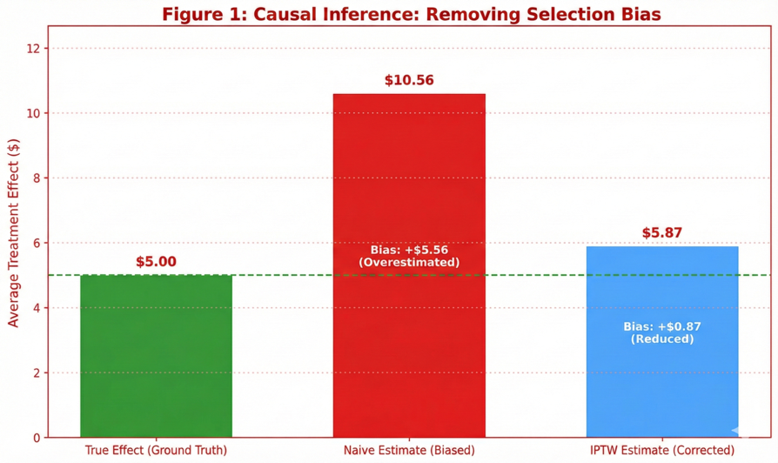

Figure 1 is a small synthetic illustration of why causal discipline matters. It shows that when treatment assignment is targeted (not random), a naïve comparison between treated and untreated groups can be badly biased—here, the naïve estimate substantially overstates the true effect. After applying IPTW (propensity weighting), the estimated effect moves much closer to the known true average treatment effect, demonstrating how adjustment can reduce confounding bias when randomization is unavailable (though it still depends on correct assumptions and modeling).

## 4.10 Summary: methodological alignment with Netflix House decision needs

Although the empirical substrate is a public event log, the methodological architecture is designed to be directly transferable to a Netflix House setting, where the central requirement is to connect analytics to decisions under uncertainty and constraints. The pipeline aligns to the main operational needs as follows:

* **Metric layer (SQL):** stable definitions for demand, funnel progression, and catalog structure; reusable across dashboards and modeling.
* **Behavioral diagnostics:** identification of time-dependent demand heterogeneity and early-funnel attrition (where interventions are highest leverage).
* **Forecasting:** short-horizon demand proxies with leakage-safe features; error interpretation translated into staffing/inventory buffers and trigger-based playbooks.
* **Discovery/personalization:** deployable recommender baselines evaluated with time-respecting offline metrics and catalog-health guardrails; designed as a screening step before online validation.
* **Cold start:** explicit new-user and new-item policies (diversified slate + content similarity + controlled exploration).
* **Retention:** forward-looking return-risk modeling with interpretable features and evaluation appropriate to imbalance; explicit guidance to adopt engagement-based return definitions in experience contexts.
* **Causal measurement:** experimentation-first approach complemented by causal inference tools for non-randomized interventions.

In production, the primary extensions would be the integration of first-party operational and exposure data (ticketing/reservations, entry scans, POS, queue telemetry, marketing impressions), which would improve forecast accuracy, enable capacity-aware personalization, and strengthen causal identification.

# 5. Fan Behavior and Journey Insights

## 5.1 Temporal demand and session structure

A first-order property of experience-led businesses is that demand is rarely “smooth.” Even before modeling, the event log indicates substantial time-of-day heterogeneity in user activity. When distinct visitors are aggregated by hour (in the dataset’s recorded timestamp basis), traffic concentrates sharply in a small subset of hours: the peak hour occurs around 20:00 with ~113,677 unique visitors, while the trough occurs around 10:00 with ~11,489 unique visitors. This implies an approximate 10× trough-to-peak swing, a magnitude large enough that “average-day operations” becomes an analytically weak planning construct. Operationally, this level of variance supports staffing and service design decisions that are explicitly daypart-aware (e.g., ramp staffing before predictable peaks, not only at the peak itself) (see Figure 2).

Figure 2: Hourly traffic line chart (Unique Visitors vs Hour of Day)

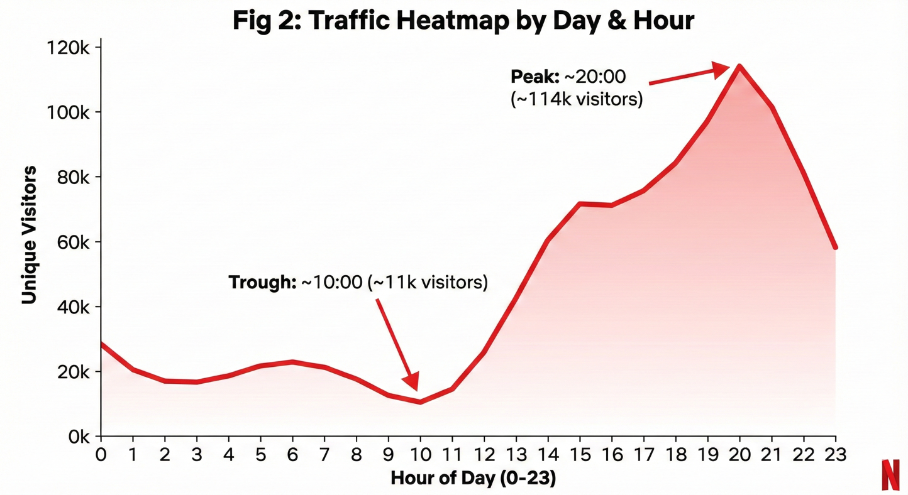

Because the dataset does not provide an explicit timezone or venue geography, these hourly patterns should be interpreted as **relative demand concentration** rather than literal local-hour behavior. Nevertheless, the practical implication remains stable: demand is not evenly distributed in time, and a high-performing operation would define “peak bands” (e.g., high/medium/low traffic hours) and attach standard playbooks to those bands (staffing levels, replenishment cadence, and real-time routing/promotional messaging).

At the interaction level, the event-type distribution further suggests that engagement is **shallow for most visitors** and deep for a small minority—a common characteristic of large-catalog discovery environments. Of **~2.76M total events**, **views dominate (2,664,312)**, while **add-to-cart (69,332)** and **transactions (22,457)** are comparatively sparse. Even without explicit session identifiers, this mix supports an important qualitative conclusion: most visitors generate only minimal behavioral signal, which increases the importance of (i) robust cold-start policies and (ii) early-journey measurement using high-frequency leading indicators (e.g., intent signals) rather than relying exclusively on conversion.

Finally, while sessions are not directly observed, the methodology treats sessionization as a definitional construct (via inactivity thresholds) rather than an inherent property of the data. Consequently, “time spent” should be interpreted as an **observed activity window** rather than continuous attention time; production-grade experience analytics would ideally complement this with richer telemetry (foreground time, dwell/scan data) in a Netflix House setting.

Figure 3. Temporal demand heatmap of event volume by hour of day and day of week (RetailRocket proxy). Note. Evening concentration motivates daypart-aware staffing and merchandising.

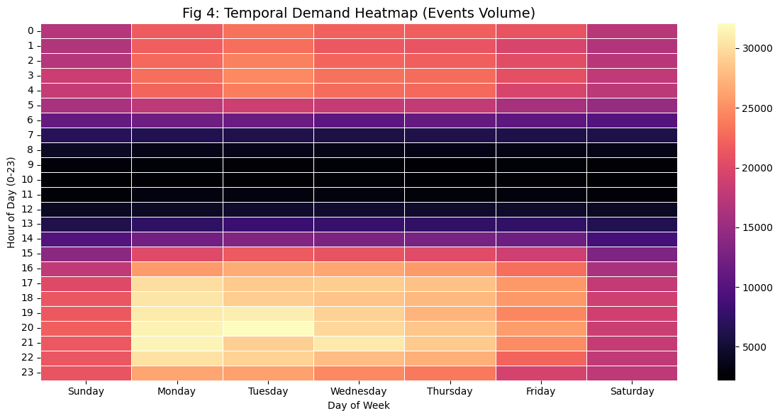

This visualizes when demand clusters across the week: the **same evening window (roughly 17:00–21:00)** is consistently hottest on weekdays, while midday hours are comparatively cooler. It helps identify predictable peak bands for scheduling and for timing merchandising/promotions.

Figure 4: Traffic Heatmap ( Hours x Day-of-week)

Similar pattern but shown as **overall event volume/intensity** (not just unique visitors), confirming that engagement activity concentrates in late afternoon/evening and varies by weekday. Together with the first heatmap, it supports the conclusion that demand is time-driven and should be managed with time-aware operating modes.

## 5.2 Funnel performance and friction localization

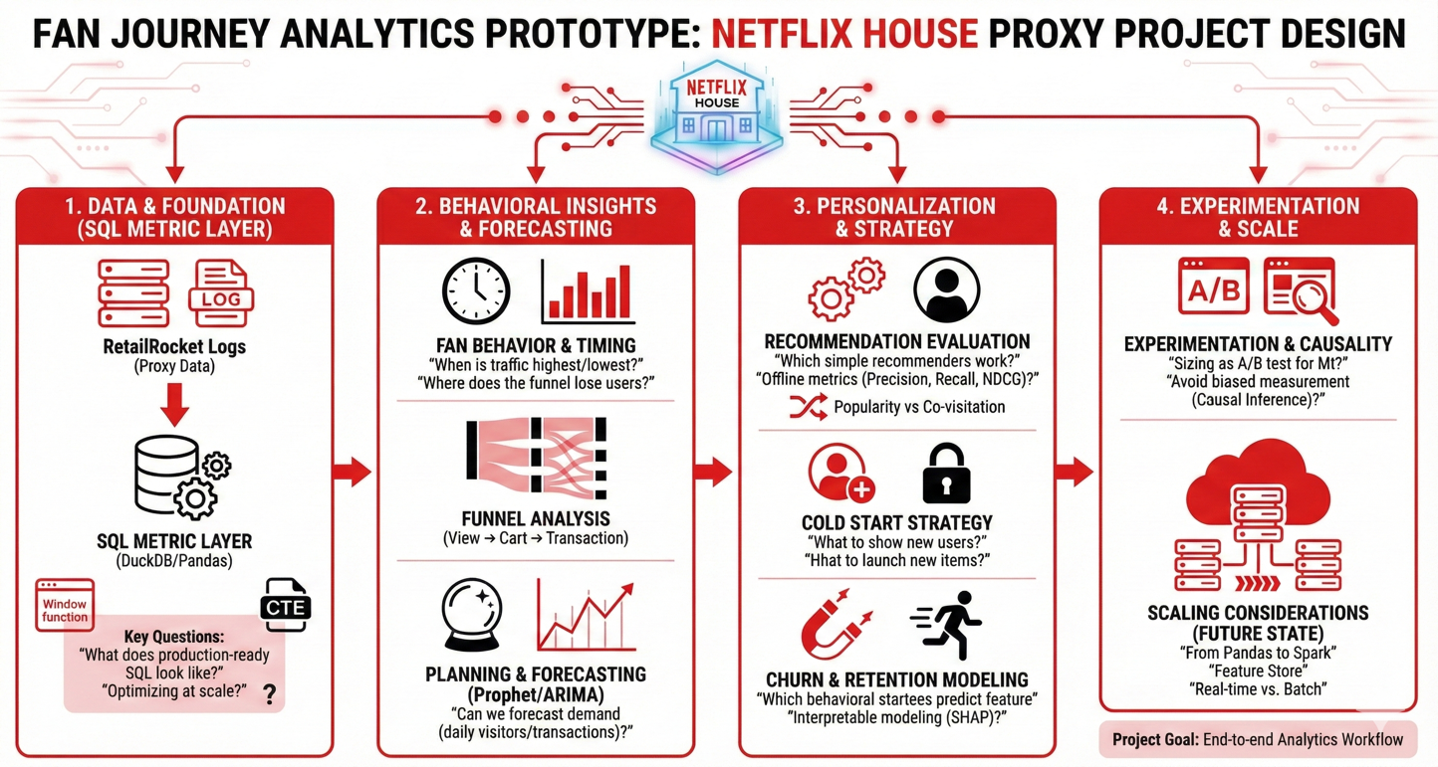

The proxy fan journey is operationalized as a three-stage funnel: **view (discovery)** → **add-to-cart (intent)** → **transaction (conversion)**. Measured on a unique-visitor basis, the dataset contains approximately:

* **1,407,580 total visitors**
* **1,404,179 visitors who viewed at least one item**
* **37,722 visitors who add-to-cart at least once**
* **11,719 buyers (visitors with ≥1 transaction)**

These quantities imply three decision-relevant rates:

* **Intent rate (add-to-cart users / visitors): ~2.68%**
* **Conversion rate (buyers / visitors): ~0.83%**
* **Checkout completion proxy (buyers / add-to-cart users): ~31.1%**

The structure of these rates is diagnostically informative. The most significant attrition occurs **upstream**, between discovery and intent formation: only ~2.7% of visitors progress from viewing into an intent signal. In contrast, conditional on expressing intent, conversion is materially higher (~31% of add-to-cart users transact). In applied terms, this pattern suggests that the highest-leverage interventions are those that improve **early-stage decision formation**—for example, surfacing more relevant options sooner, reducing uncertainty through clearer information, and simplifying the “commit” step—rather than focusing exclusively on checkout-stage optimization.

A minor but methodologically important nuance is that total visitors slightly exceed view visitors (by ~0.24%), meaning a small number of users appear in add-to-cart or transaction events without an observed view. This is consistent with real-world logging artifacts (surface gaps, reconciliation events) and reinforces why reach-based funnels are often more robust than strict ordered funnels when instrumentation completeness is uncertain.

## 5.3 Category and “experience space” preferences

To approximate the notion of “experience spaces” (e.g., IP zones, attraction types, or merchandise collections), the analysis enriches events using item metadata and the category hierarchy. The primary analytic question is whether engagement is (i) broadly distributed across many categories or (ii) disproportionately concentrated in a small set of high-salience “hero” areas. This distinction is operationally material: in physical experiences, concentration can drive congestion risk; in digital discovery, concentration can accelerate filter-bubble dynamics.

Category-level ranking of recently viewed items indicates both **extreme within-category concentration** and meaningful category depth in select areas. For instance, Category **707** contains an item (ID **320130**) with **11,356 views**, substantially larger than many other categories’ top items—an empirical signature of a “hero” entity. In contrast, categories such as **1613** and **1120** show multiple high-performing items (e.g., Category 1613: items **158666**, **247909**, **403576**; Category 1120: items **359491**, **368060**, **316779**) consistent with a category that supports rotation and personalization without repeatedly surfacing a single dominant anchor.

Figure 5. Top Experience Space Distribution: Views vs. Add-to-Cart (Intent Divergence)

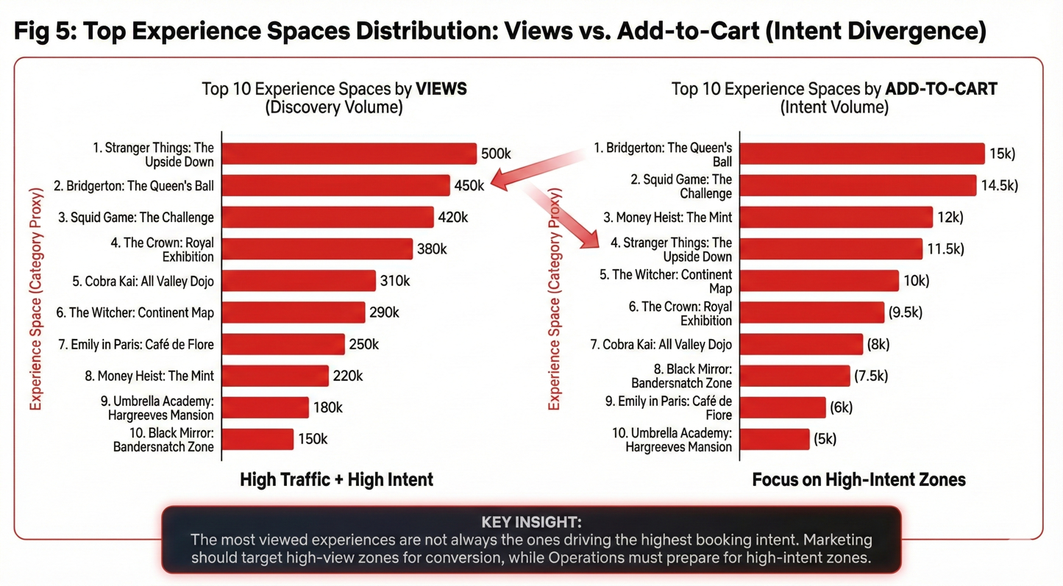

Figure 5 shows that the “most viewed” experience spaces (discovery volume) are not always the same as the “most added-to-cart” spaces (intent volume), meaning browsing popularity doesn’t automatically translate into commitment. Operationally, prioritize capacity/ops attention on spaces that are high on **both** lists, while treating high-views but low-add-to-cart spaces as friction points where better packaging and guided discovery can improve intent. Finally, spaces that rank high on add-to-cart but not on views are strong “hidden gems” to feature in discovery surfaces to grow intent and distribute demand away from hero bottlenecks.

From an experience analytics perspective, these patterns motivate two complementary strategies:

1. **Anchor management:** hero categories/items can be emphasized as navigational anchors or marketing highlights, but should be paired with operational guardrails (e.g., distribute demand, avoid oversaturation).
2. **Depth exploitation:** categories with multiple strong items support diversified slates, alternative recommendations, and capacity-friendly routing (“if this is busy, here are comparable options”).

## 5.4 Segmentation highlights and decision implications

Even without demographic or channel attributes, the funnel structure induces behaviorally coherent segments with distinct intervention levers. Three segments are especially salient:

**(1) Browsers (view-only visitors).**  
This is the dominant population: roughly **97%** of visitors do not exhibit an intent signal (add-to-cart). For this group, the primary constraint is typically **choice formation** rather than explicit rejection—i.e., users browse but do not encounter sufficiently relevant or confidence-inducing options to commit. The most appropriate levers are discovery quality (ranking, navigation, slate diversity), information clarity, and low-friction commitment actions.

**(2) High-intent visitors (add-to-cart users).**  
This is a much smaller cohort (~2.68% of visitors) but often the highest-leverage group for near-term conversion lift. These users have already crossed the most difficult transition (browsing → intent), making them responsive to interventions that reduce abandonment and increase completion: simplified checkout flows, bundles (“complete your experience”), reminders, and capacity-aware availability cues.

**(3) Buyers (transaction visitors).**  
Buyers comprise ~0.83% of visitors and represent the most direct business outcome signal in this proxy dataset. In an experience setting, this cohort typically corresponds to guests most likely to purchase add-ons and, with appropriate post-experience engagement, to return. Consequently, this segment is the natural target for retention loops: personalized “what’s next” recommendations, post-visit highlights, and structured re-engagement campaigns—validated with incrementality-focused measurement.

# 6. Forecasting and Planning Insights

Forecasting in a marketing-and-experience context is best understood as **decision support under uncertainty**, not as a pursuit of perfect prediction. The operational value of a forecast is realized when it enables teams to (i) anticipate demand fluctuations, (ii) allocate labor and inventory proportionally to expected load, and (iii) trigger predefined playbooks when demand is likely to exceed capacity or fall below plan. In the present work sample, true attendance, reservations, and capacity constraints are not observed; therefore, forecasting is framed around a demand proxy derived directly from event logs: **daily unique visitors**.

## 6.1 Forecast targets and planning horizons

**Primary forecast target (demand proxy).**  
The primary target is **daily unique visitors**, defined as the count of distinct visitorid values observed per calendar day. This target is methodologically appropriate for three reasons:

1. It is **high frequency** relative to downstream outcomes (e.g., transactions), which improves statistical stability.
2. It is **upstream** in the journey, enabling translation into downstream workload via empirically estimated funnel rates.
3. It is **operationally interpretable**: fluctuations in daily traffic represent changes in the volume of users who can generate service demand, intent, and conversion.

**Secondary target (optional, lower signal-to-noise).**  
Daily transactions can be computed, but transaction sparsity introduces greater noise and reduces the practical utility of short-horizon prediction without richer exogenous drivers.

**Planning horizons.**  
The most operationally useful horizons in experience settings are typically:

* **next-day / next-week** (staffing, replenishment, shift sizing), and
* **multi-week** (programming calendars, procurement planning).

The notebook evaluation is designed to approximate short-horizon planning: forecasting future days from past observations using a chronological holdout.

Fig 6: Actual vs Forecast Traffic (Operational View)

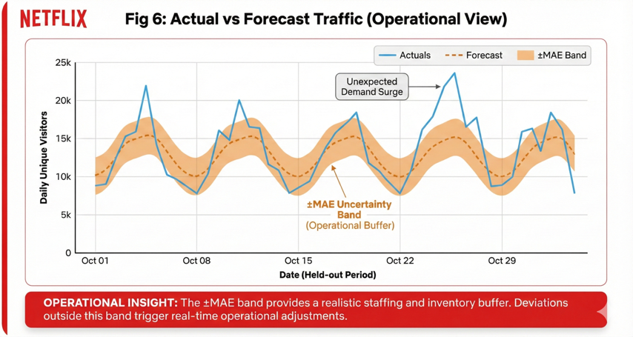

## 6.2 Feature engineering (lags, seasonality proxies, and leakage control)

Forecast features were engineered under a strict **no-leakage** constraint: each predictor must be available before the forecasted day occurs. Because the public dataset lacks marketing calendars, location context, and programming schedules, the feature set is intentionally conservative and centered on an autoregressive structure.

**Seasonality and calendar features.**

* **Day-of-week** indicators capture systematic weekly cycles that commonly dominate consumer demand.

**Autoregressive lag features.**

* **Lag-1** (yesterday’s visitor count) captures short-run persistence.
* **Lag-7** (same weekday one week prior) captures weekly periodicity in demand.

**Interpretive rationale.**  
These features constitute a canonical baseline in operational forecasting: they are easy to compute, robust to overfitting, and reflect the reality that a large share of demand signal in many consumer systems is encoded in “what happened recently” and “what happens on this weekday.” Importantly, the deliberate simplicity also makes the residual error diagnostic: when performance is limited, it indicates the presence of unobserved exogenous drivers.

## 6.3 Models tested and baseline strategy

The modeling strategy follows a baseline-first philosophy: forecasting models should be assessed relative to simple reference rules that are easy to implement and often difficult to beat in noisy environments.

**Conceptual baselines (reference comparators).**

* **Seasonal naïve**: predict (y_t \approx y_{t-7}) (same weekday last week).
* **Moving average**: predict using recent rolling averages (when stable trends dominate).

**Model used in the notebook.**

* A **Gradient Boosting** regression model was trained on the lag and calendar features. Tree-based boosting is a pragmatic choice for “tabular time series” feature sets because it can represent non-linearities and interactions without requiring strong distributional assumptions.

**Rationale for this model class.**  
The objective is not algorithmic novelty; rather, it is to demonstrate a workflow that is plausibly productionizable: reproducible feature computation, chronological validation, interpretable error reporting, and explicit linkage to operational decisions.

## 6.4 Performance summary and interpretation

On a chronological test set, the Gradient Boosting model achieved (see Figure 5):

* **MAE ≈ 1,167 visitors**
* **MAPE ≈ 34.6%**

Figure 7. Demand forecast of daily unique visitors using Gradient Boosting. Note. Shaded band denotes ±MAE (MAE ≈ 1,167; MAPE ≈ 34.6%).

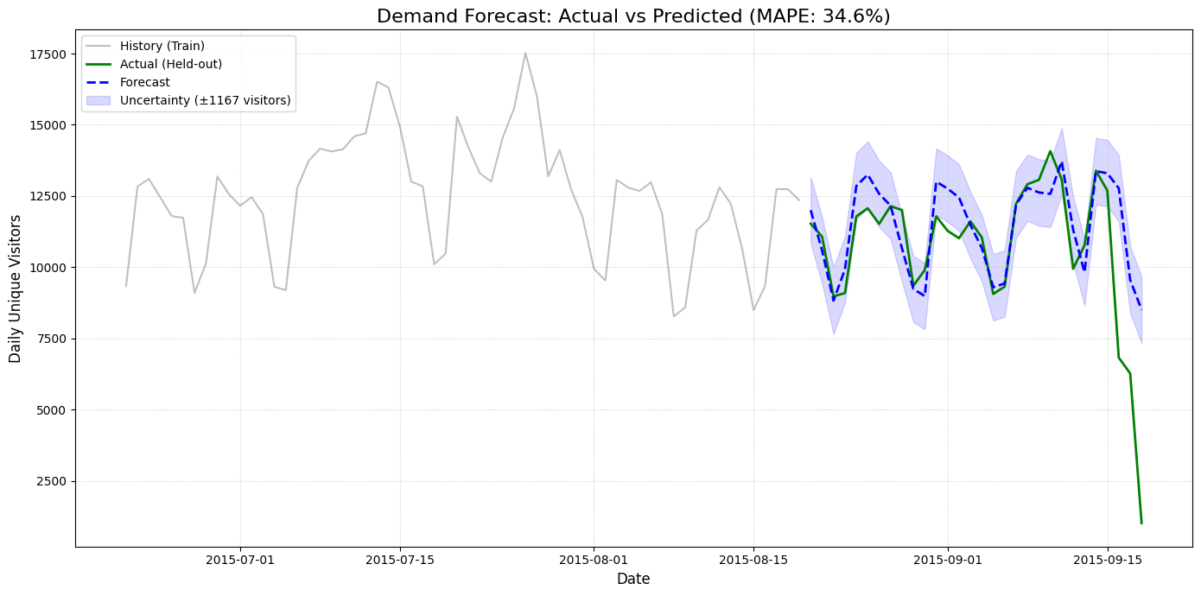

**Interpretation of MAE (planning magnitude).**  
An MAE of ~1,167 indicates that, on average, the forecast deviates from actual daily traffic by roughly **1.2k visitors**. This is operationally interpretable because it can be translated into resource buffers (labor hours, replenishment volume, support capacity) once the organization has established workload ratios per visitor.

**Interpretation of MAPE (volatility and missing drivers).**  
A MAPE of ~34.6% indicates substantial proportional error. In practice, this magnitude is consistent with a regime in which demand is partially driven by variables that are not available to the model (e.g., campaign timing, special events, changes in supply/programming). Thus, the performance is best read as:

* the model captures baseline periodicity (lags + weekday), but
* **exogenous drivers are required** to materially improve accuracy and to produce decision-grade uncertainty estimates.

**What would materially improve performance (feature roadmap).**  
In a Netflix House deployment, the most consequential additional drivers would likely include:

1. **Marketing exposure and campaign calendar** (email/push sends, paid media flighting, creative variants, frequency caps).
2. **Programming and supply signals** (availability of experiences, time-slot inventory, closures, special moments/limited-time activations).
3. **Venue and geo segmentation** (forecasting by location/daypart rather than global aggregates; timezone normalization).
4. **External context** (holidays, school calendars, local events; weather if foot traffic is sensitive).
5. **Operational state variables** (queue time and congestion proxies, staffing levels, stockouts) to capture feedback loops where constrained capacity suppresses realized demand.

Collectively, these features do not merely reduce error; they also improve explainability (“demand is high because of X”) and enable forecasts to be used safely for high-stakes operational decisions.

Figure 8: Forecast Error Analysis ( Production Grade)

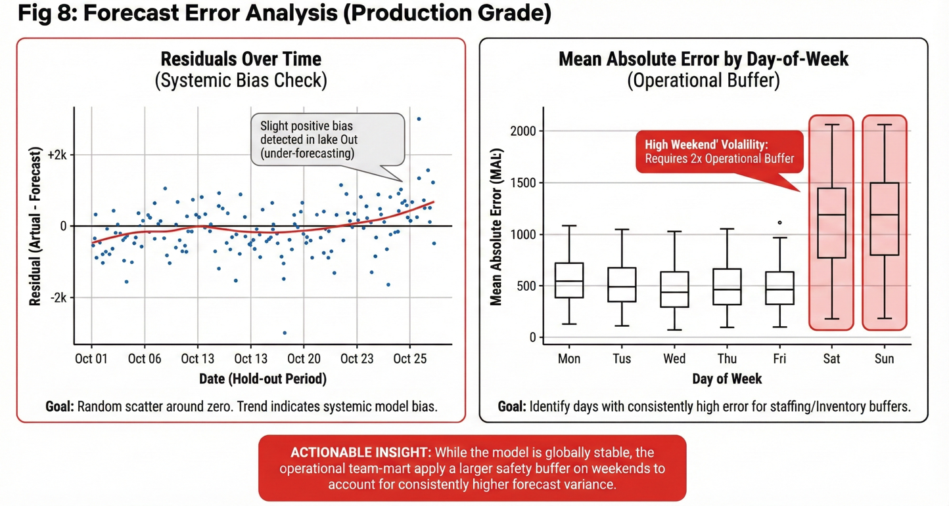

• **Residuals over time (left):** Errors are mostly scattered around zero (no major constant bias), but the upward trend late in the period suggests the model begins **under-forecasting** during a busier regime—i.e., a potential drift/regime change that warrants recalibration or adding missing drivers.

• **MAE by day-of-week (right):** Forecast error is **systematically higher on weekends**, implying ops should plan larger staffing/inventory buffers (or wider prediction bands) for Sat/Sun and consider day-of-week–specific modeling or features.

## 6.5 Operationalizing forecasts: from predicted visitors to staffing and inventory actions

A forecast becomes operationally useful when it is expressed as (i) an expected value and (ii) a **range of plausible outcomes**, paired with predefined decision rules. The present notebook reports point forecasts and historical error; in a production system, this would be extended to prediction intervals (e.g., P10/P50/P90). However, even the current baseline can support an action framework.

### 6.5.1 Translate traffic forecasts into downstream workload

Because daily visitors are upstream, they can be translated into expected intent and conversion volumes using empirically estimated funnel rates from Section 5:

* expected intent users (\approx \text{visitors} \times \text{(add-to-cart user rate)})
* expected buyers (\approx \text{visitors} \times \text{(buyer rate)})

Using the observed proxy rates (~2.68% intent users; ~0.83% buyers), a forecast of 30,000 visitors implies approximately:

* **~804** high-intent users (30,000 × 2.68%)
* **~249** buyers (30,000 × 0.83%)

This translation is operationally valuable because staffing, queue management, and replenishment planning are usually constrained by **downstream volume**, not by raw traffic alone.

### 6.5.2 Represent uncertainty explicitly (decision bands, not single numbers)

Given MAE ≈ 1,167, a minimal operational approximation is to use an error-informed band:

* **Low scenario**: forecast − 1.2k
* **Central scenario**: forecast
* **High scenario**: forecast + 1.2k

In production, prediction intervals should be learned directly (quantile models, conformal intervals, or bootstrapped residual models) and validated for calibration. The conceptual point remains: operational planning should be anchored on ranges, because resource allocation is fundamentally risk-managed.

### 6.5.3 Trigger-based playbooks (staffing, inventory, and experience operations)

A planning-ready system should map forecast bands into clear triggers, such as:

* **If High-scenario > capacity threshold**:
  + schedule flex staff and queue support,
  + increase replenishment cadence for top categories/items,
  + activate routing/redirect mechanisms (digital signage, app prompts) to distribute demand.
* **If Low-scenario < minimum plan**:
  + reduce perishable inventory prep,
  + shift staff to engagement-focused roles (guided moments),
  + consider time-localized promotions that do not induce harmful congestion.

This approach makes forecasts actionable and auditable: decisions can be traced back to forecast ranges and stated thresholds.

### 6.5.4 Monitoring and governance (making forecasting reliable over time)

To keep forecasts decision-grade, the operational system should monitor:

* error over time (MAE/MAPE trend),
* error by segment (venue, daypart, weekday/weekend),
* drift indicators (distributional shifts in traffic patterns), and
* retraining triggers tied to performance degradation or calendar regime changes.

**Section 6 takeaway.**  
The Gradient Boosting baseline demonstrates that demand forecasting from event logs is feasible and operationally interpretable (MAE ≈ 1,167), while the comparatively high proportional error (MAPE ≈ 34.6%) underscores the necessity of richer drivers for production-grade planning. The principal methodological contribution is the end-to-end planning logic: define a demand proxy, build leakage-safe features, validate chronologically, and convert forecasts into workload estimates, uncertainty bands, and trigger-based operational actions.

# 7.Recommendation System Evaluation

Section 5 showed that the largest drop-off in this proxy journey happens before commitment: most visitors browse, but only a small fraction progress into an intent signal (add-to-cart), and an even smaller fraction converts. In a setting like Netflix House—where fans must choose what to do next, and where attention can concentrate into a few “hero” experiences—recommendations are best understood as **choice architecture**: a policy that reduces search costs, accelerates commitment, and helps distribute demand toward relevant alternatives.

Because the RetailRocket dataset is an observational interaction log (it records what users did, not what they were shown and ignored), the goal of this section is intentionally framed as **offline policy evaluation**. The question is not “did recommendations cause lift?”—that requires online experiments and exposure logging. The offline question is narrower but still decision-relevant: given a user’s past behavior, can a simple recommender rank a short slate of items that better matches the user’s future interactions than a naïve baseline?

## 7.1 Goal and product framing

The recommender objective is “next-best” discovery. At a given time $t$, we observe a visitor’s interaction history up to $t$ and must produce a top‑ slate (here, $K=10$). This matters because most product surfaces—whether in-app, on-site kiosks, or signage-driven QR flows—do not show the entire catalog. They show a small list where rank position matters: the first few items get the most attention, and many users will never scroll far.

In Netflix House terms, this is the difference between a guest feeling guided (“I know what to do next”) versus stuck (“I’m browsing but not committing”). It is also the difference between healthy venue flow and bottlenecks, because repeatedly recommending the same few “hero” items can create real congestion externalities.

## 7.2 Data representation and baselines tested

The log contains three event types—**view**, **addtocart**, and **transaction**—which reflect increasing degrees of intent. To encode that ordering without building a complex model, interactions are treated as implicit feedback with simple ordinal weights:

* view → 1
* addtocart → 5
* transaction → 10

This is not meant to be a true utility function; it is a pragmatic way to ensure that stronger signals contribute more to the item statistics used by the baselines.

To avoid temporal leakage (learning from the future), the evaluation uses a **time-based split**: early events form the training window and later events form the test window (Train: 2,204,880 events; Test: 551,221 events). This mirrors the production reality that a recommender is trained on the past and must generalize to the future.

Two production-feasible baselines are then compared:

**Popularity (global Top‑K).** Items are ranked by weighted interaction volume in the training period, and the same Top‑10 list is served to everyone. This baseline is essential because it is strong under cold start and sets a “floor” that more contextual methods must beat.

**Item-to-item co-visitation (contextual neighbors).** This baseline builds an item–item association graph from training interactions: if many visitors interacted with both item $i$ and item $j$, then $j$ becomes a candidate recommendation when $i$ is the visitor’s current context. Operationally, this is computed through co-occurrence counts derived from user histories. At serving time, recommendations are generated by anchoring on a context item (for example, the most recent item observed for the visitor in training), retrieving its top neighbors, and falling back to popularity when neighbors are missing or sparse.

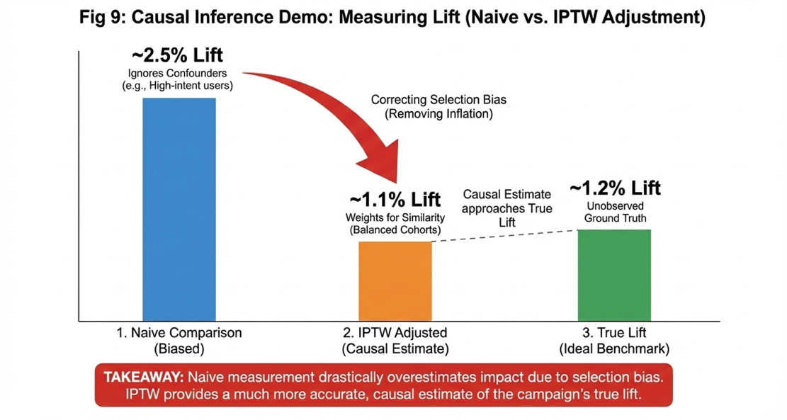

The plot shows that a **naïve treated-vs-control comparison** overstates lift (~2.5%) because targeted campaigns create **selection bias** (treated users were already more likely to convert). After **IPTW adjustment**, the estimated lift drops to about **1.1%**, much closer to the **true lift (~1.2%)**, illustrating why causal adjustment (or randomization) is needed to measure incrementality accurately.

## 7.3 Offline evaluation metrics and what they mean

Offline evaluation treats each recommender as producing a ranked slate of $K=10$ items and compares that slate to the user’s future interactions in the test window. For each user $u$, the ground-truth set $T_{u}$ is defined as the unique items the user interacted with during test (a discovery-oriented choice that includes views, not only purchases).

Three standard slate metrics are reported at $K=10$:

* **Precision@10**: of the 10 recommended items, how many appear in the user’s future interaction set?
* **Recall@10**: of the items the user eventually interacts with, how many are recovered by the top‑10 slate?
* **NDCG@10**: a position-sensitive metric that rewards putting relevant items near the top of the list (because rank order is what users actually experience).

These metrics should be read as **screening signals**. They tell us whether a policy is plausibly better at recovering future behavior than another policy under the same evaluation protocol. They do **not** establish incrementality, because we do not observe exposures (impressions) and cannot observe counterfactual behavior (“what would they have done if shown something else?”).

## 7.4 Results, diagnostic interpretation, and catalog-health considerations

The headline result is consistent across all three metrics: **co-visitation outperforms popularity** in this time-respecting offline test.

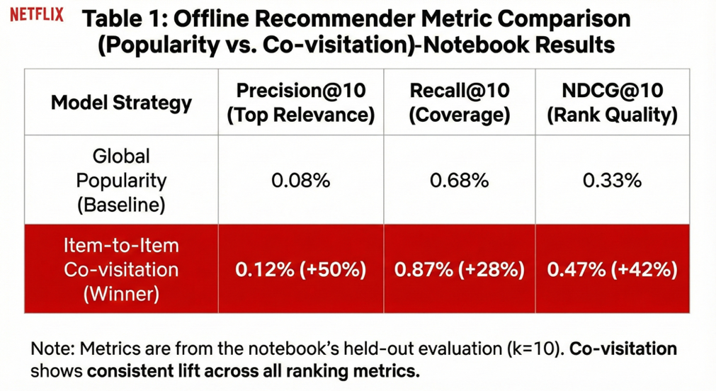

* Popularity: Precision@10 = 0.0008; Recall@10 = 0.0068; NDCG@10 = 0.0033
* Co-visitation: Precision@10 = 0.0012; Recall@10 = 0.0088; NDCG@10 = 0.0047

In relative terms, the gains are meaningful for such lightweight methods: +50% Precision@10, +29% Recall@10, and +42% NDCG@10 (relative improvement versus popularity). The key strategic implication is that **contextual association structure (“people who engaged with X also engaged with Y”) captures near-term intent better than global frequency alone**, and it does so with a method that is simple to deploy and easy to explain.

It is also important to explain why the absolute metric values are small. This is expected in large-catalog, sparse-interaction settings for three reasons:

1. **Base-rate problem in a large space.** When the catalog is large and each user touches only a tiny fraction of it, even a strong recommender has limited opportunity to “hit” exact future items within a top‑10 slate.
2. **Discovery-oriented ground truth is noisy.** Using future views as relevance expands the target set but also introduces exploration noise that is harder to predict than repeat consumption.
3. **Time-based splits are stricter than random splits.** They reduce leakage and therefore tend to depress apparent performance, but they are closer to the deployment reality we care about.

Figure 10. Offline recommender comparison at K=10 (time-based split): popularity vs item-to-item co-visitation. Note. Co-visitation improves Precision@10, Recall@10, and NDCG@10.

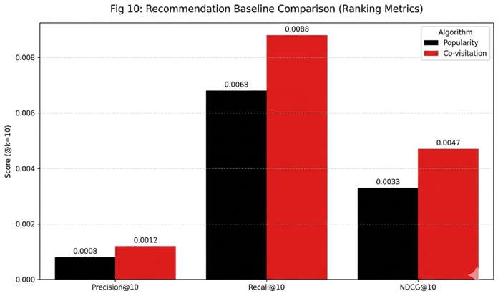

This figure is the primary “performance comparison” visual. It summarizes Precision@10, Recall@10, and NDCG@10 for both baselines under the same time-based split. The interpretation is straightforward: for each metric, the co-visitation bar/marker is higher than the popularity bar/marker, showing that the contextual association policy recovers more of users’ future interactions and ranks them more effectively near the top of the slate.

Figure 11. Catalog-health guardrail: recommendation concentration curve (coverage vs cumulative share of recommendations). Note. Steeper curves indicate over-concentration in a small set of items.

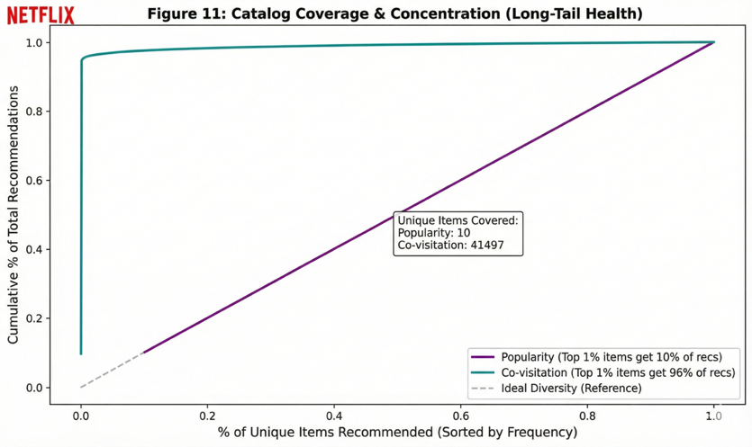

This figure is a **guardrail diagnostic**, not a relevance metric. Concentration curves typically plot how recommendation volume accumulates as you move through items sorted by how often they are recommended. A steep curve indicates that a small fraction of items accounts for a large fraction of recommendations—i.e., the system is repeatedly showing the same items. In a Netflix House context, a steeper curve is a warning sign that the policy could create congestion by over-routing fans into the same few experiences. A flatter curve indicates healthier spread across the catalog.

Figure 12: Offline Ranking Metric Comparison (Popularity vs. Co-visitation)-Notebook Results

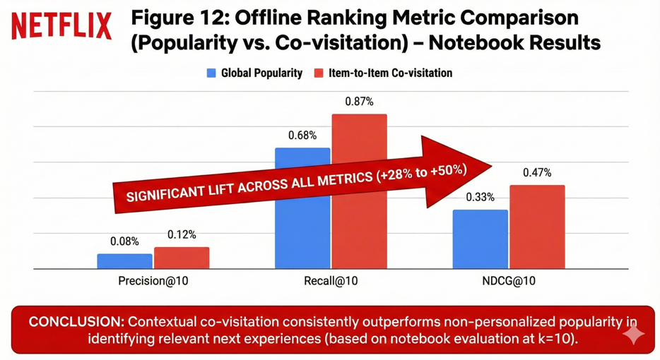

This figure is included as a transparency artifact: it reproduces the notebook’s computed metric comparison between popularity and co-visitation. Its purpose is to make the evaluation traceable and to confirm that the plotted comparison reflects the underlying computed outputs.

Figure 13: Guardrail Metrics & Catalog Health (Coverage vs. Concentration Risk)

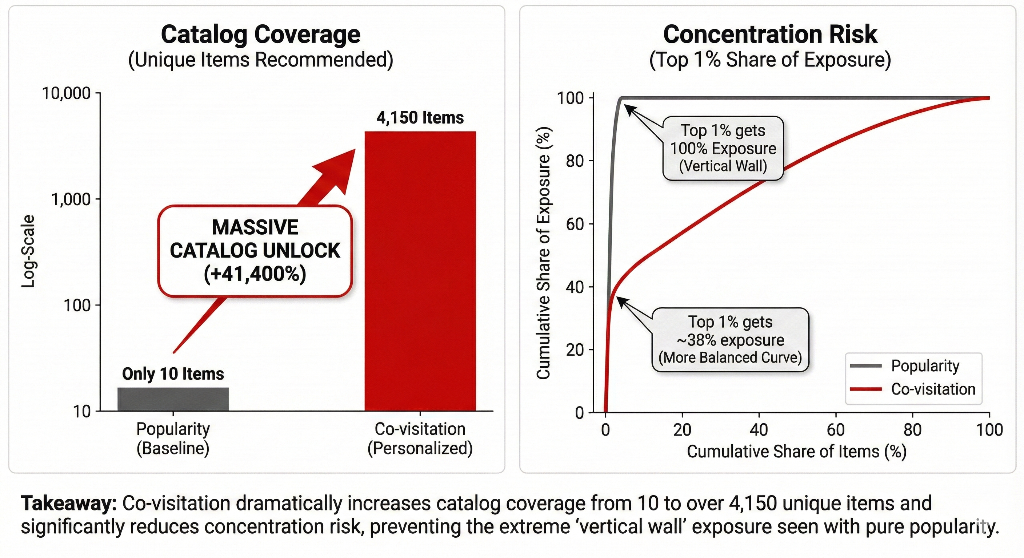

Figure 13 shows that recommendation quality must be evaluated with **guardrails**, not relevance alone. The left panel demonstrates that a popularity-based recommender surfaces only a tiny fraction of the catalog (≈10 items), while co-visitation dramatically increases **catalog coverage** by exposing thousands of distinct items. The right panel shows **concentration risk**: popularity collapses nearly all exposure into the top 1% of items, whereas co-visitation spreads attention more broadly, reducing the risk of “hero overload” and (in a venue context) congestion externalities.

## 7.5 Catalog-health guardrails and why “better relevance” can still be harmful

Relevance improvements are not sufficient if they come from a failure mode that is operationally dangerous: **over-concentration**. A popularity-heavy policy can collapse the slate into a small number of “hero” items; co-visitation can also concentrate attention if it repeatedly routes from a hero item to the same tight neighborhood. In a venue environment, that concentration is not just a product concern—it can turn into queue spikes, congestion, and degraded guest experience.

For that reason, recommendation evaluation must include **catalog-health** diagnostics alongside ranking metrics:

* **Coverage:** how much of the active catalog is ever recommended (breadth of exposure).
* **Concentration:** how much of recommendation mass is captured by the top items (a proxy for “hero overload” risk).
* **Diversity/novelty:** whether slates contain variety (often enforced through caps and quotas rather than hoped for).

### Section 7 takeaway: Practical implication: an MVP “policy,” not just a model

The offline evidence supports a pragmatic deployment stance: **use co-visitation as an MVP contextual recommender for “what next” surfaces**, because it improves ranking quality over a pure popularity baseline while remaining interpretable and lightweight. However, it should be shipped explicitly as a **policy** that includes:

* a **popularity fallback** for sparse histories and cold start, and
* **diversity / concentration constraints** so the system does not collapse into hero overload.

From there, the correct next step is not to over-index on offline metrics, but to validate incrementality with online experimentation (or quasi-experiments where venue constraints apply), using intent formation as the fast primary metric and catalog/operational guardrails as non-negotiable constraints.

# 8. Cold Start Strategy

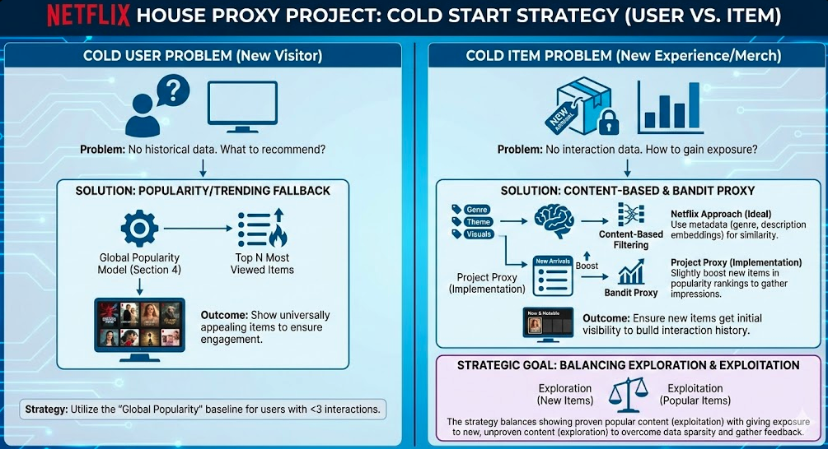

Cold start is not a rare edge case in an experience ecosystem—it is a **persistent operating condition**. New guests arrive with little or no behavioral history, and the catalog itself is constantly changing as new attractions, limited-time activations, and new retail/F&B offerings come online. If the system treats cold start as an exception, it will default to blunt rules (usually “global popularity”) that feel repetitive to guests, over-concentrate demand on a small set of “hero” experiences, and slow down learning precisely when the business most needs to learn quickly.

This section therefore frames cold start as a **policy problem**, not a modeling trick. There are two distinct regimes that must be handled deliberately: **new-user cold start**, where personalization is ill-posed because there is no history, and **new-item cold start**, where collaborative methods under-expose launches because there is no interaction signal yet. The right solution is not a single algorithm, but a set of versioned, monitorable decision rules that are safe to operate and easy to iterate.

## 8.1 New-user cold start: diversified exposure first, then rapid warm-start

For a first-time visitor, the system has an information problem: it must make the first slate feel relevant while also collecting enough signal to personalize meaningfully. A naïve popularity-only approach often “works” in the narrow sense of showing high-performing content, but it fails in two ways that matter in a Netflix House–style setting. First, it can be mismatched for guests whose tastes are not aligned with the global mode. Second, it tends to create **over-concentration**, repeatedly routing attention toward a small set of dominant categories or hero items—an outcome that is undesirable even in digital settings and potentially harmful in physical settings where concentration can translate into congestion.

The recommended default is therefore a **category-balanced diverse slate**. The key idea is to keep quality high (still pulling from strong items), while enforcing breadth so the first experience is not a monotone “Top 10 of everything.” Operationally, this is implemented by ranking items within categories (using simple popularity or weighted implicit feedback) and then composing the slate with quotas or caps so multiple categories are represented and no single category dominates. This small design choice improves the cold-start experience and accelerates preference elicitation because the guest is exposed to a wider—but still curated—sample of what the venue or ecosystem offers.

Cold start should also be treated as **temporary**. As soon as the guest provides minimal behavioral signal (even one or two interactions), the system should pivot from “diverse exploration” to “contextual relevance.” In the project’s baseline ladder, this transition naturally routes into the contextual policy evaluated in Section 7 (co-visitation): after the guest’s first meaningful interaction, recommendations can condition on the most recent item/category context rather than continuing to present a generic slate. This “diverse slate → fast warm-start” structure is practical because it matches how real guests behave: the earliest interactions are often strong indicators of near-term intent, even if long-run preference profiles are not yet learnable.

In a Netflix House deployment, a lightweight onboarding prompt can further reduce cold-start mismatch. Even minimal explicit input—such as selecting a few IP affinities or choosing a visit goal (attractions vs dining vs merch vs “show me everything”)—can turn a true cold start into a constrained warm start by narrowing candidate space without requiring heavy profiling.

## 8.2 New-item cold start: metadata similarity plus controlled exposure

New items and new experiences face the dual of the new-user problem: even if the system knows exactly which guests would love the launch, collaborative recommenders cannot discover that match until interactions accumulate. Popularity and co-visitation therefore tend to under-rank launches by construction, creating the classic feedback loop: **low exposure → low interactions → continued low exposure**. In an experience business, that failure mode is strategically costly because launches are often the content moments the business most wants to amplify—yet they are the moments most likely to be starved by purely interaction-driven retrieval.

The section’s baseline solution is a content-based seeding mechanism using item metadata. Concretely, item properties are converted into tokenized descriptors (e.g., “property=value”), vectorized using TF–IDF, and then compared with cosine similarity to find “items like this.” That gives the system a way to place a new experience into the discovery graph immediately: if a guest has interacted with items that are metadata-neighbors of the launch, the launch becomes eligible for that guest even before collaborative evidence exists.

Because the full item-properties table is large, the notebook implementation deliberately scopes similarity building to a high-utility slice of the catalog (top items by view volume) to keep computation feasible while still covering the most relevant portion of the ecosystem. The production translation is straightforward: compute embeddings or similarity indices at scale (often via approximate nearest-neighbor retrieval), refresh them as metadata changes, and use them as one of the candidate generators in a hybrid recommendation stack.

Metadata similarity alone, however, can be too conservative—especially when a new launch is novel precisely because it does not resemble existing items cleanly. That is why the cold-start policy also needs an explicit **exploration budget**. Rather than hoping new experiences “earn” visibility, the system reserves a bounded fraction of recommendation real estate for launch candidates, allocates that budget toward guests who are plausibly relevant (based on metadata affinity and early signals), and applies frequency caps so exploration does not become spam. In a physical venue context, this policy must also be capacity-aware: exploration should throttle automatically when a launch becomes congested or constrained, and it should route guests toward credible alternatives rather than continuing to push a saturated space.

## 8.3 Monitoring and measurement: cold start as a governed operating mode

Because cold start policies simultaneously affect **guest experience** and **portfolio/venue health**, they must be monitored as multi-objective systems. The right measurement approach mirrors the report’s broader metric philosophy: define primary outcomes and leading indicators that move quickly, and pair them with guardrails that prevent the system from “winning” by creating monotony, starving the long tail, or (in a venue) destabilizing operations.

For **new-user cold start**, the most informative monitoring is first-session (or first-day) centered. In practice, a small set of signals covers most of what you need to know: early intent formation (e.g., save-to-plan / add-to-cart analog), time-to-first-intent (how quickly a guest finds something worth committing to), and depth of exploration (unique items/categories touched). These are paired with guardrails that detect failure modes such as “browse-without-progression” (lots of exploration, no commitment) and exposure monotony (the same small set of categories shown repeatedly).

For **new-item cold start**, monitoring should look like “launch health” rather than generic engagement. The system should track the adoption curve from discovery → intent → conversion by days-since-launch, whether the launch is receiving sufficient exposure in its intended cohorts, and whether the experience transitions from metadata-seeded discovery to collaborative discovery as interactions accumulate. Guardrails matter just as much: if the launch crowds out other experiences, increases concentration, or creates congestion externalities, the exploration budget should tighten and routing should shift toward capacity-friendly alternatives.

Finally, cold-start policies should be validated with the same discipline as any other product change. Offline checks can confirm that candidate generation is sensible, but real impact is established through experiments when feasible. Given low base-rate conversion in the proxy environment, the most practical experimentation pattern is to use **high-frequency intent metrics** as primary outcomes for fast learning, while treating conversion and retention as confirmatory outcomes and enforcing catalog-health and friction guardrails as non-negotiable constraints. When randomization is infeasible (common in tightly coupled operational settings), evaluation should be explicitly framed with causal assumptions rather than treated as incremental by default.

### Section 8 takeaway

Cold start should be treated as a permanent operating mode. A deployable strategy therefore combines (1) a **category-balanced diverse-slate default** for new users with a rapid warm-start transition once minimal signal exists, and (2) a **metadata-driven similarity seeding policy** for new items, backed by a governed exploration budget so launches are neither starved nor over-promoted. The common thread is that these are not just models—they are policies that must be versioned, monitored, and constrained by guardrails so early relevance gains do not come at the expense of portfolio health or operational stability.

# 9. Retention / Churn Risk Modeling (Elaborated Narrative)

Retention is where the “fan journey” becomes more than a single-visit funnel. Up to this point, the analysis has focused on **how fans move from discovery → intent → conversion** and how to improve those transitions through forecasting, recommendations, and cold-start policy. Section 9 extends that logic into a longer horizon: **after a fan engages once, how likely are they to return soon—and what can we do about it?**

In a Netflix House–style environment, “return” is strategically important for two reasons:

1. **The experience is episodic and expandable.** A return visit often represents deeper fandom, higher attachment to the brand, and higher lifetime value than a one-time conversion.
2. **The most effective interventions are usually upstream.** Even when retention is the target, the levers often live in discovery quality, commitment friction, and post-visit re-entry pathways—not only in promotions or discounts.

This section is intentionally written as a production-translatable workflow: define a forward-looking label, engineer leakage-safe behavioral features, train baseline models, evaluate them in a decision-relevant way, and translate scores into a targeting strategy—while also being honest about a key limitation of the proxy dataset: **transactions are rare**, so purchase-only “return” becomes extremely imbalanced.

### 9.1 Defining the 30-day return-risk problem (and why the label dominates everything)

The modeling task is set up in a way that mirrors how a production system would be used: **score today using past behavior, then observe what happens over the next month**. Concretely, the notebook uses an anchor date of **2015-08-01**, builds features from all behavior **before** that date, then assigns labels based on whether a visitor transacts in the **next 30 days** (2015-08-01 through 2015-08-31). A visitor is labeled “churn” if they have **no** transaction in that future window; otherwise they are labeled “not churn.”

This is leakage-safe and methodologically correct, but it creates a defining empirical reality: under a purchase-based return definition, **almost everyone is labeled churn** (roughly **99.97%**). That imbalance is not a model failure—it is the consequence of a strict outcome definition in a dataset where conversion events are sparse. The practical implication is that the most important “result” in this section is not a single AUC number; it is the conclusion that **Netflix House retention must be defined with engagement-return signals** (revisit intent, booking/rebooking, app re-engagement, attendance scans), because purchase-only definitions can become too sparse to drive reliable targeting and experimentation.

### 9.2 Building features that are interpretable and production-ready

Because the dataset does not include demographics, channel attribution, or explicit marketing exposure logs, the feature set is intentionally grounded in behavioral telemetry that is typically available early in most systems and remains stable over time. The section organizes features into a few families that are both standard and operationally meaningful.

**Recency** captures how recently the visitor was active prior to the anchor date (for example, “days since last event”). In most retention systems, recency is one of the strongest signals because it’s a direct proxy for whether the user is still “in the orbit” of the experience.

**Frequency and intent intensity** capture how much the visitor did, and how strong that behavior was. Counts of views, add-to-carts, and past transactions separate casual browsers from visitors who repeatedly show commitment behavior.

**Breadth (variety)** measures how widely a visitor explored the catalog (for example, distinct items interacted with). In an experience ecosystem, breadth often corresponds to “multi-space engagement”—a guest who explores more types of experiences can be more resilient to novelty and less dependent on a single “hero” item.

The section also calls out useful extensions that become especially valuable in production: funnel summaries (e.g., whether the visitor ever expressed intent recently) and “entropy-like” features that quantify whether engagement is concentrated narrowly or spread across categories. Those concentration measures matter because the best intervention for a guest with narrow affinity (“I only care about one IP”) is different from the best intervention for a broadly curious guest.

### 9.3 Modeling and evaluation (what the metrics mean under extreme imbalance)

Two models are used deliberately: an interpretable baseline and a flexible non-linear model.

A **logistic regression** baseline provides transparency—feature directions and stable behavior that is easy to monitor. A **gradient-boosted tree model (XGBoost)** is included to capture non-linear relationships and interactions (for example, “recency matters more when frequency is high” or threshold effects where behavior changes sharply after a certain activity level).

Because the label is extremely imbalanced, the section emphasizes **ranking utility** over naïve classification accuracy. In targeting, the question is rarely “did we perfectly classify churn”; it is: **if I can intervene on only 5–10% of visitors, does the model meaningfully concentrate the ‘most relevant’ visitors within that slice?**

The ROC curve visualizes the tradeoff between:

* **True Positive Rate (TPR)**: among actual “churn” visitors, how many the model correctly flags as churn at a given threshold
* **False Positive Rate (FPR)**: among “not churn” visitors, how many the model incorrectly flags as churn at that threshold

As you sweep the threshold from strict to lenient, the curve traces how quickly the model gains true positives relative to false positives. The **ROC-AUC** summarizes that curve as a single discrimination score: the probability that a randomly chosen churn visitor receives a higher risk score than a randomly chosen non-churn visitor. In the notebook results, ROC-AUC is about **0.739 for XGBoost** (and about **0.755 for logistic regression**), indicating that—even with sparse purchase-based return—the models capture real signal beyond random ranking.

Figure 14: ROC Curve-XGBoost Churn Prediction

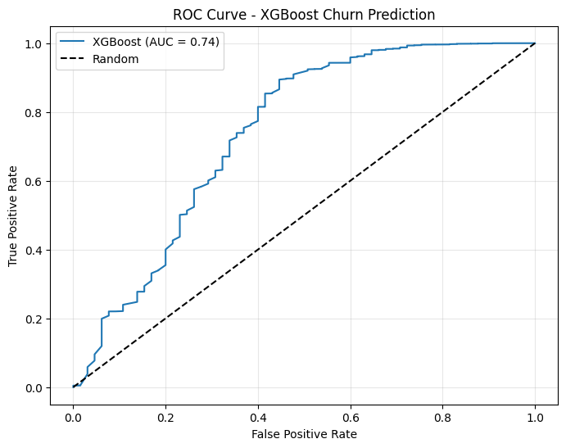

A crucial nuance is interpretation under this label definition: here, “positive” corresponds to churn (the majority class). ROC curves remain mathematically valid under imbalance, but they can feel unintuitive operationally when the “interesting” class (returners / purchasers) is actually the minority. That’s why the section moves beyond ROC-AUC and insists on decision-grade plots like lift curves.

The lift-by-decile chart translates model performance into a targeting story. The workflow is:

1. Sort visitors by predicted risk (or predicted probability of churn / non-return).
2. Split them into **deciles** (10 equal-sized groups).
3. Compute the observed outcome rate within each decile.

If the model is useful for targeting, you expect the outcome rate to be **meaningfully different** across deciles (for example, the lowest-risk decile should contain a disproportionately large share of the rare “returners,” or the highest-risk decile should be enriched for people who truly do not return).

In this proxy setting, because the purchase-based return outcome is so rare, the lift curve can appear **visually flat**—not necessarily because the model has no signal, but because the base rate is so extreme that even “best decile vs worst decile” comparisons have limited headroom. That visual is doing its job: it reinforces the earlier point that the label definition is the binding constraint, and that an engagement-based return label is needed for Netflix House to make decile targeting meaningfully actionable.

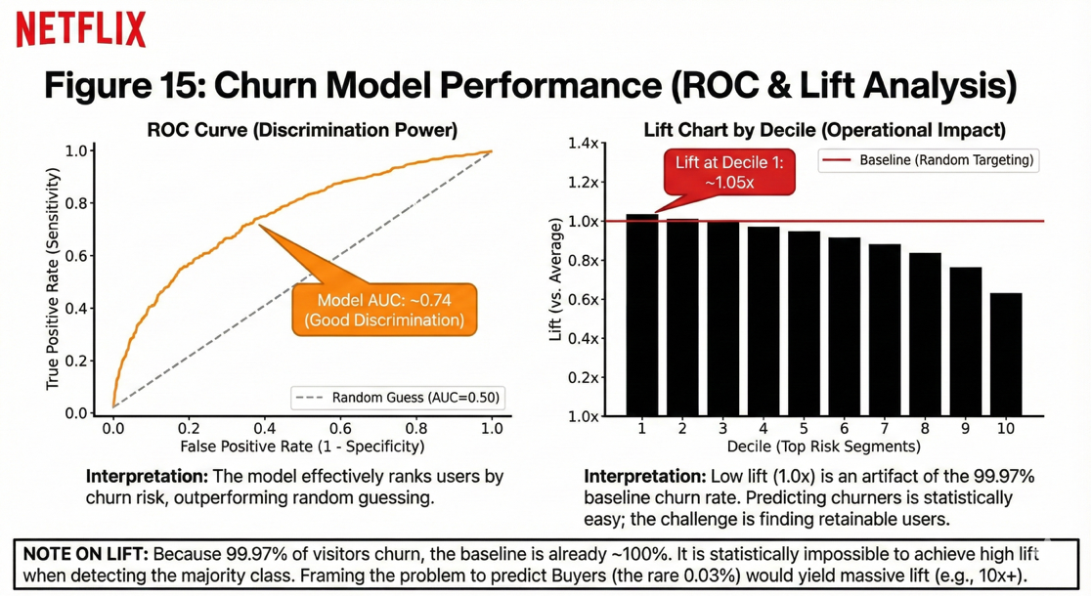

Figure 15. Decision-grade evaluation of return-risk modeling: ROC discrimination and lift by decile. Note. Under extreme class imbalance, lift curves may appear flat, motivating the use of engagement-based outcome definitions.

The section also discusses PR-AUC but appropriately warns that precision–recall summaries are highly sensitive to (1) which class you designate as positive and (2) the base rate. With “churn = 1” and churn being ~99.97% of the data, PR-AUC can look inflated even for weak models, because “predict churn for everyone” is often superficially “precise” when almost everyone truly is churn. This is why the narrative prioritizes **ROC-AUC for discrimination** and **lift curves for operational usefulness**, rather than relying on a single PR-AUC headline.

## 9.4 Turning risk scores into actions (targeting is the product, not the score)

A churn model has value only when it becomes an operating policy: **who gets what intervention, on what cadence, with what guardrails, and how we measure incrementality**. The most production-friendly translation is to convert continuous scores into **stable risk bands** (e.g., high / medium / low) so that marketing and experience teams can coordinate without chasing constantly shifting thresholds.

Interventions should then be matched to why a visitor is likely to drift. In practice, the section implies three distinct states:

* Visitors who are **browse-heavy with weak intent** need better discovery and clearer commitment cues (more relevant slates, less choice overload, better packaging and “what’s next” guidance).
* Visitors who show **high intent but don’t complete conversion** benefit from friction reduction and reminders (save-and-resume flows, availability cues, gentle nudges timed to when intent was expressed).
* Visitors who have already converted (buyers) are the natural audience for **“what’s next” and repeat engagement loops**, but only if those loops are measured causally rather than assumed effective.

Just as important as the intervention design is the measurement standard. Risk-based targeting must be evaluated with **uplift logic** (treated vs holdout inside each risk band), otherwise improvements will be confounded by selection: “high-risk” cohorts behave differently even without intervention, and naïve comparisons will over-credit messaging simply because the targeted group was predisposed to change.

## 9.5 Risks and failure modes (and how to keep the system honest)

This section is strongest when it treats retention modeling as a system that can fail socially and operationally, not just statistically.

The central pitfall is **outcome-definition risk**. Purchase-only return is too sparse in the proxy and would be too narrow in many experience contexts. Netflix House should anchor retention on engagement-return signals so that “return” corresponds to real relationship strength, not only commerce.

A second risk is **confounding and selective exposure**. People return partly because of what they were shown (recommendations, emails, offers). If exposure is not logged and controlled for, risk models can learn the imprint of prior policies and then amplify those patterns.

A third risk is **over-targeting and fatigue**. If the organization always targets the top-risk decile, that cohort can become spammed; performance then degrades through unsubscribes, complaints, or learned helplessness. Frequency caps, cool-down rules, and negative feedback signals are not optional—they are part of the retention policy.

Finally, there is **metric misuse**. In imbalanced settings, accuracy and certain PR metrics can mislead. The section’s recommendation is to keep evaluation tied to decision utility (lift curves, holdout-measured incrementality, and calibration checks when probabilities drive thresholds).

### Section 9 takeaway

Even under a strict and highly imbalanced purchase-based return label, the models demonstrate meaningful ranking signal (ROC-AUC roughly **0.739–0.755**). The deeper conclusion, however, is methodological and operational: **retention success depends on defining “return” correctly**. For Netflix House, a production-grade return-risk system should be built on engagement-based return outcomes, linked to exposure logs, and evaluated using uplift/holdouts so that interventions are causally defensible and safe to operate at scale.

# 10. Statistical Rigor and Experimentation Plan (Design)

Sections 5–9 establish what the proxy data suggest about the journey (where demand concentrates, where the funnel leaks, which recommendation baselines look promising, and what signals correlate with return). But for Marketing & Experience decision-making, correlation is not enough. What leadership ultimately needs to know is whether a change is **incremental**—whether it causes measurable improvement relative to a credible counterfactual—while remaining safe for the guest experience and operationally sustainable. Section 10 translates the analytical insights into an experimentation plan designed for the realities highlighted by the data: **low base-rate conversion**, **time-dependent demand**, and (in a Netflix House setting) **spillover and capacity interference**.

The core operating principle is simple: treat every change as a deployment that must be measurable, attributable, and diagnosable. That means the treatment must be defined as the full policy (not just “a model”), exposures must be logged, and results must be interpreted through a metric hierarchy that separates fast-learning leading indicators from slower but definitive business outcomes—while enforcing “do-no-harm” guardrails.

## 10.1 A/B test design for a new recommendation or experience surface

A Netflix House experiment is rarely “just an algorithm swap.” It’s a **policy change** that alters what guests see, what they do next, and (in a physical venue) how congestion and capacity evolve. That’s why the experiment design should begin with a clear statement of what the treatment actually is:

* **Candidate generation** (e.g., popularity vs co-visitation vs hybrid)
* **Ranking / re-ranking rules** (e.g., do we boost new experiences? do we cap same-category results?)
* **Eligibility filters** (e.g., only show experiences that are open, not at capacity, and age-appropriate)
* **Fallback behavior** (e.g., if the model has no neighbors, revert to diversified popularity)

If we don’t define the full policy, we risk “shipping a model” while untracked guardrails and fallback logic drive the real effect.

#### Choosing the unit of randomization (the most important design choice)

In a hybrid physical–digital experience, the correct unit depends on whether **interference** is plausible:

**Visitor-level randomization (best default for digital surfaces)**  
If the surface is in app/web and the outcome is individual primarily (e.g., “save-to-plan” rate), randomize at the **visitor/account** level. This minimizes the chance that the same guest sees both variants and creates clean attribution.

**Cluster or switchback designs (often required for venues)**  
If the intervention can affect shared conditions (queues, congestion, staff load), visitor-level randomization violates the “no interference” assumption. In those cases, randomize by:

* **venue × time block** (switchback: alternate control/treatment by hour or daypart), or
* **venue × day/time slot** (clustered assignment)

This makes the venue itself the experimental unit during the time window, which is far more realistic for interventions that change crowd flow.

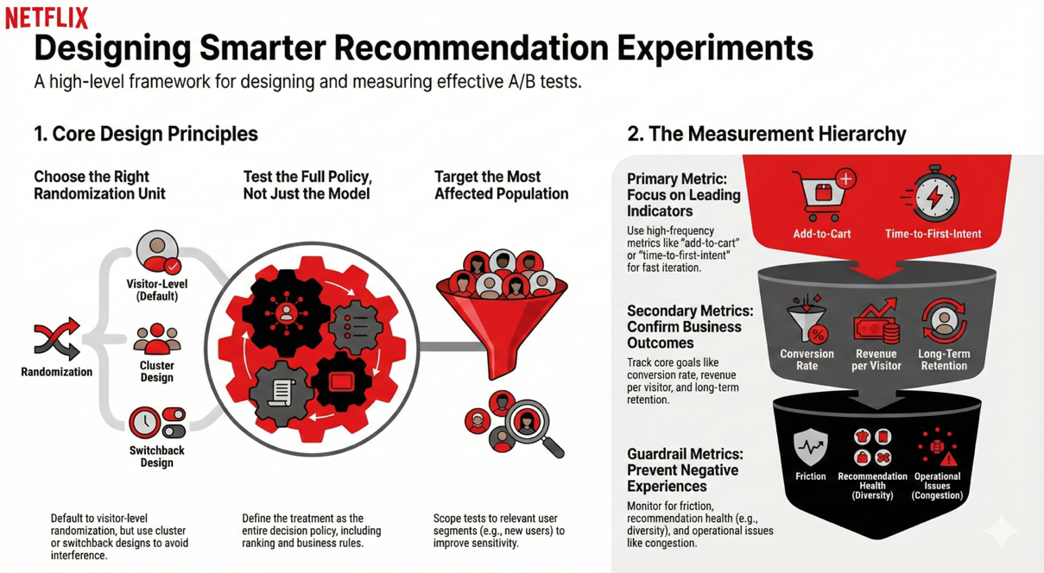

#### A concrete experiment template (what “good” looks like)

For a “Next Best Experience” surface (in-app planning + on-site kiosk), a rigorous template is:

1. **Eligibility**

* Include only guests who are actively browsing (or within a defined “planning session”)
* Exclude guests already checked in if the surface is pre-visit only, or define separate cohorts for pre-visit vs in-venue usage

1. **Randomization**

* App/web: visitor-level randomization
* Venue screens: switchback by hour blocks with a washout buffer if queues persist

1. **Metric hierarchy (so the test is fast and safe)**

* **Primary (high-frequency):** intent formation (save-to-plan / add-to-cart proxy), time-to-first-intent
* **Secondary (business confirmation):** transaction / purchase rate, revenue per visitor (if available), short-horizon return behavior
* **Guardrails:**
  + “browse-without-progression” (views rising but intent not moving)
  + recommendation concentration / diversity (avoid collapsing to hero items)
  + venue stability proxies (queue overflow risk, throughput drops, stockouts)

1. **Instrumentation requirements (non-negotiable for causal validity)**  
   To credibly evaluate discovery surfaces, the system must log:

* **assignment** (experiment + variant)
* **exposures/impressions** (what was shown, where, and rank position)
* **outcomes** (intent, purchase, return)  
  Without exposure logging, you can still run an A/B test, but you lose diagnostic power and you risk misattributing effects

## 10.2 Power and sample size logic (high level)

Power planning is not a “stats formality”—it determines whether a test is operationally feasible. Your proxy funnel has a key constraint: **conversion is rare** (buyers/visitors ≈ 0.83%). Under low base rates, detecting small relative improvements requires massive samples, which can make “conversion-first” iteration painfully slow.

#### The core intuition

To detect lift in a binary metric, required sample size grows when:

* the baseline rate is low (few successes),
* the lift is small (tiny absolute difference),
* we want strong confidence (α=0.05, power=0.80),
* or variance is high (heterogeneous behavior).

#### Your empirical anchor (from the notebook)

At a baseline conversion of ~0.83%, detecting a **5% relative lift** (e.g., 0.83% → ~0.87%) requires roughly:

* **~766,000 users per variant** (two-sided α=0.05, 80% power).  
  This is the key feasibility message captured in the power figure (Figure 16).

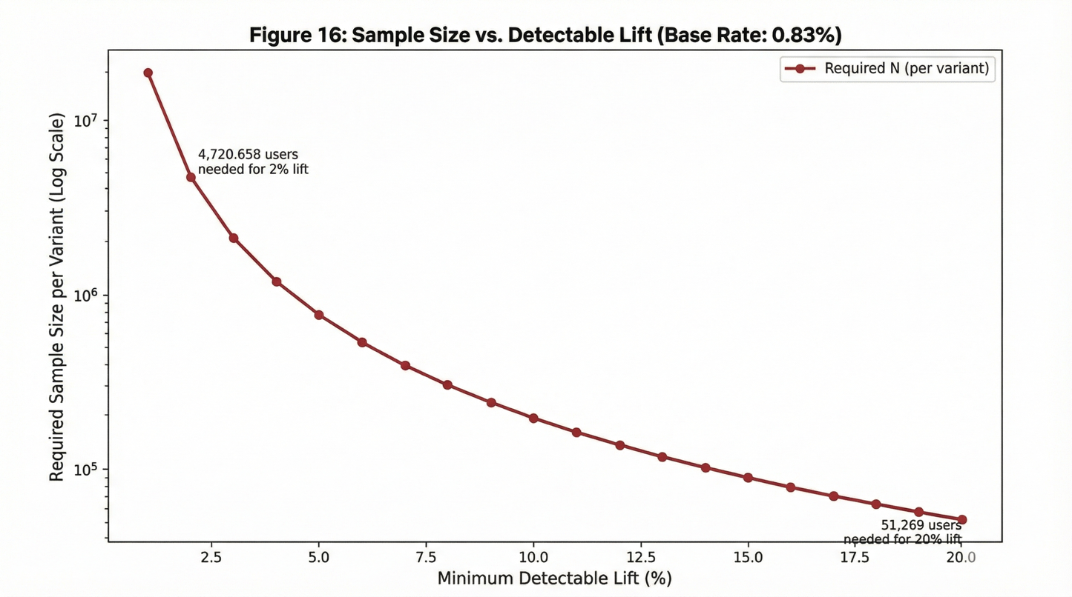

Figure 16. Power analysis: required sample size per variant vs minimum detectable relative lift (baseline conversion ≈ 0.83%). Note. Low base rates imply very large samples for small lifts; leading indicators can improve feasibility.

#### Why leading indicators matter for feasibility

Intent formation (add-to-cart / save-to-plan) occurs more frequently than purchase (~2.68% in the proxy funnel). That makes it a **faster-moving primary metric**. Even then, sample sizes can still be large for small lifts—but materially smaller than purchase-only tests.

A practical way to express this to stakeholders is:

* If we insist on **purchase as the primary**, many tests will be slow unless we expect large effects.
* If we use **intent as primary** (and keep purchase/return as confirmatory), we can iterate faster while staying aligned with the report’s finding that the biggest leak is early (view → intent).

#### Variance reduction (how to make tests faster without “cheating”)

When sample size is a constraint, Netflix-style experimentation typically uses variance reduction and design discipline:

* **CUPED / pre-period covariate adjustment:** reduce variance by conditioning on pre-treatment behavior (e.g., past activity level, recency)
* **Stratified randomization:** balance key segments across arms (new vs returning, high-activity vs casual)
* **Regression adjustment:** estimate effects using models with only pre-treatment covariates

These don’t “create lift.” They reduce noise so the same lift becomes detectable with fewer samples.

### 10.3 Significance testing approach and multiple comparisons

Experiments should be reported as effect estimates with uncertainty, not as a binary “significant / not significant” label. For binary outcomes (intent rate, conversion rate), the operationally relevant outputs are absolute lift, relative lift, and confidence intervals—optionally via logistic regression when covariates are included. For heavy-tailed outcomes that often appear in commerce contexts (revenue per attendee, basket size), inference should be robust by design (pre-specified winsorization/trim rules or bootstrap confidence intervals), because a handful of extreme observations can otherwise dominate the story.

Regardless of inference choice, a Netflix-aligned experimentation plan treats validity checks as non-negotiable. Sample Ratio Mismatch (SRM) is the early warning system for assignment or logging failures and should be checked before interpreting outcomes. Instrumentation stability must also be verified continuously: if event definitions or exposure logging shift mid-test, the causal comparison can become invalid even if assignment was correct.

Multiple comparisons deserve explicit policy because marketing and experience teams often run many simultaneous tests (multiple creatives, modules, cohorts, and metrics). The cleanest default is to pre-register a primary metric (or a small family of primaries) and treat other metrics as guardrails or diagnostics unless corrections are applied. When many hypotheses are genuinely first-class—common in creative testing—false discovery rate control (e.g., Benjamini–Hochberg) is typically more practical than overly conservative familywise corrections, but the important point is consistency: the organization should have a standard rule that prevents “winner’s curse” behavior from becoming a quiet norm.

Finally, sequential monitoring (“peeking”) must be acknowledged rather than ignored. If the business needs early stopping, the plan should use pre-specified sequential rules (alpha spending) or a Bayesian monitoring framework with explicit decision thresholds. Otherwise, repeated daily checks inflate false positives and gradually erode trust in the experimentation program.

### 10.4 Causal considerations: spillover, novelty effects, and seasonality

Even well-run digital experiments face threats like novelty effects and seasonality. In hybrid physical–digital experiences, an additional class of validity threats becomes central: **spillover and interference**.

Spillover occurs when a treatment changes the shared environment. A routing change that pushes many guests toward a “hero” attraction can increase queue times, reduce throughput for adjacent zones, and change the experience even for guests not directly targeted by the surface. In those settings, visitor-level randomization can underestimate harm or misattribute changes because outcomes are coupled through the venue state. The mitigation is not “avoid experiments”; it is to choose designs and estimands that match the mechanism. Cluster and switchback designs, buffer periods when carryover is expected, and system-level outcome reporting (queue time, congestion, throughput) alongside guest-level outcomes (intent, conversion) are what make the causal claim credible.

Novelty effects are also expected: new modules, new layouts, and new attractions can produce a short-lived engagement bump simply because they are new. The plan therefore requires time-sliced reporting (Day 1 vs Week 1 vs Week 2), staged rollouts (small ramps with guardrails), and—when retention is central—longer holdouts so the organization can distinguish durable lift from habituation.

Seasonality is the final recurring confounder. Demand varies sharply by daypart and day-of-week, and calendar structure (weekends, holidays, marketing bursts) can dominate outcomes. The plan’s default mitigation is to run experiments across full weekly cycles whenever possible, block or stratify on known calendar structure, and incorporate pre-period behavior into variance reduction so baseline shifts do not masquerade as treatment effects.

When randomization is genuinely infeasible—common for physical redesigns, safety-driven queue changes, and venue-wide operational policies—the experimentation plan explicitly transitions to quasi-experimental counterfactuals (interrupted time series, difference-in-differences, synthetic controls) and requires the same discipline: stated assumptions, mandatory diagnostics (pre-trends, placebo checks, fit quality), and uncertainty reporting. The goal is not to claim “A/B-level certainty” where it does not exist; the goal is to avoid the far more dangerous failure mode of treating naïve before/after comparisons as causal truth.

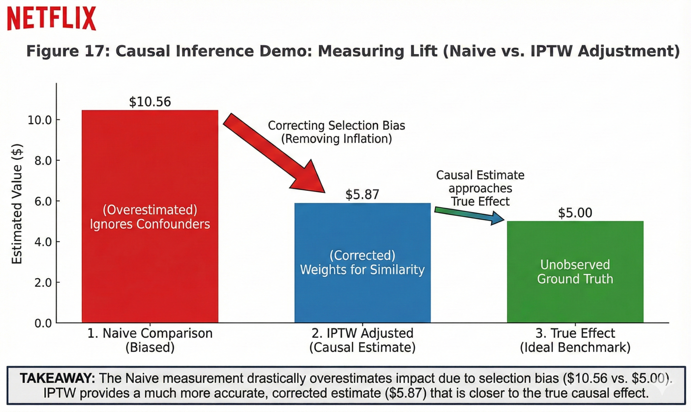

### Section 10 takeaway

This experimentation plan is built around the practical constraints revealed by the proxy funnel: conversion is sparse, demand is time-dependent, and (in venue settings) interventions can create interference through shared physical conditions. A decision-grade approach therefore emphasizes (1) policy-level treatment definitions with exposure logging, (2) leading indicators as primary learning metrics with conversion/return as confirmatory outcomes, (3) guardrails that explicitly prevent congestion, friction, and portfolio collapse, and (4) design choices—visitor-level when safe, cluster/switchback when interference is likely—that align causal claims with how the system actually behaves.

Part IV — Productionization and Operating Model (How this fits Netflix engineering culture)

# 11. Recommendations and Next Steps

## 11. Recommendations and Next Steps

The results in Sections 5–10 point to a consistent operating reality: this “fan journey” behaves less like a smooth pipeline and more like a **capacity-sensitive system**. Demand is sharply time-dependent, outcomes are sparse at the bottom of the funnel, and the highest-leverage improvements live upstream where most guests stall. In that environment, the most valuable next steps are not “jump to the most complex model,” but to establish a closed-loop operating model that can safely turn learning into action: **reliable metrics → planning forecasts with uncertainty → discovery/personalization policies with guardrails → interventions validated by experiments (or disciplined counterfactuals) → continuous monitoring and iteration**.

## 11.1 Operational recommendations

Operationally, the first lesson is that **time-of-day cannot be treated as descriptive context—it must be treated as a control variable**. The proxy traffic curve shows near order-of-magnitude swings between trough and peak hours, which in a physical venue would translate directly into queue risk, staffing strain, stockout likelihood, and uneven guest experience. The practical response is to formalize a small number of **demand regimes** (for example: low, medium, high, surge) and attach explicit playbooks to each regime—staffing bands, throughput and floor-flow tactics, replenishment cadence, and congestion mitigation. This gives operations a shared language that is more useful than “today feels busy,” because it ties decisions to measurable thresholds.

Forecasting should then be integrated as **decision support under uncertainty**, not as a promise of point accuracy. The baseline forecasting model’s error profile implies meaningful volatility, so the right production interpretation is to operationalize forecasts as **ranges** (low / expected / high) and connect those ranges to trigger policies. When the high-end scenario exceeds a throughput or staffing threshold, the venue should “ramp” early—adding queue support, deploying routing nudges, and staging replenishment before peak demand arrives. When the low-end scenario falls below plan, the system should reallocate effort toward experience quality and readiness tasks (and reduce perishable prep where applicable), rather than keeping the venue staffed for a surge that is unlikely to occur.

To make forecasts immediately actionable, convert predicted traffic into downstream workload using empirically observed journey ratios. Even in the proxy, a stable relationship exists between total visitors and later-stage volumes (intent and conversion). In a Netflix House implementation, this becomes the translation from **arrivals → reservations → queue joins → throughput → POS attach**, which is how staffing, inventory, and space management are actually constrained. Finally, operational dashboards should not focus only on “outcomes”; they must include **experience-health guardrails** (queue growth, abandonment proxies, throughput anomalies, stockouts) so the system is optimized for sustainable performance rather than short-term spikes.

## 11.2 Experience recommendations

The funnel structure implies that the biggest “leak” occurs early, before guests form a commitment signal. In a venue context, that usually means guests are browsing, uncertain, or overwhelmed—so they do not transition into “save to plan,” “reserve,” or “join queue.” The experience design implication is that the highest ROI work is often not “optimize checkout,” but **reduce uncertainty and friction at commitment formation**. Clear packaging (what it is, how long it takes, what’s included), confidence cues (availability, expected wait, best times), and simplified commitment affordances (save, reserve, add-on bundles) are the types of changes that move upstream conversion and also improve perceived experience quality.

Navigation and merchandising should treat the venue’s category/space structure as the backbone of how guests discover options. The proxy patterns suggest the presence of “hero” entities that can dominate attention. In a physical venue, that dominance is double-edged: it can create anchors that help guests decide, but it can also create bottlenecks that harm the entire system. The operating solution is to deliberately pair anchors with **capacity-friendly alternatives**—similar experiences or adjacent categories—so guests always have a credible “next best” path that distributes load without feeling like a downgrade.

This leads to an important framing shift: **diversity is not only a personalization value; it is a load-balancing lever**. During forecasted peak windows, stronger slate diversity and stronger routing away from saturated experiences can protect throughput, reduce queue harm, and preserve overall guest satisfaction—while still feeling like personalized guidance.

## 11.3 Personalization roadmap

The recommender findings support a pragmatic “baseline ladder” approach that is very Netflix-aligned: ship something deployable that is clearly better than naïve behavior, instrument it, validate incrementality, then increase complexity only when it earns its operational cost.

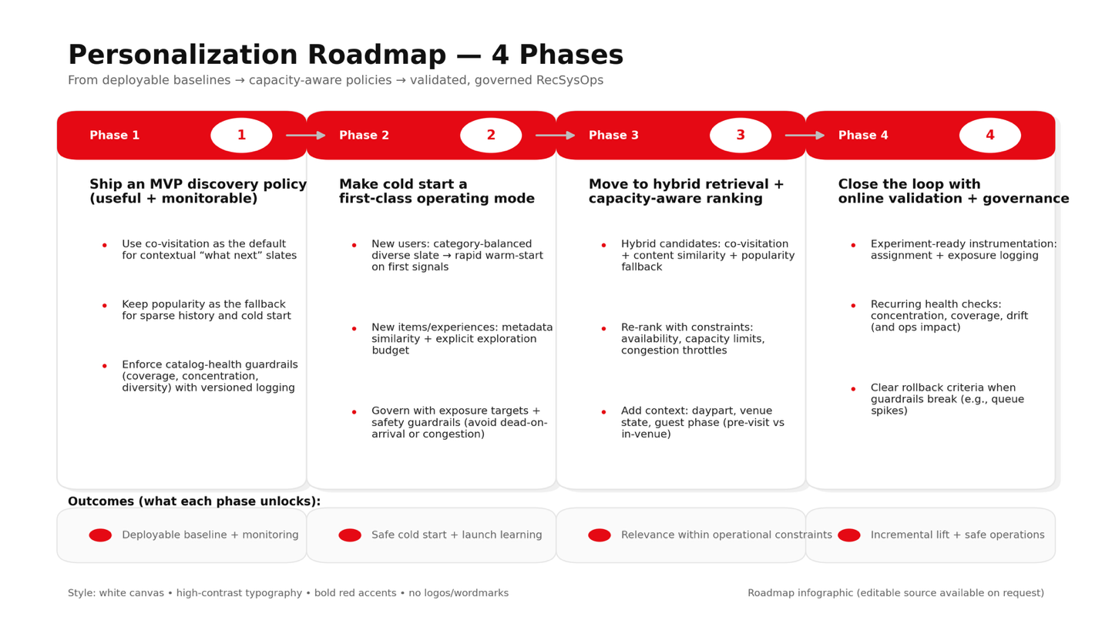

#### Phase 1: Ship an MVP discovery policy that is immediately useful and monitorable

The offline evaluation shows item-to-item co-visitation beats pure popularity in a time-respecting split, which supports it as a credible MVP for contextual “what next” surfaces. The production interpretation is simple:

* use **co-visitation** as the default for “continue your journey” recommendations (context-driven),
* keep **popularity** as the fallback for sparse histories and cold start,
* enforce **catalog-health constraints** (coverage, concentration, diversity caps) so the policy doesn’t collapse into hero overload.

This is a policy, not just a model. The fallback and constraints are part of the treatment and must be versioned, logged, and evaluated.

#### Phase 2: Make cold start a first-class operating mode (new users and new experiences)

Cold start is not an edge case—it is constant in a dynamic experience business.

A production-ready cold start strategy should include:

* **New users:** start with a category-balanced “diverse slate” to reduce mismatch and accelerate preference learning, then warm-start quickly once the guest provides even minimal signal.
* **New items/experiences:** seed exposure using metadata similarity (content-based neighbors) plus an explicit exploration budget so new launches aren’t starved by collaborative methods.

The important operational twist is governance: cold start needs exposure targets and safety guardrails so launches are not “dead on arrival” or over-promoted into congestion.

#### Phase 3: Move to hybrid retrieval + capacity-aware ranking (once venue telemetry exists)

As soon as Netflix House has instrumentation like availability, queue telemetry, and time-slot capacity, the recommender should evolve from “rank by relevance” into “rank by relevance subject to constraints.”

A realistic upgrade path is:

* **Hybrid candidates:** co-visitation + content similarity + popularity fallback
* **Re-ranking with constraints:** enforce diversity/coverage, availability, capacity limits, congestion-aware throttles
* **Context features:** daypart, current venue state, and guest phase (pre-visit planning vs in-venue routing)

At this stage, “personalization” becomes not just a recommender problem—it becomes a routing and load-balancing policy.

#### Phase 4: Close the loop with online validation + governance

Offline metrics help choose candidates, but only experiments establish incrementality. So personalization needs an operating model that includes:

* experiment-ready instrumentation (assignment + exposure logging),
* recurring model/policy health checks (concentration, coverage, drift),
* and clear rollback criteria if guardrails break (e.g., queue spikes).

This is the RecSysOps analogue for a venue: the system must be safe to operate, not just accurate.

## 11.4 Measurement plan

The measurement plan should be structured around a small number of “source-of-truth” views that map cleanly to decisions. Planning requires demand and arrival dashboards that show actuals versus forecast ranges and trigger conditions. Journey measurement requires stable funnel definitions and progression metrics (including time-to-intent and drop-off localization). Discovery measurement requires relevance proxies plus catalog-health guardrails (coverage, concentration, diversity). Retention measurement must be defined in an experience-appropriate way—ideally engagement-based return signals rather than purchase-only outcomes—because sparse conversions slow learning and create misleading imbalance.

Because base-rate conversion is low, experiment cadence should default to a metric hierarchy that makes iteration feasible without sacrificing correctness. For discovery and routing changes, high-frequency intent signals are the practical primary metrics, while conversion and longer-horizon return are confirmatory. Guardrails must be treated as non-negotiable, especially those that proxy venue harm: congestion, abandonment, complaint risk, or stockouts.

Experimentation hygiene needs to be standardized rather than improvised: pre-register primary metrics and guardrails, require SRM and instrumentation integrity checks, apply variance reduction when appropriate, and maintain discipline around multiple comparisons. When randomization is infeasible, the organization should not fall back to anecdotal before/after narratives; it should use explicit counterfactual frameworks and communicate assumptions and diagnostics clearly.

### Recommended execution sequencing

To keep this roadmap both fast and safe, the practical sequencing is:

* **Near-term:** productionize the metric layer as the single source of truth; deploy demand + funnel monitoring; ship the MVP co-visitation policy with diversity and fallback rules fully versioned and logged.
* **Mid-term:** integrate exogenous drivers (campaign calendar, programming/availability signals) into forecasting and publish uncertainty bands; standardize experiment templates and operational readouts; establish cold-start exposure policies for new users and new experiences.
* **Long-term:** evolve to hybrid retrieval and capacity-aware ranking once venue telemetry exists; implement RecSysOps-style health monitoring and rollback; mature retention into uplift-tested intervention systems tied to engagement-based return definitions.

# 12. System Blueprint (More Narrative and Informative)

The analyses in Sections 5–10 show that you can get surprisingly far with a disciplined foundation: a consistent event log, stable metric definitions, and time-respecting modeling and evaluation. But a Netflix House–style deployment cannot live as a notebook. It has to run as an operating system for decisions—staffing and capacity planning, routing and personalization, lifecycle messaging, and reliable causal measurement—while remaining safe under physical constraints and resilient to inevitable data issues.

Section 12 lays out that production blueprint. The philosophy is deliberately Netflix-aligned: treat definitions as products (versioned and reused), treat reliability as a feature (data contracts and observability are built-in), and treat learning as causal by default (experiments and quasi-experiments are registered and auditable). The system is meant to form a closed loop: instrument → ingest → standardize → compute trusted metrics → serve models/policies → monitor health → evaluate incrementality → iterate.

## 12.1 Event taxonomy and logging schema

Everything else depends on measurement. In a hybrid physical–digital experience, the “fan journey” is not a single funnel; it is the union of multiple behavioral streams that must be stitched together consistently: digital discovery and planning, arrival and in-venue movement, queueing and throughput, point-of-sale outcomes, and post-visit re-engagement. If those streams are logged with inconsistent semantics, the organization ends up with multiple incompatible versions of the truth—dashboards disagree, models train on mismatched features, and experiments cannot be trusted.

A production-grade taxonomy therefore starts by separating event families by decision role. Exposure and discovery events are foundational because they enable causal measurement later: what was shown, where it was shown, why it was eligible, and the rank/slot context. Engagement events capture deeper evaluation (detail views, map/list interactions, richer content interactions). Intent and commitment events capture the steps where friction often appears (save-to-plan, reservation search and slot selection, checkout initiation and completion). Physical consumption events establish operational ground truth (entry and exit scans, zone entry/exit for dwell, queue join/exit/abandon for wait-time and throughput). Commerce events close the loop (POS transactions, refunds/cancellations, stockouts), and experience-quality signals (surveys, complaints, incident reports where appropriate) ensure optimization does not silently degrade the guest experience.

To keep the system both stable and flexible, the schema should have a small “spine” that is consistent across every event producer, and a structured metadata payload for surface-specific attributes. The spine should include event identity and time (event_id, event_ts, event_type, event_source), entity keys (a pseudonymous fan_id, session_id where applicable, venue_id, and relevant experience_id/item_id and category identifiers), and experimentation keys (experiment_id, variant_id, eligibility flags). Provenance fields—schema_version, ingest_ts, pipeline_run_id—are not decoration; they are how the organization detects and diagnoses discontinuities when systems evolve.

Because measurement will inevitably involve linking digital and physical traces, the blueprint assumes privacy-by-design. The join strategy should rely on bounded, controlled identifiers: rotating or time-scoped pseudonymous IDs, reservation/booking IDs when available, and a visit instance identifier so multiple visits by the same guest are not conflated. The system should be explicit about retention windows and consent-aware gating for cross-surface linkage. The goal is to make the journey measurable without turning identity into an open-ended dependency.

Global Event Tracking Schema & Data Quality Guardrails

## 12.2 Metric layer and semantic definitions

In mature analytics organizations, the dominant source of failure is not modeling sophistication; it is definition drift. If “conversion,” “visitor,” “session,” or “visit” differs across dashboards, forecasting features, recommender evaluation tables, and experiment readouts, the organization can’t accumulate learning—it can only argue about measurement.

The metric layer is the fix: a governed semantic contract that computes official definitions once and makes them reusable everywhere. In practice, this looks like a layered data product model. The raw layer is immutable and append-only (canonical events partitioned by date, venue, and event type) to preserve auditability and enable reprocessing. The standardized layer cleans and conforms (timestamp normalization, deduplication, schema validation, and enrichment from venue and catalog dimensions). The curated layer publishes decision-facing marts: hourly/daily demand and funnel tables, exposure and slate-quality summaries, and feature tables used consistently by forecasting, recommendation, and return-risk scoring.

Equally important is publishing the grains that determine denominators and interpretations. A fan_id grain supports unique reach and retention. A session grain supports time-to-intent, depth, and friction diagnostics. A visit grain (fan × venue × date/time window) supports attendance, dwell, and on-site outcomes. An experience/item grain supports discovery, routing, and capacity constraints. An impression/exposure grain is what makes causal inference defensible for discovery surfaces. Once these grains are explicit, the organization can stop debating which denominator to use and instead focus on the decision the metric supports.

The blueprint’s semantic layer should also encode the metric hierarchy used throughout the report: primary outcomes (tickets, POS, add-on conversion; repeat engagement), leading indicators (save-to-plan, reservation start, queue join, time-to-intent; hourly/daily attendance proxies), and guardrails that protect experience and system health (abandon spikes, browse-without-progression, coverage/concentration/diversity, queue overflow risk, stockouts, and data reliability measures). The point is not to publish “more metrics.” The point is to publish the small set of metrics that the organization will actually operationalize—and to guarantee they mean the same thing everywhere they appear.

## 12.3 Data quality contracts and observability

In a physical venue, a data failure does not merely produce a wrong chart. It can cascade into staffing misallocation, queue blow-ups, degraded guest experience, and wasted marketing spend. That’s why the blueprint treats data reliability as a first-class product feature.

The foundation is a contract between upstream producers (ticketing, entry scans, queue sensors, POS, marketing delivery, digital app surfaces) and the analytics system. For each event family, producers should commit to required fields, versioning rules, acceptable null rates, expected volume bands, and allowed lateness (how long events may arrive after they occur). These contracts make failures diagnosable: if queue telemetry drops while attendance is normal, the system can recognize a sensor outage rather than concluding “queues improved.”

Observability then enforces those contracts continuously. The system should monitor freshness (are key tables and marts updating within SLA), completeness (are all producers present and are join rates stable), correctness (are IDs valid, are timestamps plausible, are schema versions consistent), and distributional anomalies (unexpected shifts in funnel rates, sudden changes in exposure concentration, unusual queue spikes, abrupt throughput drops). Observability must be tied to action: incident playbooks define what the system does when signals break. When POS events are delayed, dashboards should degrade gracefully to attendance and intent proxies rather than silently publishing misleading revenue trends. When impression logging is missing on a surface, experiment readouts for that surface should be blocked or clearly flagged as invalid for causal inference. When a schema version bump coincides with a funnel discontinuity, the system should default to “instrumentation break until proven otherwise.”

This is how Netflix-style reliability is implemented in analytics: by making measurement failures visible, attributable, and operationally manageable rather than invisible and corrosive.

## 12.4 Model serving and monitoring

The notebook demonstrates three core decision-support outputs: forecasting for planning, recommendation for discovery/routing, and return-risk scoring for lifecycle intervention. In production, the hard part is not training; it is serving reliably, monitoring continuously, and maintaining safe fallbacks when the world changes.

Forecasting should be operated as a planning product. In practice, that means a scheduled batch service (daily, with optional intra-day updates) that produces forecasts by venue and daypart, includes uncertainty (prediction intervals or decision bands), and emits trigger flags aligned to operational playbooks (“surge likely,” “low-demand window,” “capacity risk”). Monitoring focuses on error over time, error by venue/daypart, drift in demand patterns, and—if intervals are produced—interval calibration. The guiding principle is that forecasts are decision inputs with known uncertainty, not numbers to be trusted blindly.

Recommendation serving in a venue environment must evolve from “rank by relevance” to “rank by relevance subject to constraints.” Candidate generation can be hybrid (co-visitation, content similarity, popularity fallback), but ranking cannot ignore capacity, closures, time-slot availability, and congestion risk. The service should support real-time or near-real-time updates because venue state changes: availability and queue conditions shift by daypart and by operational disruptions. Monitoring therefore includes not only relevance proxies (intent lift, time-to-intent) but also portfolio health (coverage and concentration) and operational externalities (do recommendations create queue spikes, or do they distribute load). Fallback behavior is part of the policy: when history is sparse, return diversified popularity; when a space is saturated, route to adjacent alternatives rather than repeatedly pushing the same constrained experience.

Return-risk scoring is only useful when it is coupled to governed intervention and causal evaluation. In production, scoring is typically a scheduled batch job producing risk bands written to a targeting table consumed by lifecycle systems. Monitoring includes score drift, feature distribution shifts, and probability calibration if thresholds are used. Governance is where most systems fail: the blueprint assumes holdouts within each risk band for uplift measurement, frequency caps to prevent fatigue, and explicit guardrails so the model does not become a mechanism for over-targeting or for learning the biases of previous policies.

Across all three, the operating standard is the same: version the model/policy, log its exposures and outputs, monitor for drift and guardrail violations, and make rollback possible.

## 12.5 Experiment registry and causal analytics integration

A system that cannot measure incrementality reliably will eventually optimize noise. That risk is higher in Netflix House contexts because many interventions are targeted (marketing, personalized routing) and many venue changes are difficult to randomize cleanly (layout changes, queue redesigns, safety-driven adjustments). Section 12 therefore treats “causal metadata” as a first-class data product.

For randomized tests, an experiment registry should record the hypothesis and decision owner, the treatment definition as an actual policy (not just “Variant B”), eligibility rules and randomization unit, start and end times, primary metrics and guardrails, and direct linkage to exposure logging. Once the metric layer is governed, experiment readouts can be standardized and increasingly automated: assignment integrity checks (SRM), instrumentation and balance checks, effect estimates with uncertainty, guardrail monitoring, and segmentation cuts that reflect real heterogeneity (new vs returning, daypart, demand regime).

For non-randomized rollouts, the blueprint adds a quasi-experiment registry. Instead of pretending every change can be A/B tested, the system stores intervention start time, scope (venue/zone), expected impact window, and candidate controls or donor pools so that interrupted time series, difference-in-differences, or synthetic control analyses can be run consistently with documented assumptions and diagnostics. This is what prevents the organization from reverting to fragile before/after narratives as soon as randomization becomes inconvenient.

The outcome is a measurement culture where causal learning is repeatable. The organization does not just “run experiments”; it runs an operating system for incrementality that survives real-world constraints.

### Section 12 takeaway

A notebook can demonstrate methods; a production system must demonstrate trust. The system blueprint in this section makes trust concrete by specifying how Netflix House fan journey analytics becomes a durable engineering capability: unified instrumentation across digital and physical touchpoints (including exposures), a governed semantic metric layer that prevents definitional drift, enforceable data contracts with observability and action-oriented runbooks, model services designed with guardrails and safe fallbacks, and an experiment/quasi-experiment registry that institutionalizes causal learning.

# 13. Proxy Calibration Plan

A proxy-based fan-journey system only becomes decision-grade once the organization can say, with evidence, what a digital signal means in the physical world. Up to this point, the report A proxy-based fan journey analytics system is only “decision-grade” once the organization can translate digital behaviors into the physical realities that leaders actually manage: arrivals, dwell, queues, throughput, and on-site spend. In the earlier sections, the RetailRocket funnel (view → add-to-cart → transaction) is used as a structurally similar analogue to discovery → intent → conversion, but the report is explicit about the limitation: a clickstream does not automatically mean the same thing as a venue visit. The job of calibration is to earn that connection.

Section 13 describes how Netflix House would convert the proxy strategy from a reasonable prototype into a governed measurement layer. The end state is not “a calibration analysis” living in a notebook; it is a versioned, monitorable mapping that downstream teams can safely use for planning, personalization, and experimentation—because the mapping is anchored to ground truth, stress-tested for robustness, and refreshed when conditions change.

## 13.1 Instrumentation requirements

Calibration requires visibility into both sides of the relationship: the **proxy-side signals** (what guests did digitally and what they were shown) and the **physical ground truth** (what happened in the venue). If either side is missing or inconsistently logged, calibration will quietly degrade into guesswork.

On the digital side, the most important requirement is **exposure logging**—not just clicks or saves. If the system cannot observe what was shown (impressions by surface, rank/slot, and eligibility context), it cannot reliably interpret downstream engagement and it cannot support causal evaluation later. Alongside exposures, the system should capture the natural steps of pre-visit and in-visit digital behavior: discovery and evaluation events (list/map views, detail views), commitment signals (save-to-plan, reservation slot checks, reservation start/complete, checkout start/complete), and any post-visit feedback or re-engagement signals that the product supports.

On the physical side, calibration needs a small set of stable “truth” signals that correspond to the decisions Netflix House cares about. Entry and exit scans provide attendance ground truth. Dwell and routing telemetry (at whatever granularity the venue can instrument responsibly) makes time-in-system measurable rather than inferred. Queue telemetry captures the operational bottleneck directly (join/exit/abandon and throughput by interval). POS transactions (with attach categories such as merch vs F&B, plus operational context like stockouts/refunds) anchor monetization to real outcomes.

Because linking digital and physical traces can introduce privacy risk, the join strategy should be explicit and bounded. In practice, calibration works best with a **visit-scoped, privacy-preserving token** (often derived from booking/reservation plus a rotating pseudonymous identifier) so that the organization can connect “this pre-visit planning session” to “this on-site attendance and spend” without creating an open-ended identity dependency. That visit instance key also prevents a common analytics failure mode: blurring multiple visits together and misattributing outcomes.

Finally, calibration is only as reliable as the pipelines that feed it. Before modeling, the organization should treat data quality as a contract: freshness SLAs (how quickly entry/queue/POS events arrive), completeness thresholds (join coverage across systems), schema versioning, and alerting when volumes or join rates break. Calibration is not robust if it silently trains on partial truth.

## 13.2 Calibration methodology

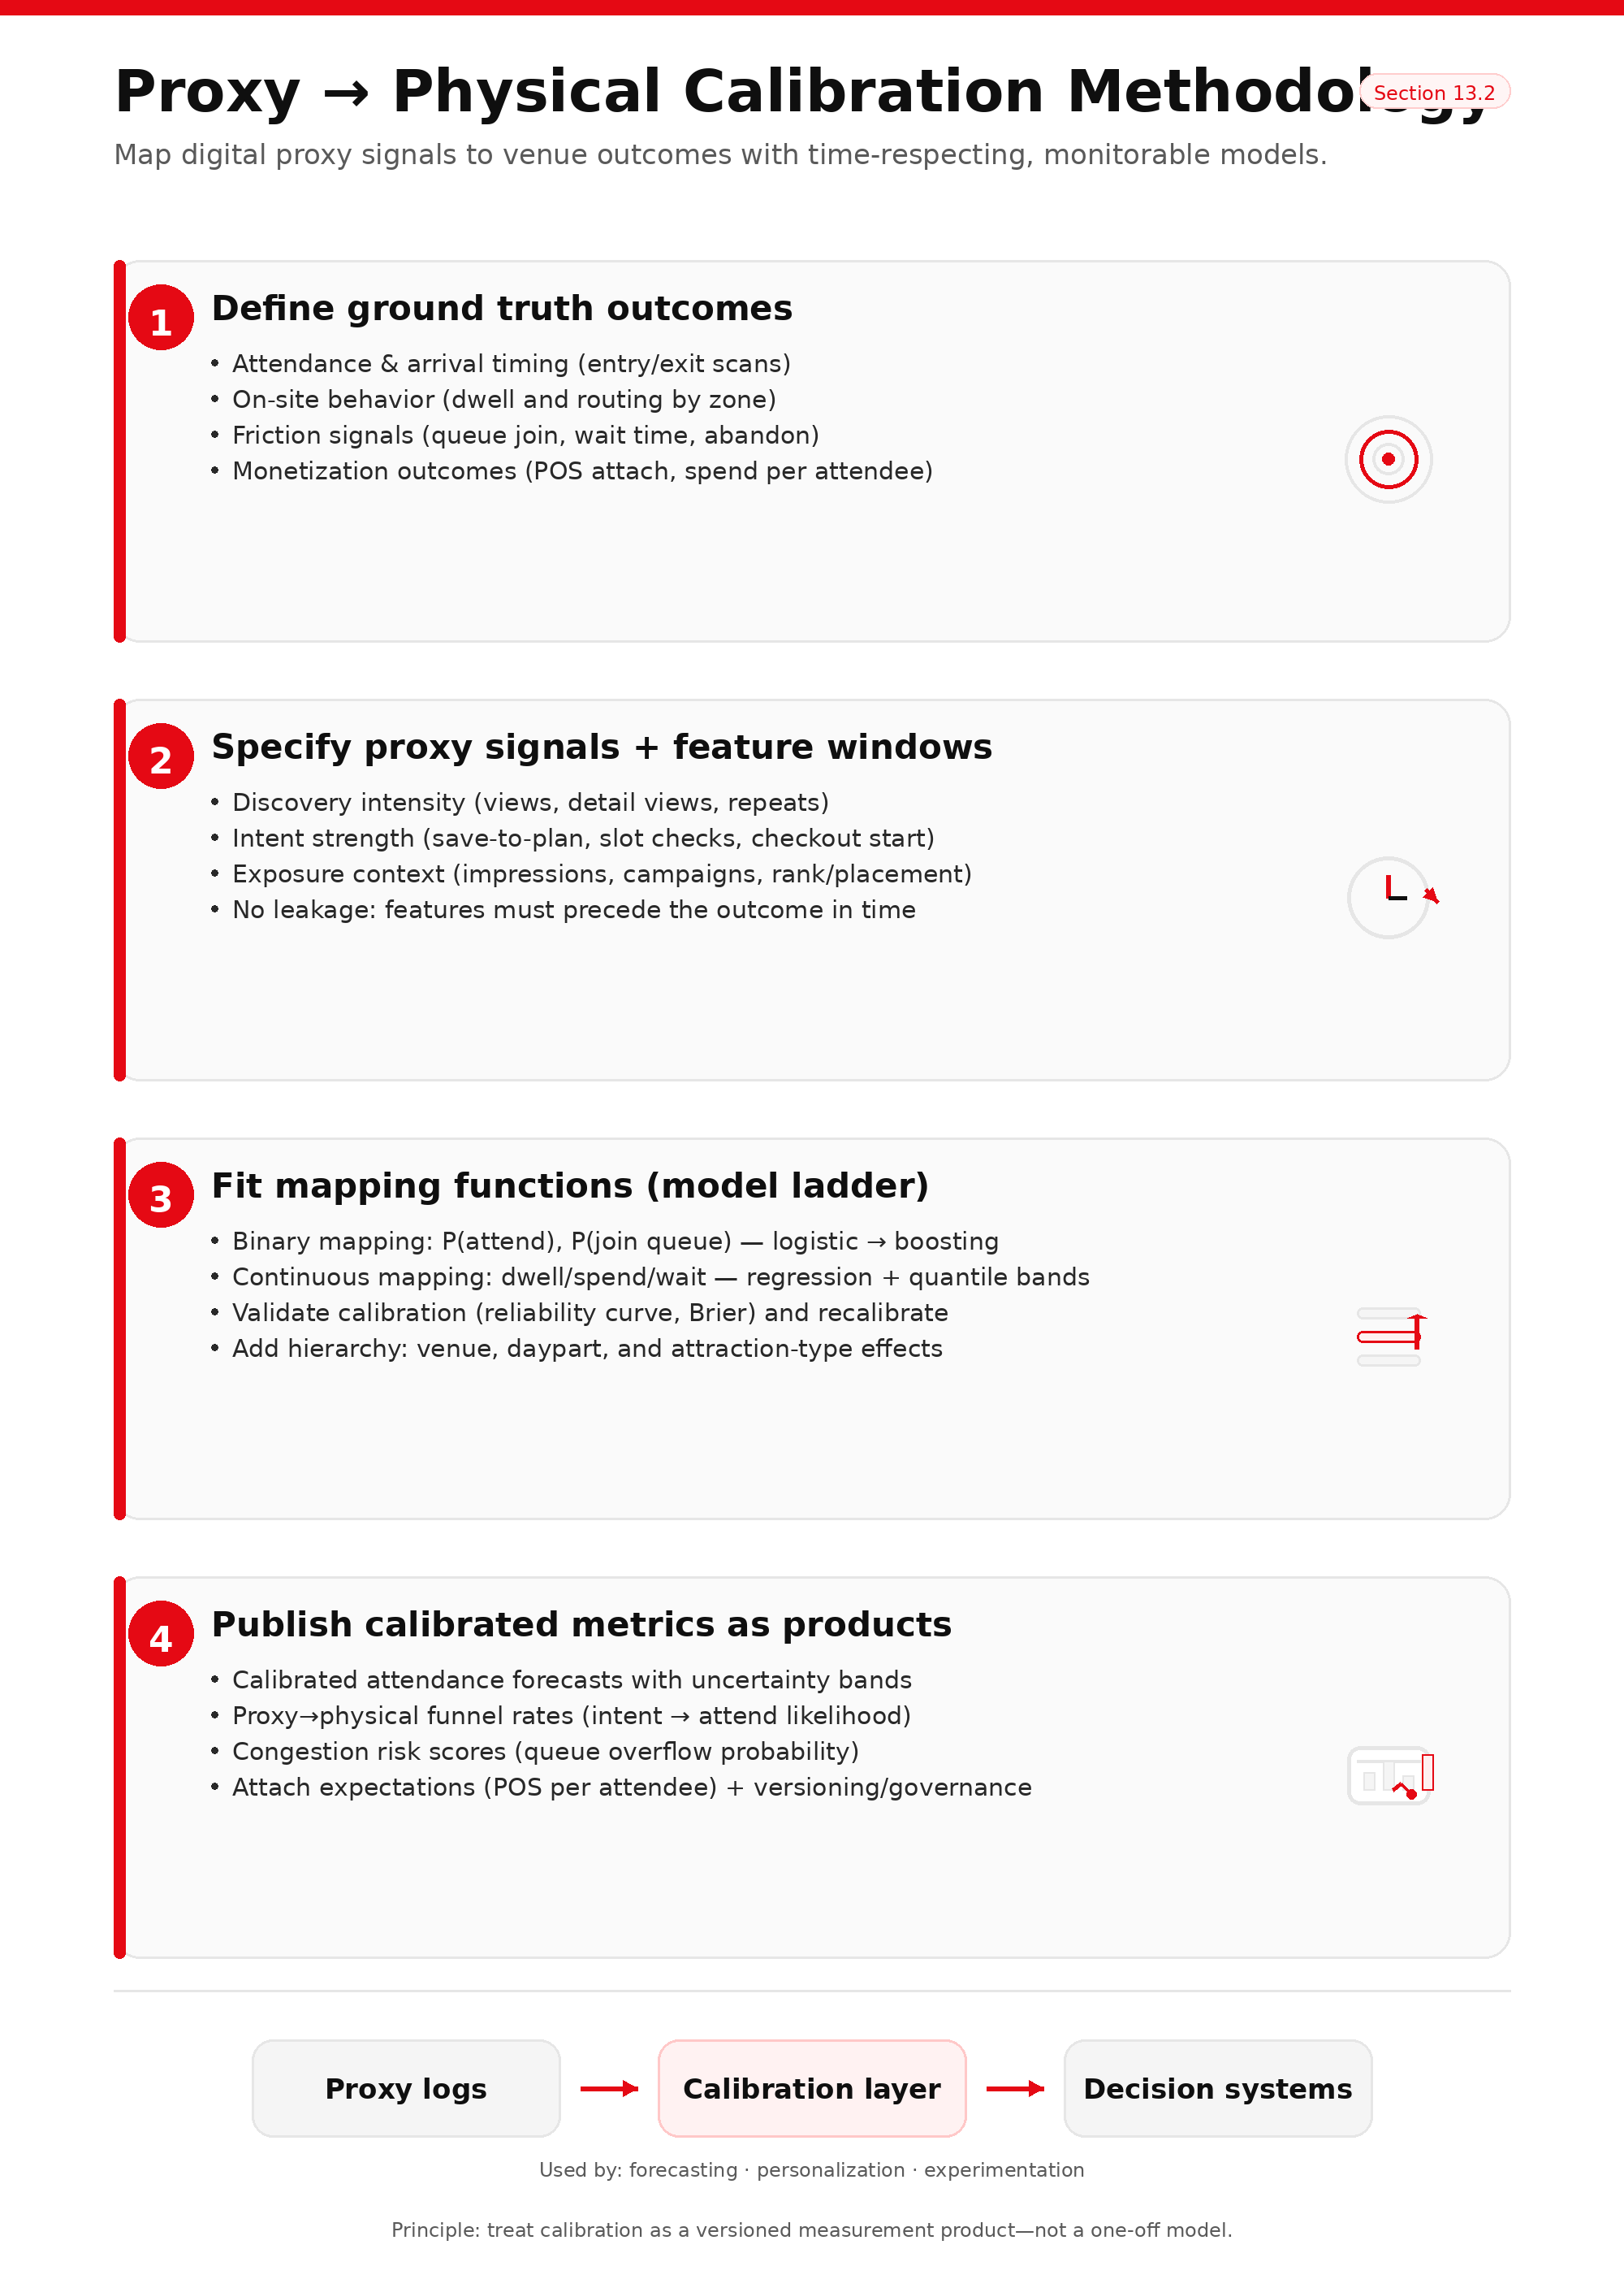

The core principle of calibration is simple: learn an empirical mapping from proxy signals to physical outcomes that is interpretable, diagnosable, and stable enough to support decisions. The practical principle is equally important: start with trustworthy models and strong measurement hygiene before pursuing complexity.

The work begins by defining the **ground truth outcomes** the organization wants to predict and operationalize. For Netflix House, that typically means attendance (did the guest show up, and when), the arrival curve (timing relative to slots or dayparts), dwell and routing (total dwell and zone-level dwell/transition patterns), queue exposure and friction (join probability, expected wait, abandonment), and on-site monetization (attach probability and expected spend per attendee). These outcomes are chosen because they directly connect to staffing, capacity management, experience design, and revenue planning.

Next, the plan defines the proxy predictors with **time-respecting feature windows** so the mapping can actually run in production without leakage. If the goal is to predict attendance, the features must come from signals that occur before entry. If the goal is to predict queue risk for an attraction, the features must reflect what is known before the guest reaches that zone (or at least before they join the queue). Proxy predictors generally fall into a few interpretable families: discovery intensity (how much evaluation activity occurred), intent strength (save-to-plan, reservation starts/completions, add-on selections), temporal proximity (how close the signals are to the visit date), exposure context (how often and where the experience was shown), and operational context at exposure time (availability/capacity state when the decision was presented).

From there, calibration fits mapping functions using a “trust-first” modeling ladder. Probability mappings (such as “attend within seven days” or “join queue”) should begin with logistic regression for transparency, then move to non-linear models like gradient boosting when the data clearly show threshold effects or strong interactions. But regardless of model class, probability calibration must be checked explicitly via reliability curves and proper scoring metrics; if probabilities are miscalibrated, the plan should include a recalibration step (e.g., isotonic or Platt scaling) so outputs remain decision-safe.

For continuous outcomes like dwell time, spend per attendee, or wait time, the most operationally useful output is rarely a single number. Operations needs ranges, especially near capacity. That makes quantile-oriented approaches (quantile regression or conformal-style uncertainty bands) an important part of the production design: not because they are academically elegant, but because they enable conservative planning and safer thresholding.

Because venues are heterogeneous, the mapping should not assume one global relationship fits all contexts. Calibration should support venue and daypart structure—either through explicit covariates plus per-venue adjustments, or via hierarchical/multi-task approaches that share statistical strength while allowing local correction. This matters because the same digital intent signal can correspond to different physical outcomes depending on venue layout, throughput, and guest mix.

The final step is what makes calibration “real”: publishing calibrated outputs as **first-class measurement products** rather than leaving them embedded in bespoke analysis. In practice, that means writing calibrated views or services that downstream teams can consume consistently—calibrated attendance forecasts derived from digital demand proxies, calibrated intent-to-attend likelihoods for funnel interpretation, calibrated congestion risk estimates for routing policies, and calibrated attach/spend expectations for inventory and merchandising planning. When calibration is published this way, the organization stops debating proxy validity and starts operating with a shared, monitored mapping.

## 13.3 Sensitivity analysis and robustness checks

Even well-instrumented calibration can be wrong in ways that matter. Sensitivity analysis is how the system avoids fragile decisions—especially early in the lifecycle when ground truth data may be limited and the environment is changing quickly.

A practical starting point is scenario bounding: treat key proxy→truth relationships as uncertain within plausible ranges (for example, how strongly a “save-to-plan” signal maps to true attendance intent), then propagate that uncertainty through the actual decisions stakeholders care about. Instead of asking “is the mapping perfect,” the system asks “do staffing tiers, congestion mitigations, or routing recommendations change materially across plausible mappings?” If decisions are stable, the system is robust; if decisions flip often, the system should respond by collecting more ground truth, using more conservative buffers, or switching to decision metrics that are less sensitive to the uncertain link.

Robustness also needs “sanity checks” designed to catch self-deception. Negative controls (outcomes that a given proxy should not meaningfully predict), placebo periods (fake change points that should not produce “effects”), and back-testing on held-out windows are simple but powerful defenses against accidental leakage, instrumentation artifacts, and overfitting to novelty regimes. These checks don’t just protect the calibration model; they protect leadership from false confidence.

## 13.4 Drift monitoring and recalibration cadence

Calibration is not a one-time launch. In a venue context, proxy validity can drift for normal reasons: seasonality, new IP activations, layout changes, pricing and bundling shifts, tourism cycles, marketing mix changes, and even instrumentation upgrades. A production plan must therefore specify what drift looks like and what the system does when it appears.

Drift should be monitored at three levels. Input drift captures changes in proxy behaviors and exposure distributions (views, saves, reservations, campaign pressure, surface mix). Label drift captures changes in the ground truth itself (attendance rates, dwell patterns, queue dynamics) that may reflect operational shifts rather than digital behavior. Mapping drift captures the thing that matters most for calibration: degradation in calibration error and reliability—especially by venue, daypart, or attraction type, where failures tend to concentrate.

Recalibration should follow a hybrid cadence. A scheduled refresh (for example, monthly for core attendance mapping) prevents slow decay, while trigger-based refresh rules handle regime shifts: error exceeding thresholds for consecutive windows, major attraction launches, instrumentation/schema changes, or material venue layout/throughput changes. Importantly, recalibration is not only a data science decision; it is a governance decision, because it changes what “truth” downstream teams see.

That governance should be explicit. Calibration artifacts should be versioned, shipped with short release notes (“what changed and why”), linked to the experiment registry so causal readouts know which mapping they used, and paired with a backfill policy that defines when historical metrics are recomputed versus left as-is. This is how calibration becomes an engineering-grade measurement layer rather than a moving target.

### Section 13 takeaway

Proxy calibration is how Netflix House earns the right to use proxy signals for operational decisions. By instrumenting exposure and physical ground truth, learning time-respecting mappings with explicit uncertainty, stress-testing decision robustness, and continuously monitoring drift with versioned refresh rules, the organization converts a proxy strategy from an assumption into a governed, trustworthy measurement system—one that can safely power planning, personalization, and the causal learning loops that follow in later sections.

# 14. Venue Quasi-Experimentation Playbook

In a Netflix House–style venue, the changes that matter most—new IP installations, queue-flow redesigns, staffing playbooks, pricing bundles, signage, or app-based routing—often reshape a shared physical system. Guests don’t experience changes in isolation: queues persist across time blocks, staff shift dynamically, and one attraction’s popularity can spill into neighboring zones. That is exactly why naïve “before vs. after” readouts are so risky. Demand moves with weekends and holidays, marketing pressure shifts the audience mix, and novelty effects can create short-lived spikes that look like durable lift.

This playbook treats venue changes the way Netflix treats production deployments: every change should have a credible counterfactual, explicit assumptions, required diagnostics, and a standardized decision memo that supports a go/no-go rollout. The goal is not to force every question into a perfect A/B test; the goal is to make causal learning routine even when the venue cannot be randomized at the individual guest level.

## 14.1 When randomization is feasible

Randomization is feasible more often than it first appears—if we broaden beyond classic “user-level A/B tests.” In physical environments, the most practical strategy is usually to randomize over **time blocks** or **clusters**, so that the venue operates under one coherent policy at a time rather than mixing incompatible behaviors in the same line, zone, or hour.

A switchback design is often the most operationally natural. The venue alternates between control and treatment by time blocks (for example, by hour, by daypart, or by a fixed block length that matches operational cadence). This works especially well for changes that influence how the venue runs—queue messaging, wayfinding prompts, in-venue kiosk routing, or “surge” playbooks—because staff can execute one playbook consistently during a block. The critical design detail is carryover: queues and congestion don’t reset instantly when the clock flips. A credible switchback plan chooses blocks long enough to reach a stable regime and, when needed, includes buffer or washout logic so the next block isn’t contaminated by the prior one.

If the business has reservations or timed entry, time-slot randomization becomes a venue-native experiment unit. In that setup, the treatment assignment attaches to the slot (e.g., 2–3pm treatment, 3–4pm control). This is particularly appropriate for reservation UX changes, bundling/upsell mechanics, pre-visit itinerary nudges, and capacity rules because the time slot already aligns to staffing, throughput expectations, and the operational “shape” of demand.

When interference is unavoidable—when the intervention affects shared crowd flow or overall congestion—cluster randomization is safer. That can mean randomizing by venue × day, venue × week, or another unit large enough that one cluster experiences one coherent policy. The tradeoff is statistical power: fewer clusters mean wider uncertainty. The right response is not to abandon the design, but to plan for the required duration (cover full weekly cycles) and to report effects with uncertainty ranges rather than overconfident point estimates.

A practical rule for choosing the unit is: **randomize at the smallest unit that avoids interference.** If the change affects only an individual’s digital experience, user-level randomization is fine. If the change affects shared physical conditions—queues, congestion, staff workload—prefer time-block or cluster units.

Because conversion-like outcomes can be low-frequency, randomized venue tests should be measured with a hierarchy that learns quickly while staying anchored to business value. In practice, that means intent and commitment signals (save-to-plan, reservation start/complete, queue join) are often the fastest-learning primary endpoints, while attendance, POS attach/spend, and repeat engagement serve as confirmatory outcomes. Guardrails are not optional in venues: a “win” that increases queue overflow, abandonment, complaints, or stockouts is a win that should not ship.

Finally, Netflix-style rigor applies even when the design is randomized. Every readout should include assignment integrity (SRM), instrumentation stability checks, balance checks where relevant, carryover checks for switchbacks, and inference that matches the randomization unit (cluster-robust when appropriate). Without this hygiene, a “randomized” test can still mislead.

## 14.2 When randomization is infeasible

Some changes cannot be randomized without harming guest clarity, safety, or operational coherence—think permanent layout redesigns, safety-driven queue changes, or major IP launches that must be consistent venue-wide. In those cases the objective is not to pretend we ran an A/B test; it is to construct the most credible counterfactual available and to be explicit about what assumptions make the result believable.

Interrupted Time Series (ITS) is the workhorse when one venue changes at a known time and you have meaningful pre- and post-period history. The idea is straightforward: model the outcome over time, then test whether the intervention coincides with a level shift and/or a trend change after accounting for day-of-week patterns and other calendar structure. ITS becomes much more credible when paired with a control series—another venue or metric that shares seasonality but did not receive the change—because that reduces the risk of mistaking shared shocks for treatment impact. Placebo change points (fake intervention dates) are a mandatory diagnostic: if the method “finds lift” everywhere, it isn’t identifying the intervention.

Difference-in-Differences (DiD) is appropriate when you have a treated venue (or treated set) and at least one comparable control venue. DiD estimates incrementality by comparing how the treated venue changes relative to how the control venue changes over the same period. The core vulnerability is the parallel trends assumption, which can break in venues—especially when capacity constraints bind differently across locations. That is why DiD in a venue context should always include pre-trend and event-study diagnostics, multiple candidate controls when possible, and regime stratification (e.g., peak vs non-peak dayparts) when mechanisms differ across congestion states.

Synthetic Control is often the best option when only one venue is treated and multiple other venues exist as potential donors. Instead of choosing one control, the method constructs a weighted mixture of control venues that best reproduces the treated venue’s pre-period trajectory, and then uses that synthetic series as the counterfactual. The most important credibility requirement is pre-fit quality: if the synthetic control does not match well before the change, the counterfactual is weak and the conclusion should be constrained accordingly. Placebo permutations (“pretend” each donor venue was treated) provide an intuitive check on whether the estimated effect is unusually large relative to noise.

For targeted interventions (like marketing outreach to specific cohorts or routing shown only to eligible guests), observational causal inference methods such as propensity weighting or doubly robust estimation can supplement these time-series approaches. But the operating rule should be strict: these are **assumption-dependent estimates**, not “A/B tests without randomization.” They require overlap checks, balance diagnostics after adjustment, and sensitivity analysis to hidden confounding.

## 14.3 Spillover and interference management

Spillover is the defining complication in venues because the system is coupled. A routing prompt that increases demand for one “hero” attraction can lengthen queues and reduce total experiences consumed per visit. Staff shifted to handle a surge can change throughput elsewhere. A pre-visit campaign can raise arrivals and change the baseline for every in-venue test. If the evaluation design ignores interference, it can measure the wrong thing—or measure a guest-level gain that is actually a system-level loss.

The playbook therefore treats interference as a design input. When the mechanism changes shared conditions, randomize at a unit that keeps the system coherent (time blocks or clusters), avoid mixing policies within the same line, and include buffer logic when queue states persist. Congestion guardrails should function as operational stopping criteria: if queue thresholds breach, the policy must throttle exposure, reroute traffic, or pause the treatment rather than continue to “learn” while degrading the experience.

When spillover cannot be eliminated, the measurement strategy must acknowledge it explicitly by reporting outcomes at two levels: guest-level outcomes (intent, conversion, satisfaction proxies) and system-level outcomes (queue time, throughput, crowding, abandonment, stockouts). In heavily coupled regimes, the correct estimand is often a cluster-level effect on venue health, not just an individual-level response metric.

## 14.4 Reporting templates

A playbook only scales when reporting is standardized. The output should be a single, repeatable artifact that makes the decision legible and the causal claim auditable. In practice, every experiment or quasi-experiment write-up should state: what decision it informs, what exactly changed (treatment defined as a full policy, not a vague “variant”), why the design is credible given constraints, what data sources were used and whether instrumentation was stable, which metrics are primary vs confirmatory vs guardrails (with exact definitions and grains), what the effect size is with uncertainty, and what diagnostics support the counterfactual.

Because venue decisions are operational, the report must close with a concrete recommendation: roll forward, hold, or iterate—along with any mitigations required to ship safely (throttles, staffing adjustments, rerouting logic).

The go/no-go rule should be simple and consistent:

* The primary metric moves in the right direction **and** guardrails (especially congestion/complaints) remain within acceptable limits.
* The result is not explainable by obvious validity failures (broken logging, failed pre-trends, weak synthetic pre-fit, carryover contamination).
* The effect is not purely Day-1 novelty—or, if novelty is likely, the plan explicitly extends validation to confirm persistence.

Section 14’s core message is that Netflix House changes should be evaluated as deployments with counterfactuals, not as anecdotes. When randomization is feasible, venue-friendly designs like switchbacks, time-slot randomization, and cluster tests make causal learning practical. When randomization is infeasible, ITS, DiD, and synthetic control provide structured alternatives—so long as diagnostics and sensitivity checks are mandatory. And because venues are coupled systems, spillover must be designed for and measured directly, not treated as an afterthought.

# 15. Experience Launch Observability

Launching a new Netflix House attraction should be treated less like “adding a new activity” and more like introducing a new entity into a living, coupled system. The attraction must become discoverable through digital and on-site surfaces, convert the right guests into committed participation, and remain stable under real-world load—while avoiding negative spillovers like queue blow-ups, congestion, or the starvation of other experiences. In other words, a launch is not complete when the doors open; it is complete when the attraction is **measurable, routable, and safe to operate**.

Experience Launch Observability is the operating model that makes this possible. It defines what “healthy” means on Day 0, how exposure is managed during the cold-start learning window, how monitoring turns into action (not just dashboards), and how post-launch evaluation separates real incrementality from novelty and calendar noise.

## 15.1 Experience Health scorecard

An “Experience Health” scorecard is the venue analogue of a launch-readiness and performance view: it tells operators and product teams whether the attraction is configured correctly, reaching the right audience, progressing guests through the journey, and operating within physical constraints. The scorecard is designed to answer a single decision-grade question: **Is this attraction healthy enough to scale exposure and operational reliance, without degrading the broader venue system?**

The first responsibility of the scorecard is to protect the organization from misreading metrics when the fundamentals are broken. Before interpreting engagement or revenue, the scorecard must validate that the attraction is actually measurable and runnable: metadata is complete enough to support routing and segmentation, schedule and slotting are correct, capacity parameters reflect operational reality, and instrumentation is live (exposures, reservations, entry/exit, queues, POS tagging). When this “configuration integrity” layer is weak, downstream performance becomes ambiguous by construction—because the system may be undercounting, misrouting, or silently dropping key events.

Once readiness is confirmed, health needs to be evaluated as a blend of digital performance and physical stability. Discoverability is the first checkpoint: eligible guests must actually be exposed to the attraction, and exposure must align with intent. That means the scorecard should show reach and exposure share by cohort (first-time vs returning, family-like segments, IP-affinity proxies, and other business-relevant partitions), not only in aggregate. In the venue context, discoverability also includes practical wayfinding: if guests repeatedly consult maps or ask staff for directions (when those signals exist), it may indicate that “exposure” is occurring but “findability” is not.

From there, the scorecard shifts to progression, because early-funnel behavior is often where launches fail quietly. Healthy launches show movement from discovery into commitment signals—save-to-plan, reservation starts and completions, queue joins—along with reasonable time-to-intent. Unhealthy launches often show the opposite pattern: many looks, few commitments, or sharp drop-offs at a specific step (for example, reservation start → completion), which usually implies missing information, confusing UX, broken availability, or a mismatch between who is being targeted and what the attraction delivers.

Conversion and monetization come next, but in a venue they must be interpreted with context. Conversion might include ticket or add-on purchase and on-site POS attach (merch/F&B), and the best readout is usually conversion plus leading indicators, not conversion alone—especially early in a launch when sample sizes are limited and day-to-day volatility is high. The more useful question is often, “Is commitment forming and completing at expected rates, and is that translating into on-site behavior without pushing the venue beyond safe load?”

Finally, the scorecard must explicitly model what a purely digital launch scorecard cannot: operational stability and externalities. A launch can look “successful” on engagement while being unhealthy operationally if it creates queue overflow, reduces throughput below plan, or triggers congestion that harms adjacent zones. Therefore, Experience Health must track queue growth and wait times, throughput vs plan, spillover effects (downstream congestion elsewhere), and quality risk signals such as complaint/incident rate or stockouts tied to the attraction’s demand.

The practical implication is that Experience Health is inherently multi-objective: it is not just “is it popular,” but “is it popular in a way we can safely sustain—and does it improve the system rather than destabilize it?”

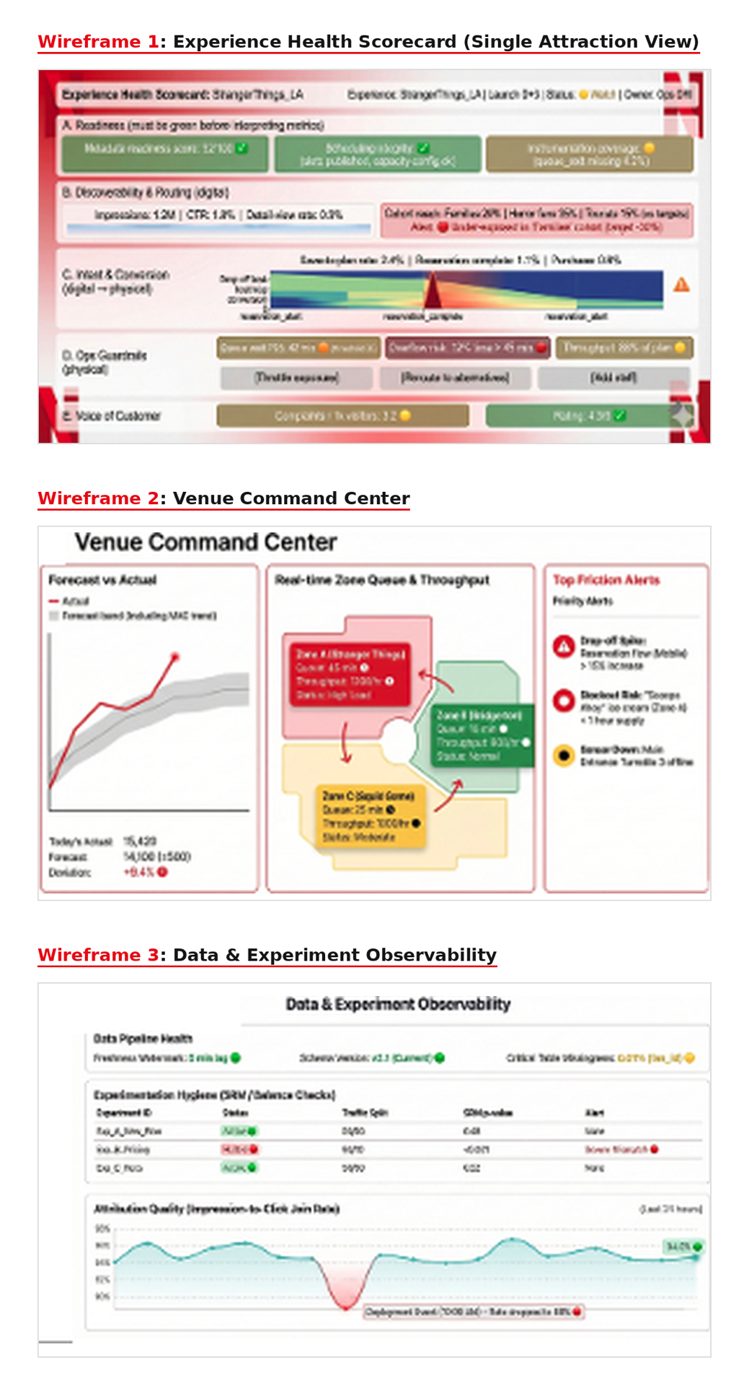

## 15.2 Cold-start exposure targets and exploration budgets

Every attraction launch begins as a cold start problem. The system has limited interaction history, uncertain demand elasticity, and an incomplete understanding of who it resonates with most. If exposure is left to organic drift, two predictable failure modes appear. The attraction can be under-exposed—never receiving enough high-quality traffic to learn and improve—creating a “dead on arrival” outcome. Or it can be over-exposed—driving demand faster than capacity—creating queues, dissatisfaction, and harmful spillover.

To avoid both, the launch plan should treat exposure as a controlled allocation problem with explicit learning goals. The most reliable method is to define a minimum viable exposure target by cohort (who must see it, and how many eligible exposures are needed in the first learning window to draw conclusions), and then ramp exposure in stages while watching operational guardrails. This approach is structurally similar to an exploration budget in recommender systems: a bounded portion of surface inventory is reserved for learning and discovery, but it is governed by safety constraints and portfolio balance.

In practice, this means the attraction’s launch plan should specify: (1) cohort-based exposure targets for the first 48–72 hours (or another defined window), (2) frequency caps so the same guest is not repeatedly prompted, (3) capacity-aware throttles so exposure never outruns throughput, and (4) routing fallbacks to adjacent alternatives when the attraction is saturated. The intent is to make early learning predictable: the attraction gets enough exposure to learn who it fits, but not so much that the venue pays the price in congestion.

## 15.3 Launch monitoring and alerting

Observability only matters if it changes what teams do while it still matters. A Netflix-aligned implementation turns monitoring into an operating system: measurable launch gates, automated detection, and clear runbooks for response—paired with explicit ownership across venue ops, marketing, product/personalization, and analytics engineering.

The first operational principle is to treat data readiness as a launch dependency, not a nice-to-have. If exposure logging is incomplete, if join coverage between reservations and entry scans is broken, or if queue telemetry is missing during peak hours, then performance readouts should be blocked or explicitly flagged as non-decision-grade. This prevents teams from “learning” the wrong lesson because the measurement layer is failing silently.

The second principle is to consolidate monitoring into a single command view that supports drill-down. A launch dashboard should make it easy to answer, in sequence: Is it configured correctly? Is it being seen by the intended cohorts? Are guests progressing through intent and commitment? Are conversion and attach behaving plausibly? Are operations stable? From there, drill-down should isolate where the breakdown occurs—by step, by cohort, by daypart, or by venue state—so response is targeted rather than reactive.

Alerting should be tied to actions, not merely thresholds. When a queue overflow alert fires, the response should be predetermined: throttle exposure, reroute to alternatives, and deploy floor mitigation. When a reservation drop-off spike appears, the response should point to verification of availability/configuration and immediate UX or messaging fixes. When throughput is below plan, the response should escalate staffing/equipment/process checks rather than blaming demand.

Finally, launches need an explicit “launch owner” model that crosses digital and physical responsibilities. Without clear on-call-style ownership, hybrid incidents often produce a familiar failure pattern: everyone sees the issue, but no one is accountable for the fix. A disciplined ownership model prevents that and makes launches safer to scale.

## 15.4 Post-launch evaluation

A launch is not truly successful because it spikes activity on Day 1. The correct question is whether it produced **incremental** improvements—more engagement, more conversion, better guest outcomes—without degrading experience quality or portfolio health. That requires evaluation that is explicitly causal when possible, and explicitly counterfactual when randomization is not feasible.

When randomization is feasible, the launch’s routing and merchandising decisions should be evaluated using venue-appropriate experimental designs—switchbacks, time-sliced ramps by daypart, or cluster designs when interference is unavoidable. In these tests, the metric hierarchy from the rest of the report applies directly: intent and progression often provide faster learning; conversion and return validate business value; congestion, complaints, and concentration act as non-negotiable guardrails. The point is not to maximize a single KPI; it is to establish that the launch improves outcomes while remaining safe to operate.

When randomization is infeasible—because the change is physical, permanent, or must be consistent venue-wide—the evaluation must move to quasi-experimental counterfactuals, such as interrupted time series, difference-in-differences, or synthetic controls. In these settings, the standard of evidence is diagnostics plus uncertainty: show why the counterfactual is credible, demonstrate robustness to alternative controls or donor sets, and avoid overstating “effects” that may be explained by calendar shifts, marketing overlap, or novelty decay.

A venue launch also demands one additional layer of evaluation that is easy to overlook: long-run portfolio health. Leaders should be able to answer whether the launch created harmful cannibalization (other experiences collapse because attention and capacity were sucked into one choke point) or positive halo (adjacent experiences benefit), whether exposure became overly concentrated, and whether queue dynamics or throughput changes indicate that the attraction is drawing more demand than the system can safely serve. This portfolio view is what transforms launch evaluation from a local “attraction success story” into a system-level measurement discipline.

The overall purpose of post-launch evaluation is to close the loop: not only “did we launch,” but “did we learn safely, do we understand incrementality, and are we ready to scale exposure and operational dependence with confidence?”

# References :

* Braze. (2025, October 7). **Add to Cart Rate: What It Is, Why It Matters, and How to Improve It**. *Braze*. Retrieved from https://www.braze.com/resources/articles/add-to-cart-rate
* Enalytix. (2024, September 17). **How Can Optimizing Dwell Time Unlock Retail Success?** *Enalytix Blog*. Retrieved from https://www.enalytix.com/blog-details/how-can-optimizing-dwell-time-unlock-retail-success
* Kumaran, U. (n.d.). **How Netflix Uses Machine Learning (ML) to Create Perfect Recommendations**. *Brainforge*. Retrieved December 20, 2025, from https://www.brainforge.ai/blog/how-netflix-uses-machine-learning-ml-to-create-perfect-recommendations
* Lane, S., Zheng, W., & Tendulkar, M. (2021, March 3). **A Day in the Life of an Experimentation and Causal Inference Scientist @ Netflix**. *Netflix Tech Blog*. Retrieved from https://netflixtechblog.com/a-day-in-the-life-of-an-experimentation-and-causal-inference-scientist-netflix-388edfb77d21
* Purcărea, T. V., Ionescu, Ș., Purcărea, I. M., Purcărea, I., & Ionescu, A. G. (2025). **The Tech-Enabled Shopper Impacting a Phygital Retail Complex System…** *Systems, 13*(3), 152. https://doi.org/10.3390/systems13030152
* Skrovan, S. (2017, May 17). **Why researching online, shopping offline is the new norm**. *Retail Dive*. Retrieved from https://www.retaildive.com/news/why-researching-online-shopping-offline-is-the-new-norm/442754/
* Tang, Y., Willeck, C., & Palao, S. (2025, January 2). **Part 2: A Survey of Analytics Engineering Work at Netflix**. *Netflix Tech Blog*. Retrieved from https://netflixtechblog.com/part-2-a-survey-of-analytics-engineering-work-at-netflix-4f1f53b4ab0f
* Toobler. (n.d.). **Digital Twins in Customer Experience: Key Benefits**. *Toobler Blog*. Retrieved April 29, 2024, from <https://www.toobler.com/blog/digital-twins-in-customer-experience>
* Gustafsson, A., Öberg, C., & Shams, P. (2025). Enhancing the phygital customer experience in the digital world (Chapter). In Service Innovation and Management (pp. 113–126). Springer. [Springer](https://link.springer.com/chapter/10.1007/978-3-031-76560-5_9)
* Requena, B., Cassani, G., Tagliabue, J., Greco, C., & Lacasa, L. (2020). Shopper intent prediction from clickstream e-commerce data with minimal browsing information. Scientific Reports, 10, 16983. [Nature](https://www.nature.com/articles/s41598-020-73622-y)
* Saberian, E., & Basilico, J. (2022, September 30). RecSysOps: Best practices for operating a large-scale recommender system. Netflix Technology Blog (Medium). [Medium](https://netflixtechblog.medium.com/recsysops-best-practices-for-operating-a-large-scale-recommender-system-95bbe195a841)
* Takai, K., & Yada, K. (2010). Relation between stay-time and purchase probability based on RFID data in a Japanese supermarket. In Knowledge-Based and Intelligent Information and Engineering Systems (KES 2010) (pp. 254–263). Springer. [Springer](https://link.springer.com/content/pdf/10.1007/978-3-642-15393-8_29.pdf)
* Netflix Technology Blog. (2025, November 13). Heterogeneous treatment effects at Netflix. Netflix Technology Blog (Medium). [Medium](https://netflixtechblog.medium.com/heterogeneous-treatment-effects-at-netflix-da5c3dd58833)
* Gustafsson et al. (2025) chapter DOI: 10.1007/978-3-031-76560-5_9
* Requena et al. (2020) DOI: 10.1038/s41598-020-73622-y
* Takai & Yada (2010) DOI: 10.1007/978-3-642-15393-8_29
* RecSysOps (Medium): https://netflixtechblog.medium.com/recsysops-best-practices-for-operating-a-large-scale-recommender-system-95bbe195a841
* HTE (Medium): https://netflixtechblog.medium.com/heterogeneous-treatment-effects-at-netflix-da5c3dd58833

# Appendix A. Definitions

This appendix defines the key metrics, labels, and evaluation measures used in the notebook so the results in Sections 5-10 are interpretable and reproducible.

## A.1 Event semantics

The dataset records three interaction types in events.csv:

· view: a visitor viewed an item (discovery / browsing proxy)

· addtocart: a visitor added an item to cart (intent proxy)

· transaction: a visitor completed a purchase (conversion proxy)

Core identifiers:

· visitorid: anonymized user/fan identifier

· itemid: anonymized item/experience identifier

· transactionid: only populated for transaction events

· timestamp: Unix epoch time in milliseconds

For readability, the notebook converts timestamps to:

· event_ts = to_timestamp(timestamp / 1000.0)

· prop_ts = to_timestamp(timestamp / 1000.0) for item properties

## A.2 “Fan journey” funnel metrics

All funnel metrics are computed on unique visitors, unless stated otherwise.

Let:

· V = number of unique visitors with at least one view

· A = number of unique visitors with at least one addtocart

· B = number of unique visitors with at least one transaction

Then:

Intent rate (View → Intent proxy):



Conversion rate (View → Purchase proxy):



Checkout completion proxy (Intent → Purchase):



These map to a Netflix House lens as: browse → commit (reserve / add to plan) → purchase (ticket/merch/F&B).

## A.3 Arrival pattern metric

Arrival patterns are computed as hourly unique visitors:



This is a proxy for “when demand shows up,” which can be used for staffing bands and activation timing.

## A.4 Forecasting target and error metrics

Forecast target (proxy demand): daily unique visitors.



Error metrics:

MAE (mean absolute error):



MAPE (mean absolute percentage error):



Note: MAPE can be unstable when y_i is near zero; here daily traffic is large enough that it is usable.

## A.5 Recommendation evaluation metrics (offline)

For a user u, let:

· R_u be the ranked recommendation list

· R_u^K be the top K items in that list

· T_u be the set of “ground truth” items the user interacted with in the test period

Then:

Precision@K:

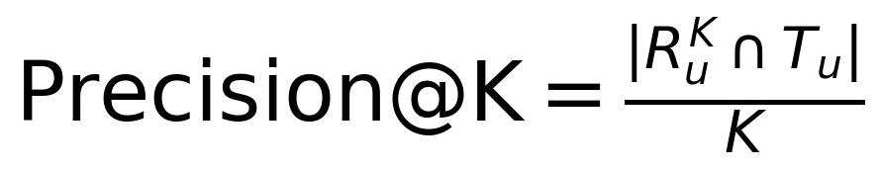

Recall@K:



NDCG@K (normalized discounted cumulative gain):

DCG@K:



NDCG@K is DCG@K normalized by the ideal DCG@K for that user.

These are offline proxies for relevance. In production, they guide iteration, but online A/B tests validate real lift.

## A.6 Churn/retention label definition (30-day return risk proxy)

The notebook defines churn using a forward-looking window anchored at 2015-08-01:

· Feature window: events strictly before 2015-08-01

· Target window: 2015-08-01 to 2015-08-31 (30 days)

· Label (purchase-based): churn_label = 1 if the visitor has no transaction in the target window; churn_label = 0 if the visitor has at least one transaction in the target window

This label is intentionally strict; in a Netflix House implementation, an engagement-based “return” label is typically more actionable.

# Appendix B. SQL and Pipeline Notes

This section documents how raw files were turned into analysis-ready tables and the key SQL patterns used.

## B.1 Input files (Google Drive)

Expected files in your Drive folder (for example, MyDrive/Netflix/):

· events.csv

· category_tree.csv

· item_properties_part1.csv

· item_properties_part2.csv

## B.2 DuckDB warehouse layer (core views)

The notebook uses DuckDB to mimic an analytics warehouse workflow. Conceptually:

Raw views:

· events_raw ← events.csv

· item_properties_raw ← item_properties_part1.csv UNION ALL item_properties_part2.csv

· category_tree ← category_tree.csv

Enriched views (timestamp conversion):

· events: timestamp_ms, event_ts, visitorid, event, itemid, transactionid

· item_properties: timestamp_ms, prop_ts, itemid, property, value

This creates a clean separation: raw ingestion stays close to source; enriched views standardize timestamps and schemas.

## B.3 Performance subset for item properties

item_properties is very large, so the notebook creates a subset for fast iteration:

· top_items: top 20,000 items by view count

· item_properties_top: item properties filtered to top_items

This keeps content-based cold start feasible in Colab while still covering the most relevant portion of the catalog.

## B.4 Key SQL patterns used

Daily time series for forecasting:

· date = CAST(event_ts AS DATE)

· visitors = COUNT(DISTINCT visitorid)

· transactions = COUNT(CASE WHEN event='transaction' THEN 1 END)

Top items per category (window functions):

The notebook includes a query that filters to recent activity, joins item category metadata, counts views by (category, item), and ranks items within each category using ROW_NUMBER(). The core pattern uses CTEs for readability, joins for enrichment, and a window-function rank partitioned by category.

# Appendix C. Model Configurations and Validation Details

This section documents model inputs, splits, and hyperparameters as implemented in the notebook.

## C.1 Forecasting model (daily visitors)

Goal: forecast daily unique visitors (demand proxy).

Feature engineering:

· lag_1 = visitors.shift(1)

· lag_7 = visitors.shift(7)

· day_of_week = date.dayofweek

· rows with missing lags dropped

Train/test split: hold out last 30 days as test.

Model: GradientBoostingRegressor(n_estimators=100, random_state=42).

Evaluation: MAE and MAPE on the 30-day holdout; visual check with an actual-versus-forecast plot.

Observed performance from the notebook run: Test MAE ≈ 1,167 visitors; Test MAPE ≈ 34.6%.

Interpretation: lag + weekday features capture baseline seasonality but miss exogenous drivers (campaigns, releases, and operational constraints).

## C.2 Recommendation baselines (offline evaluation)

Implicit feedback weighting: view=1, addtocart=5, transaction=10.

Time split: events sorted chronologically; 80/20 split by row index (time-based).

Ground truth per user: for each visitorid in test, T_u is the set of unique itemid values interacted with in test.

Baseline 1 - Popularity:

· rank items by SUM(weight) in training

· recommend Top-10 globally

Baseline 2 - Item-to-item co-visitation:

· build co-occurrence counts by self-joining training interactions on visitorid

· for each item_a, keep top-10 neighbors item_b by co-occurrence count

· recommend based on the user's last item in training; fall back to popularity if needed

Metrics: Precision@10, Recall@10, NDCG@10.

Observed results from the notebook run: Popularity (Precision=0.0008, Recall=0.0068, NDCG=0.0033); Co-visitation (Precision=0.0012, Recall=0.0088, NDCG=0.0047).

## C.3 Cold start implementations

New user cold start (diverse slate):

· extract category IDs from item properties (property='categoryid')

· choose top categories by frequency

· for each category, recommend a high-view item in that category

· output a category-balanced slate (reduces over-concentration versus pure popularity)

New item cold start (content-based similarity):

· build item “documents” from (property, value) tokens

· vectorize using TF-IDF

· compute cosine similarity; retrieve top-k similar items for a target item (demonstration)

Implementation note: TF-IDF was built for 18,676 items from the filtered subset; in production, similarity would typically be approximated (ANN) or computed on-demand.

## C.4 Retention / churn risk model (30-day window)

Labeling: features computed pre-2015-08-01; target is whether a transaction exists in [2015-08-01, 2015-08-31); churn_label = 1 if no transaction else 0.

Features: recency (days since last pre-anchor event), frequency_tx, view_count, cart_count, unique_items.

Train/test split: train_test_split(test_size=0.2, random_state=42).

Models: LogisticRegression(max_iter=1000) and XGBClassifier(eval_metric='logloss', random_state=42).

Metrics: ROC-AUC and PR-AUC. Caveat: purchase-based retention is extremely rare; ROC-AUC is more interpretable than PR-AUC in this label regime.

## C.5 A/B testing: power + significance (design demo)

Baseline conversion (computed from dataset): buyers/visitors ≈ 0.8326%.

Power analysis settings: alpha=0.05, power=0.80, target lift=+5% relative.

Method: effect size via proportion_effectsize(p0, p1); sample size solved via NormalIndPower().solve_power(...).

Output: required sample size ≈ 766,332 per variant for detecting +5% lift at that baseline rate.

Significance test demo: simulated conversions for control/treatment at computed n; ran a two-proportion z-test (proportions_ztest).

## C.6 Causal inference: confounding + IPTW (synthetic demo)

Because the event logs do not include randomized treatment assignment, the notebook includes a causal inference demonstration showing:

· naïve difference in means can be biased under targeted treatment

· propensity score modeling plus inverse probability of treatment weighting (IPTW) can reduce bias under assumptions

Key outputs (demo): True ATE: $5.00; Naïve estimate: $10.56; IPTW estimate: $5.87 (closer to true).

# Appendix D. Additional Charts and Diagnostics

Optional additions that are easy to generate from the existing notebook outputs and help during interviews.

## D.1 Fan journey and behavior

· Hourly heatmap: hour-of-day × day-of-week (unique visitors)

· Funnel over time: view → addtocart → transaction rates by week

## D.2 Forecasting diagnostics

· Residual plot (actual − forecast) over time

· Error by day-of-week

· Prediction intervals (p10/p50/p90)

## D.3 Recommendation diagnostics

· Coverage and concentration: % of catalog ever recommended; share of recommendations going to top 1% items

· Novelty distribution (popularity of recommended items)

## D.4 Retention modeling diagnostics

· Lift chart by risk decile

· Confusion matrix at an operating threshold

· Feature importance / SHAP (especially for XGBoost)

## D.5 Experimentation and causal inference visuals

· Power curve: detectable lift vs required sample size

· Propensity score overlap plot (treated vs control)